

**OpenELIS Global**

**Laboratory Information System Software**

**Administrator Manual**

Version 3.0

October 2023

For information on OpenELIS Global,

visit [www.openelisglobal.org](http://www.openelisglobal.org)

Or contact:

Casey Iiams-Hauser

OpenELIS Global Product Owner

Digital Initiatives Group at I-TECH (DIGI) University of Washington digit@uw.edu

# **PART 1: INTRODUCTION**

This Administrator Manual provides comprehensive instructions outlining step-by-step procedures for accessing and administering the OpenELIS Global system.

## **Intended Audience**

This manual will be used by the administrator of the OpenELIS Global system. The OpenELIS Global system administrator will perform the administration functions of the system.

# **PART 2: NAVIGATING OpenELIS GLOBAL**

The OpenELIS Global system is made up of a variety of concise screens and workflows to help with the collection, management, and reporting of laboratory data. The use of this system is intended to provide a structured approach to managing the data within the clinical laboratory setting to ensure high-quality testing processes and results data that is then made accessible to external systems and people in the clinical, population, and programmatic health workflows.

## **How to login to OpenELIS**

To login to OpeELIS, You will require a **username** and **password** obtained from the administrator of your OpenELIS instance.

1. Type in your **username** and **password** and click on the **Submit** button.

**Notice**: Access to this service is for authorized personnel only. If you do not have the expressed authorization of the administrator, you must exit now. This organization prohibits unauthorized access, disclosure, duplication, modification, diversion, destruction, loss, misuse, or theft of its information.

# 

*OpenELIS Global 3.0 Login page*

Once you connect to OpenELIS Global, the home page will display the laboratory management statistics for your understanding of the current state of the lab testing processes.

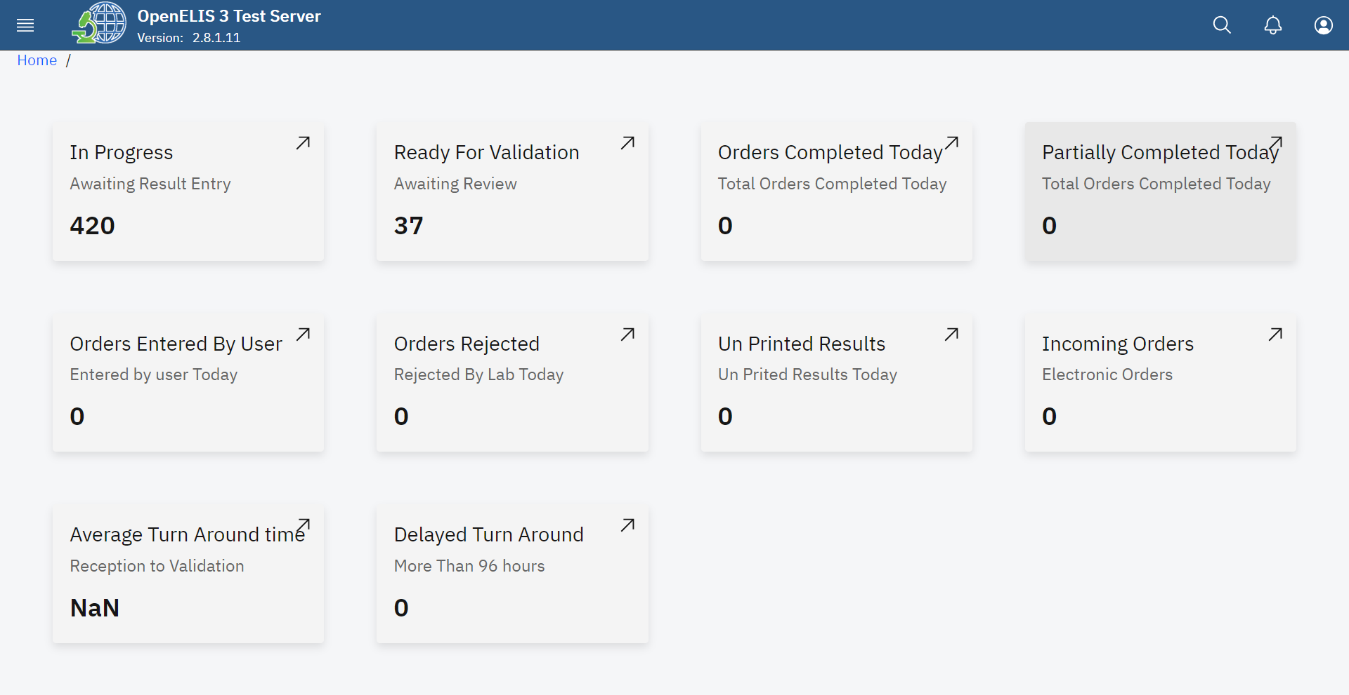

*OpenELIS Statistics*

# 

# **PART 3: ACCESSING THE OpenELIS GLOBAL ADMINISTRATION MODULE.**

## **How to access the OpenELIS menu**

1. To access the main menu, click on the menu icon at the top left side of the screen.

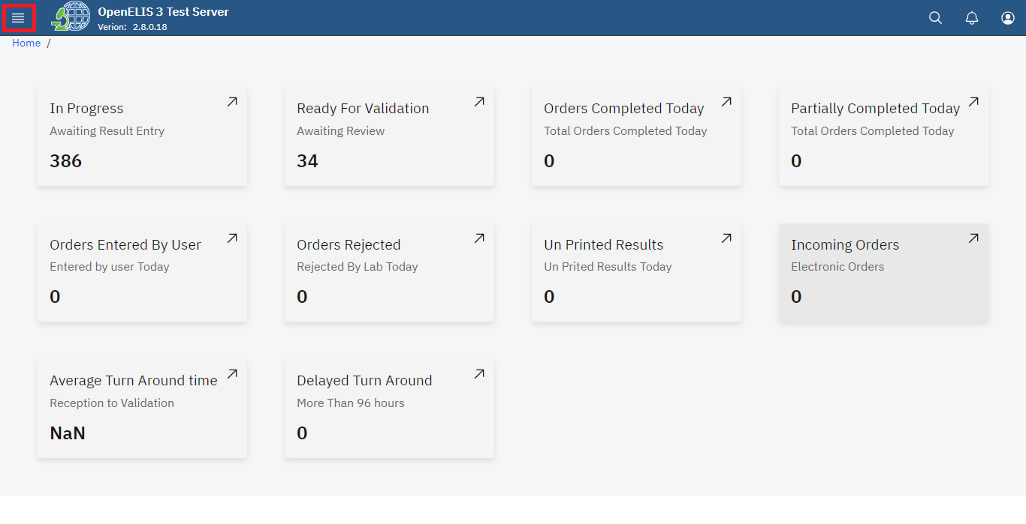

*Accessing OpenELIS 3 Menu*

Upon clicking on the menu icon, the OpenELIS menu will be displayed on the left side of the screen with modules that reflect the main activities of the laboratory workflow. The cancel will close the side menu item.

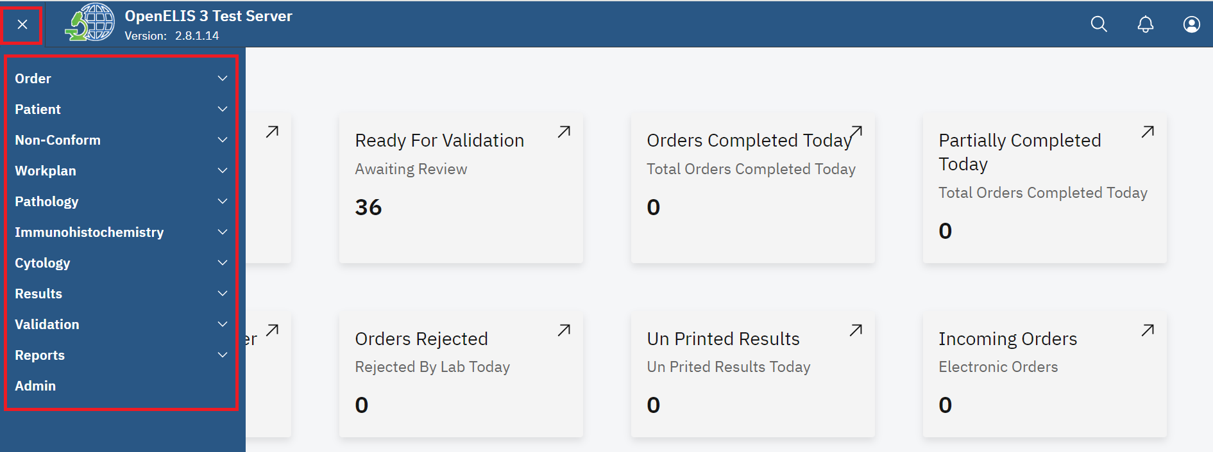

*OpenELIS Global Version 3 Menu*

## 

## **How to access the OpenELIS administrator module.**

1. To access the administrator module, click on Admin under the OpenELIS menu.

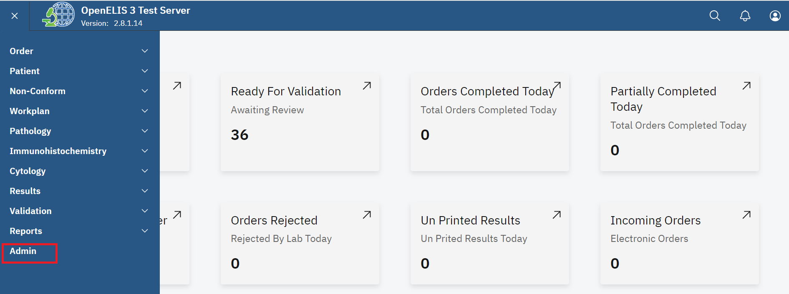

*Click on Admin*

Note: Upon clicking on the admin module, the administration page for OpenELIS 3 system will be displayed.

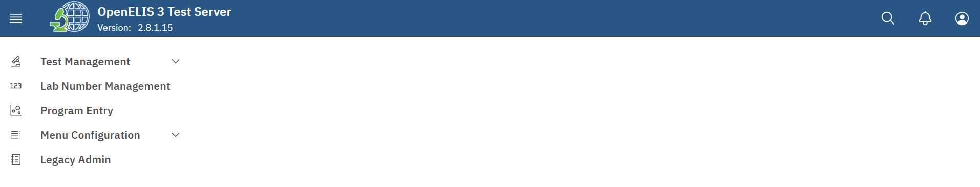

*Administration modules*

1. Click on **Legacy Admin.**

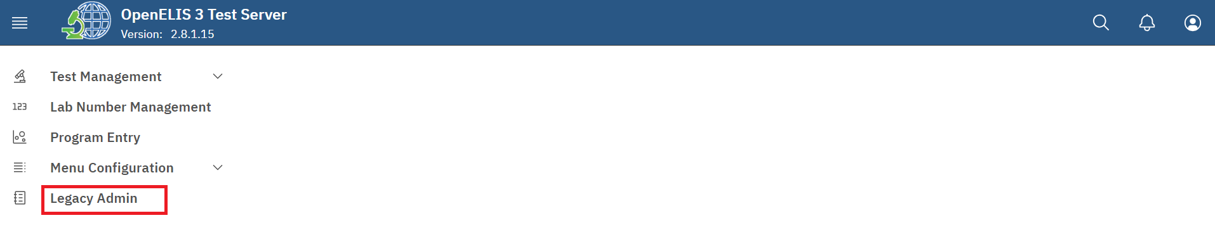

*Click on Legacy Admin*

Note: Upon clicking on **Legacy Admin**, the master list page will be displayed

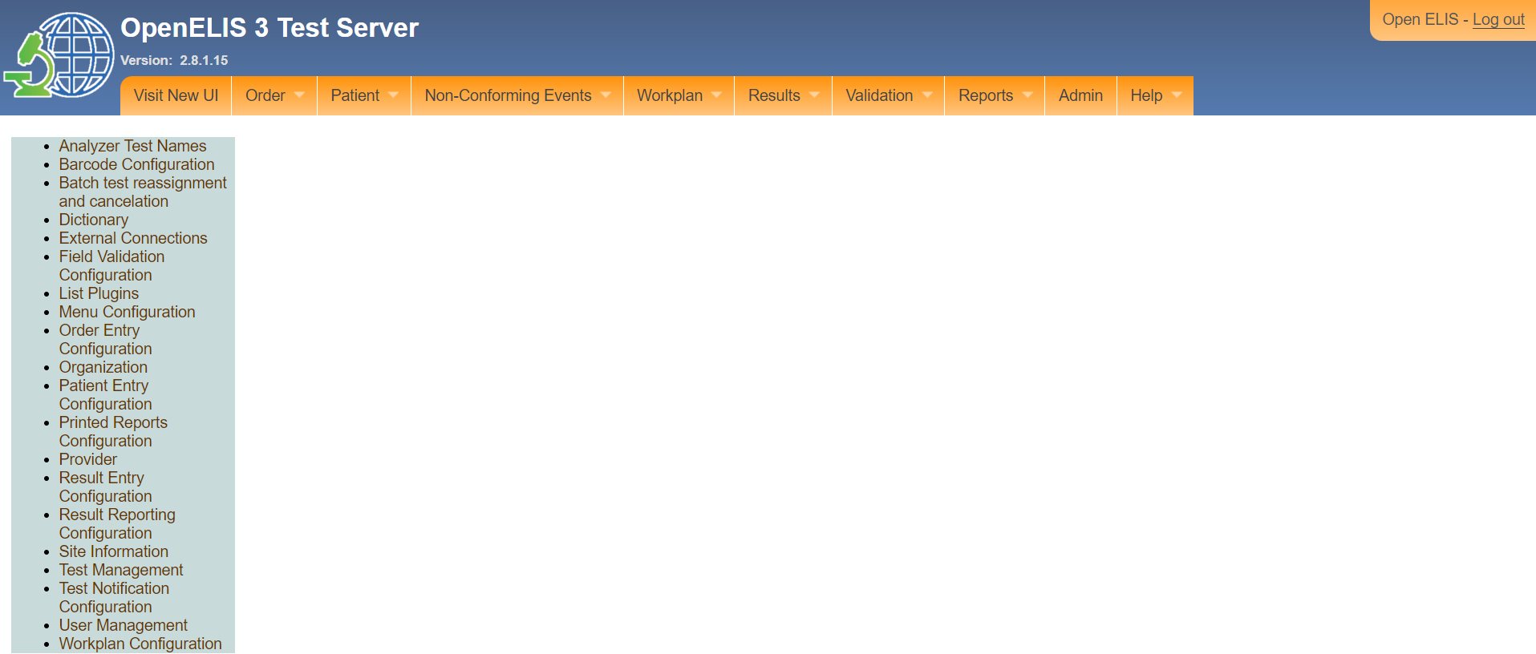

*Legacy UI master list page*

# **PART 4:BARCODE CONFIGURATION.**

## **How to configure barcode labels**

1. Follow steps 1 and 2 under how to access the OpenELIS administrator module.
2. Click on **Barcode Configuration** under the master list page.

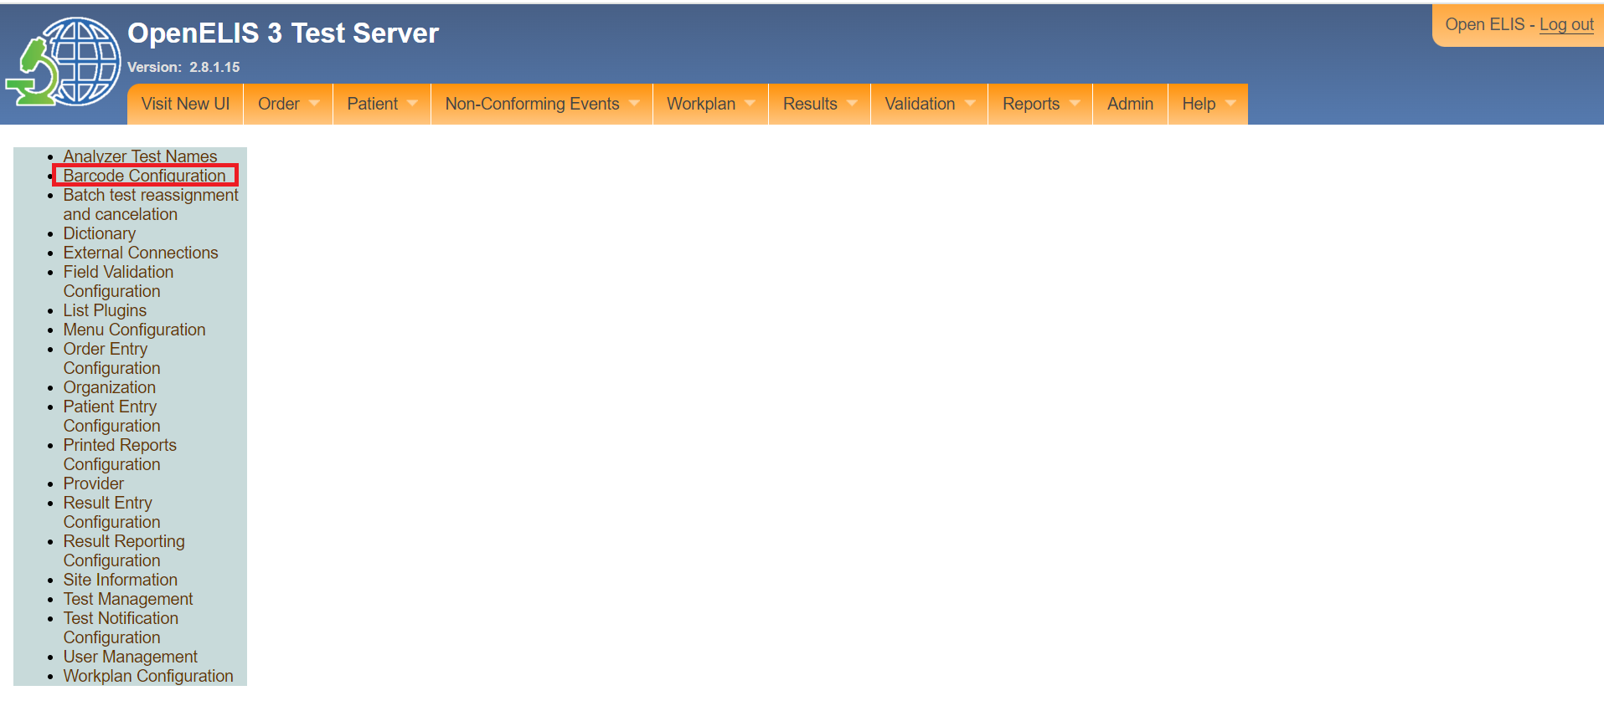

*Click Barcode Configuration*

Note: The barcode configuration page has three fields namely; **Number Barcode Label**

**Barcode Label Elements** and **Dimensions Barcode Label**.

1. In the **Number barcode Label** section, Configure the number of bar code labels to be printed with every order and specimen and indicate the number of bar code labels that can be printed for each order or specimen.

Note: Once the maximum has been reached, a user will be unable to print additional labels.

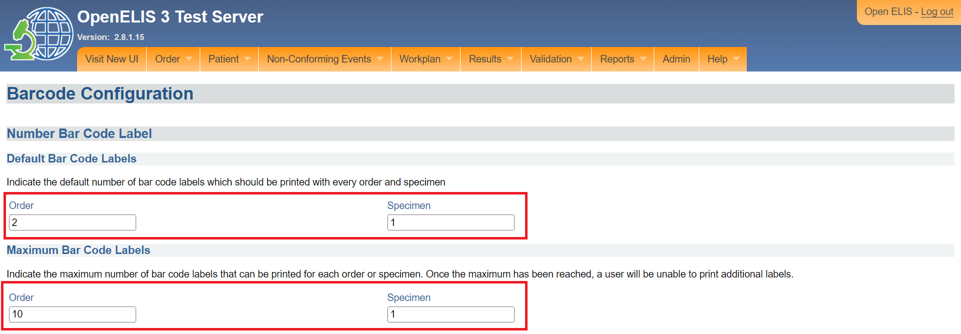

*Number barcode label*

1. In the **Barcode Label Element** section, check the check the boxes next to the optional elements that should appear on the order and sample bar code labels

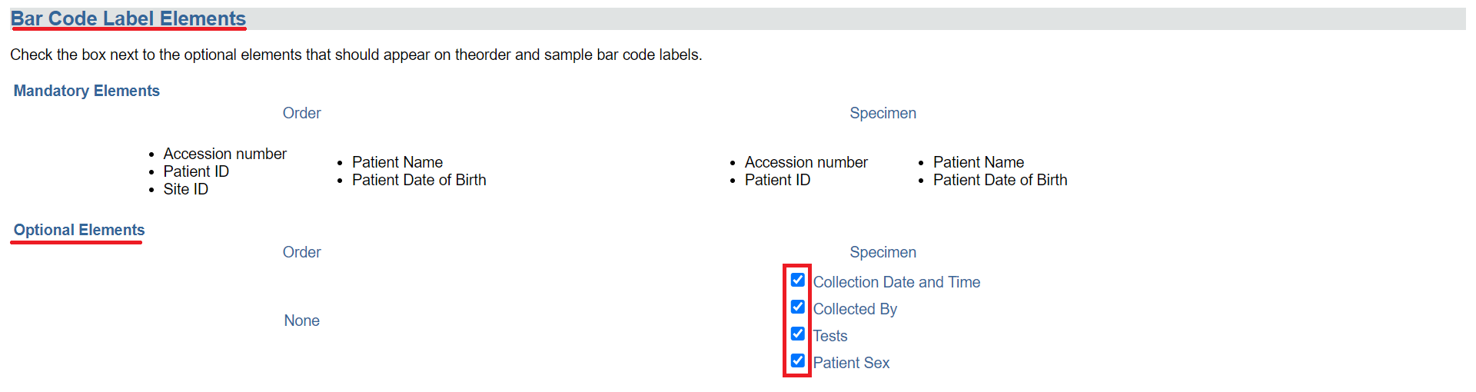

*Barcode label element*

1. The **Preprinted Barcode Accession number** when checked will make use the same accession number format and pool of available numbers as Order Entry Generation Prefix for pre-printed barcode labels



*Preprinted barcode accession number*

1. In the section **Dimensions Barcode Label**, indicate the dimensions that bar code labels should conform to when printing.

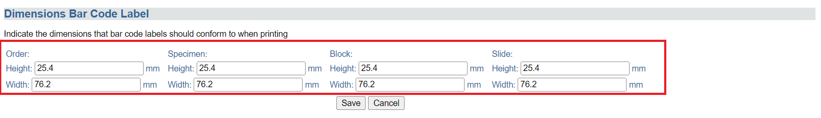

*Dimensions barcode label*

1. Click on the **Save** button to save the configurations

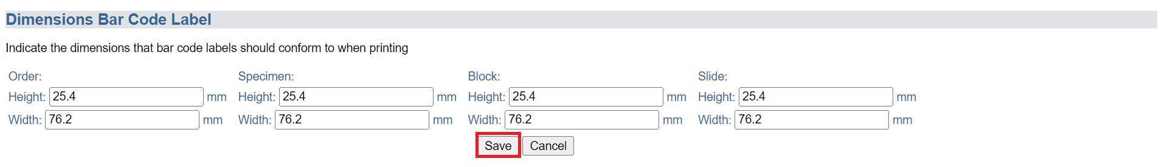

*Click save*

The configuration will be saved successfully.

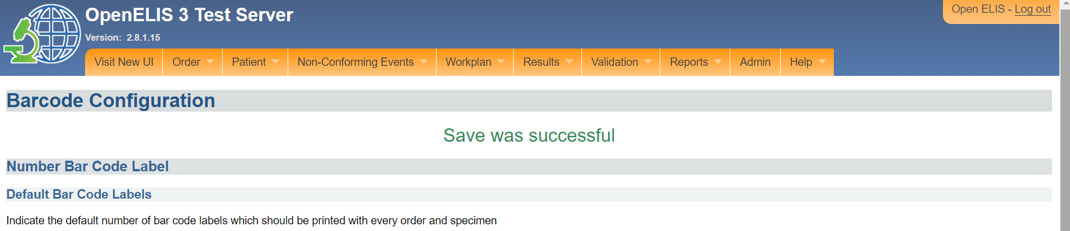

*Configurations saved successful*

# **PART 4: DICTIONARY.**

The dictionary is a core component of the OpenELIS 3 Global system that allows the configuration of items such as programs by the administrator.

## **How to access the OpenELIS Global dictionary.**

1. Follow steps 1 and 2 under [how to access the OpenELIS administrator module](https://docs.google.com/document/d/1oPIYxrLgoBi4prx2-Anhe1fm4x23_QQanpE_DqAVaVA/edit?pli=1#heading=h.but495evqliv).
2. Click on **Dictionary** under the master list page.

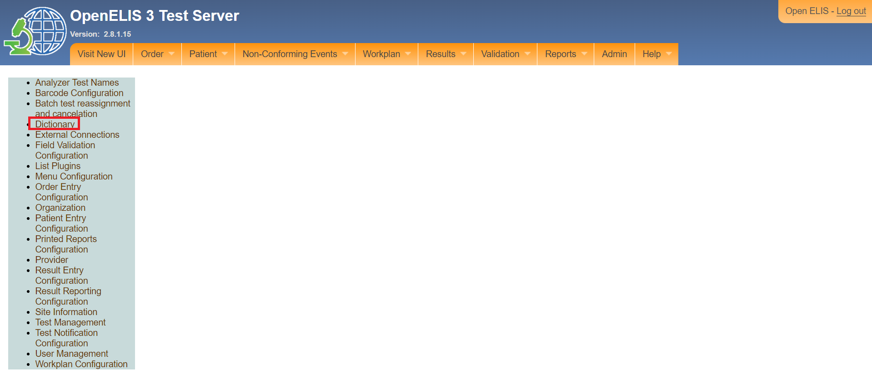

*Click on dictionary*

Note: Upon clicking on the dictionary under the master page, the dictionary menu will be displayed. The menu displays a **Select** checkbox for an entry, **Category** of an entry, The **Dictionary Entry**, **Local Abbreviation** and the **Is Active** status of an entry.

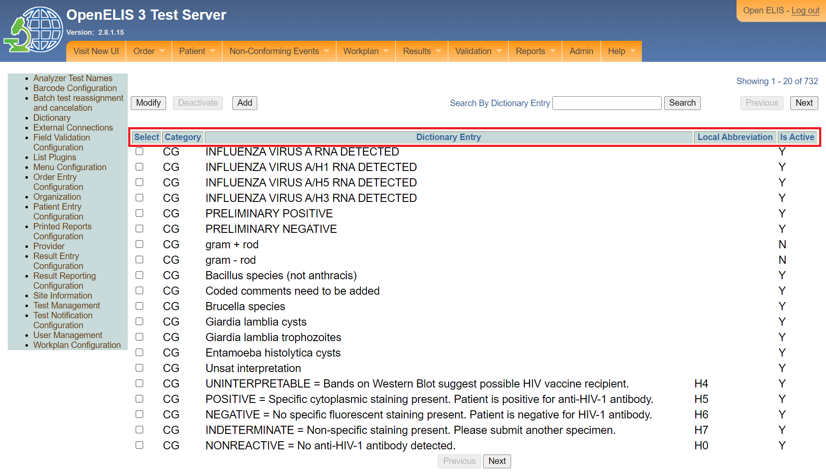

*Dictionary menu*

The **Next** button button is used to display the next 20 dictionary entries.

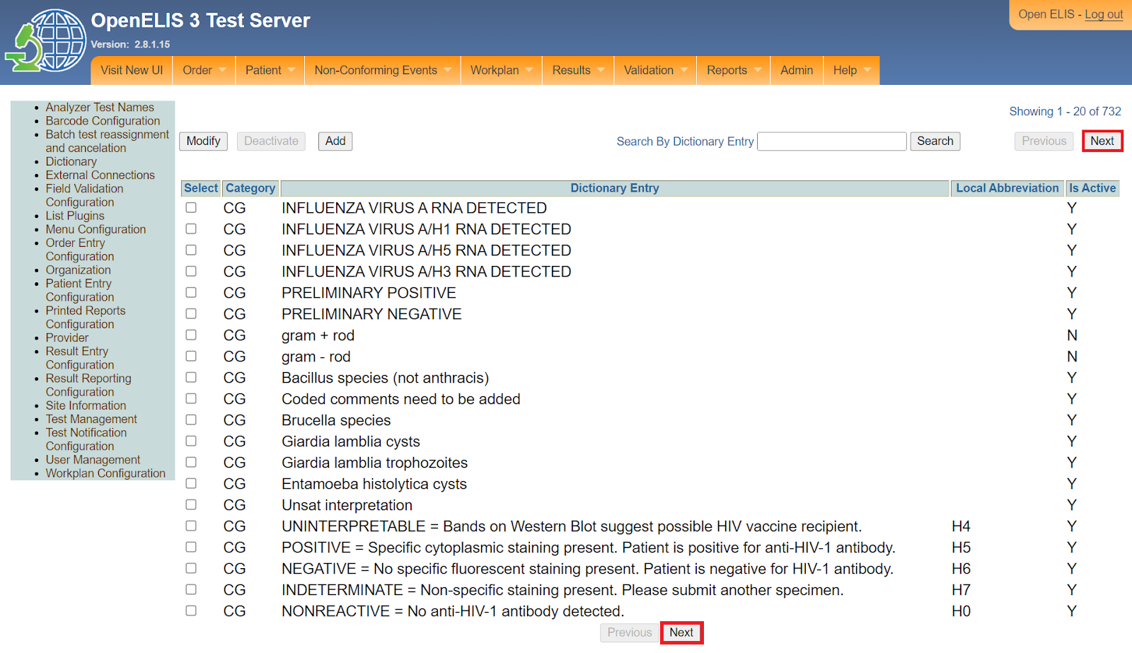

*Navigating dictionary entries*

The **Previous** button is used to display the previous 20 dictionary entries.

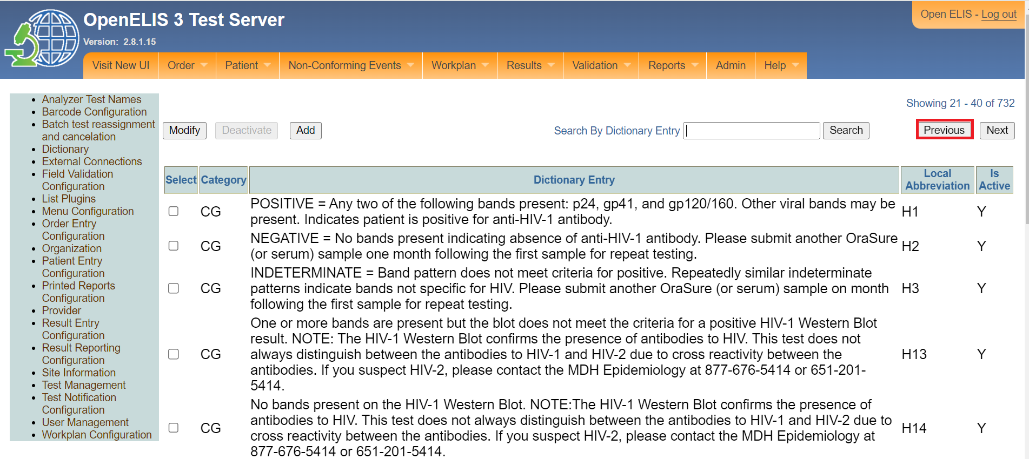

*Navigating dictionary entries*

## **How to search for a dictionary entry**

1. To search for a dictionary entry, type the entry name in the **Search By Dictionary Entry**

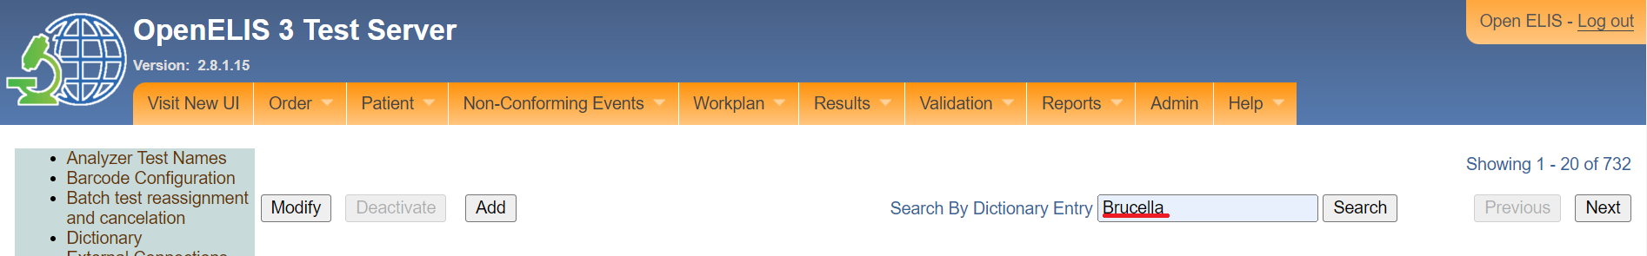

*Type the dictionary entry*

1. Click on the **Search** button.

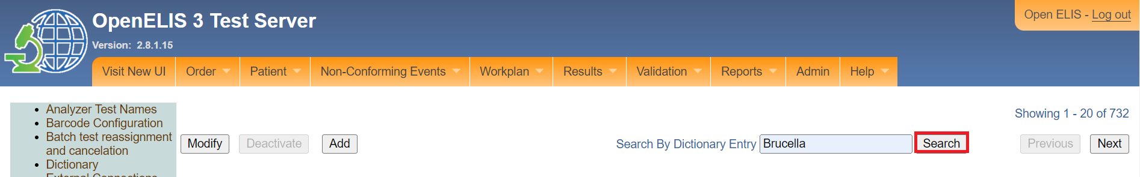

*Click search on the button*

The searched dictionary entry will be displayed.

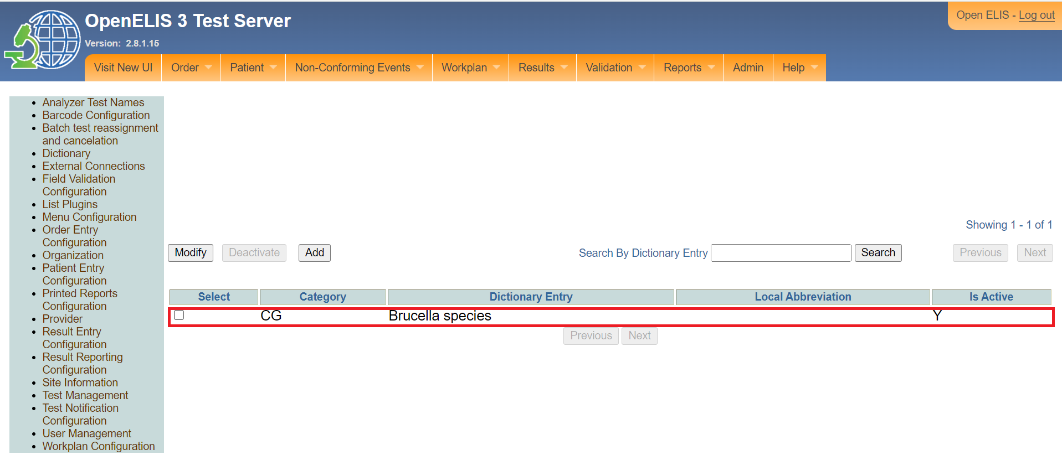

*Searched dictionary entry*

## **How to modify a dictionary entry**

1. To modify a dictionary entry, click on the **Select** checkbox next to the entry to select it.

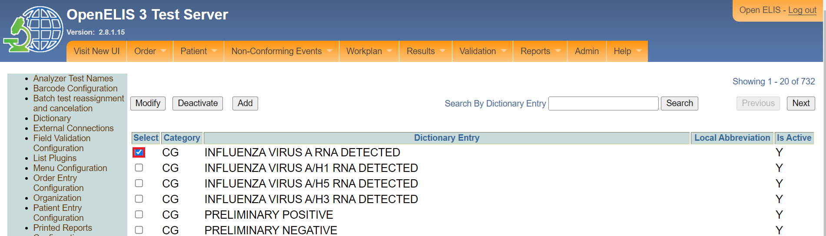

*Click on the select checkbox*

1. Click on the **Modify** button.

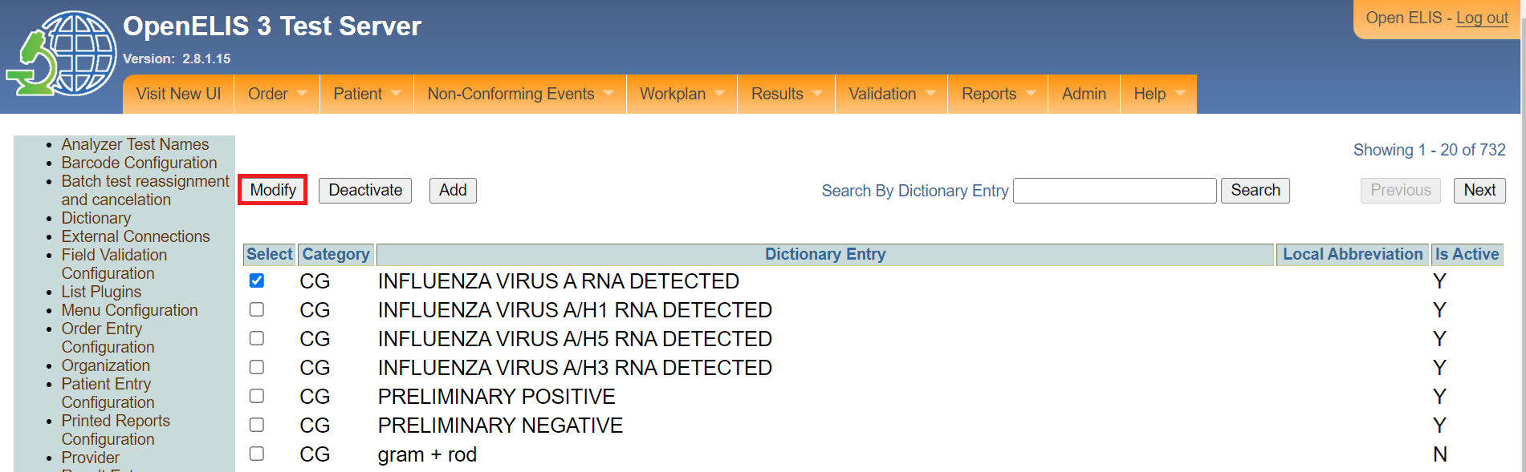

*Click modify*

1. Edit the fields under the Edit **Dictionary** page. Fields marked with asterisks * are mandatory.

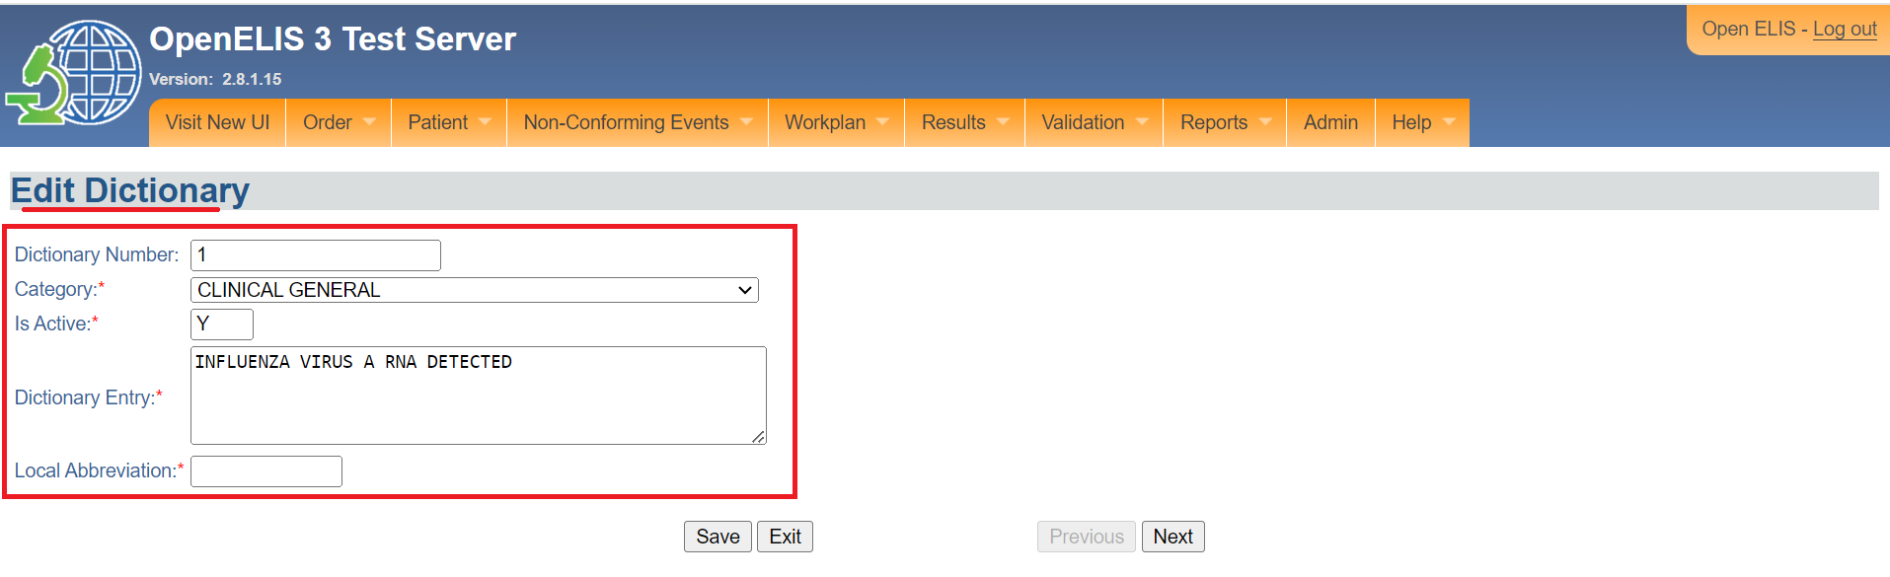

*Edit fields*

Note: The **Exit** button will close the Edit Dictionary page without saving. The **Next** button is used to display the next dictionary entry.

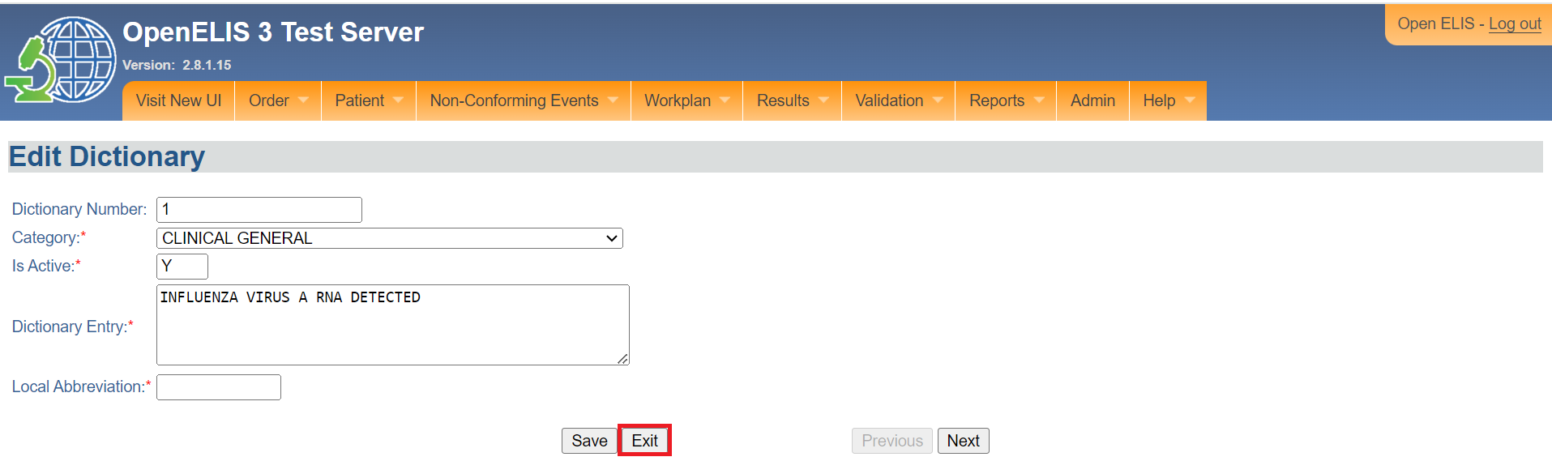

*Exit edit dictionary page*

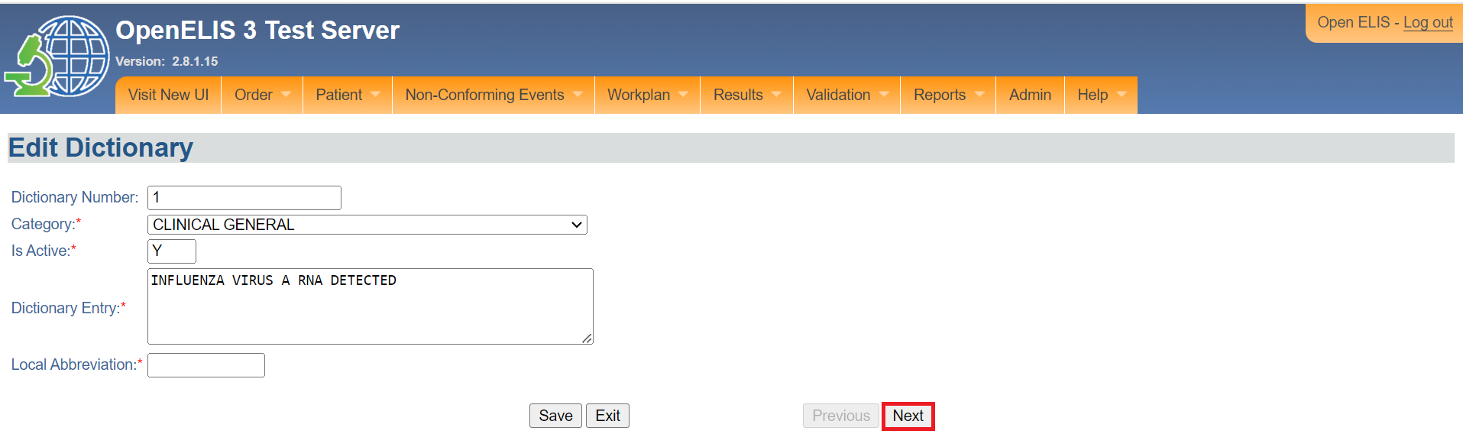

*Next dictionary entry*

1. Click on the **Save** button.

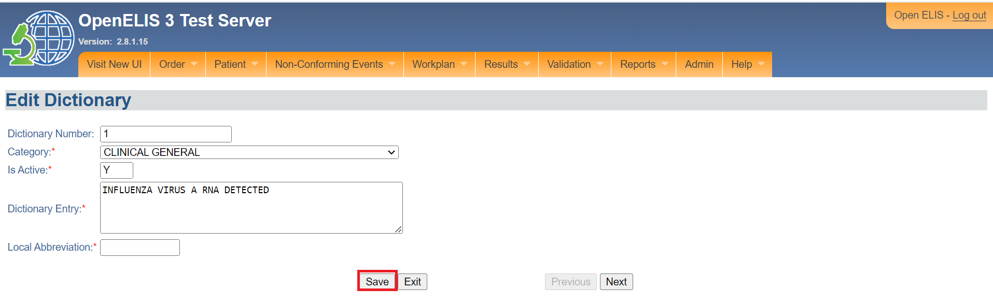

*Click on the save button*

## **How to add a dictionary entry**

1. To add a dictionary entry, click on the **add** button.

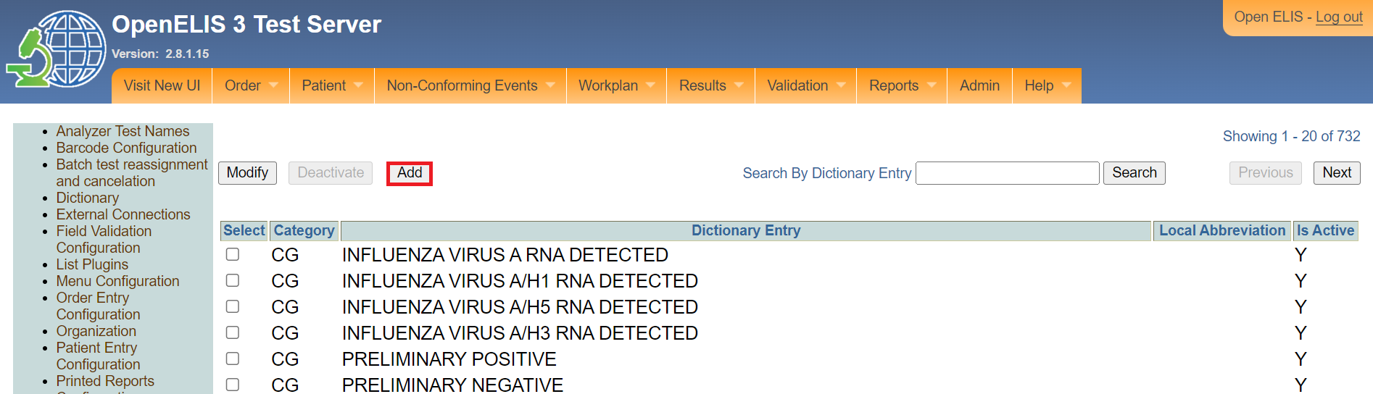

*Click on add button*

Upon clicking on the **Add** button, The Add Dictionary form will appear. Fields with red asterisk * are mandatory to fill.

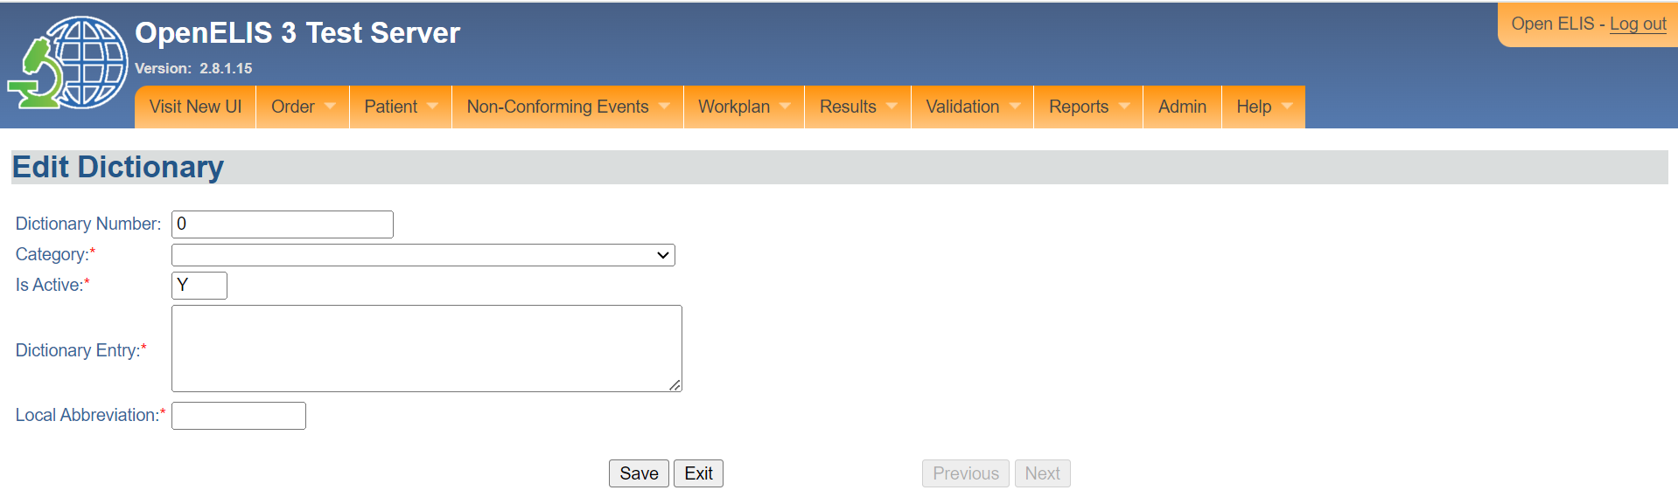

*Edit dictionary page*

1. Select the category from the drop-down menu 3.

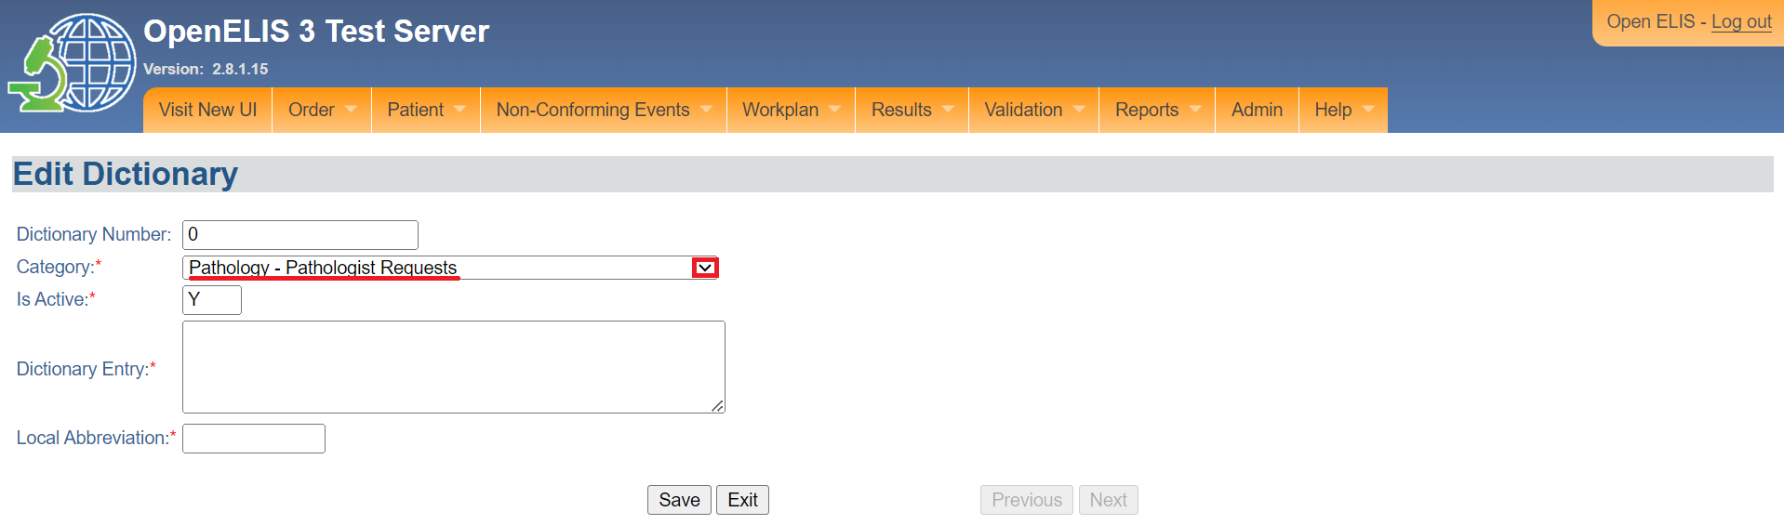

*Select category*

1. Enter the **Dictionary Entry** and the **Local Abbreviation**.

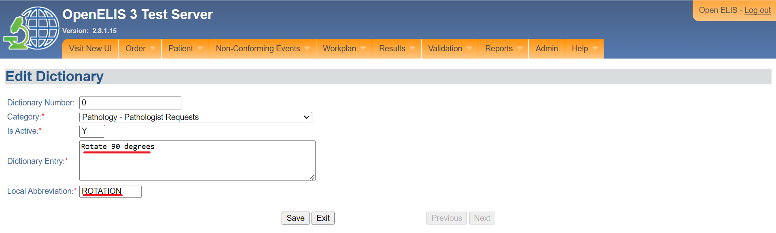

*Entry dictionary entry*

1. Click on the **Save** button.

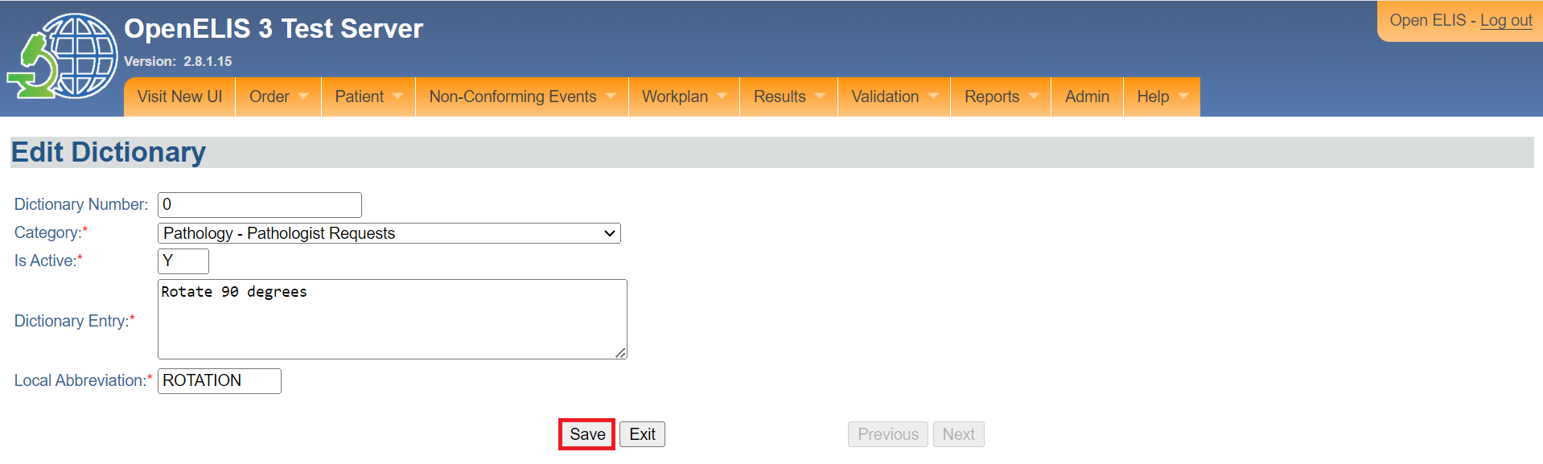

*Click save*

The dictionary entry will be added successfully.

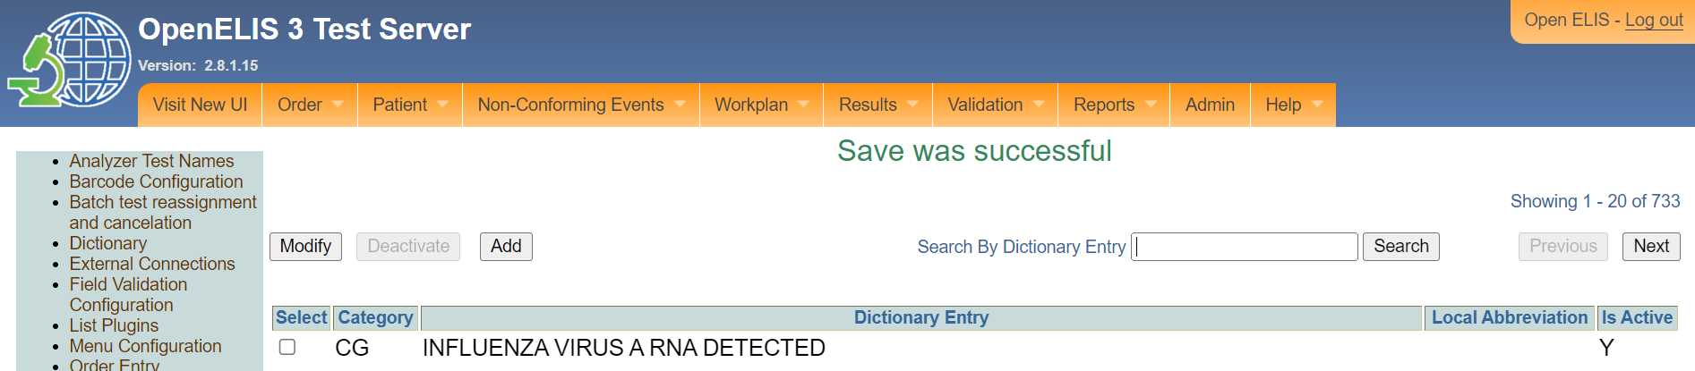

Note: The dictionary entry will be listed under pathology requests.

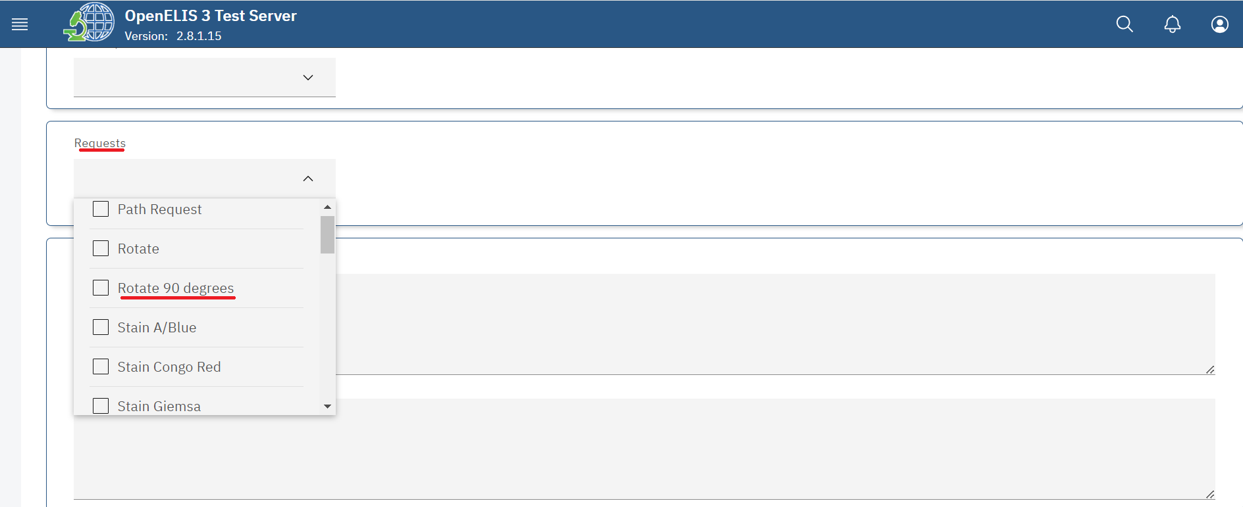

*Added dictionary entry*

# **PART 4:TEST MANAGEMENT**

## **How to access the test management configuration menu.**

1. Follow steps 1 and 2 under [how to access the OpenELIS administrator module](https://docs.google.com/document/d/1oPIYxrLgoBi4prx2-Anhe1fm4x23_QQanpE_DqAVaVA/edit?pli=1#heading=h.but495evqliv).
2. Click on **Test Management** under the master list page.

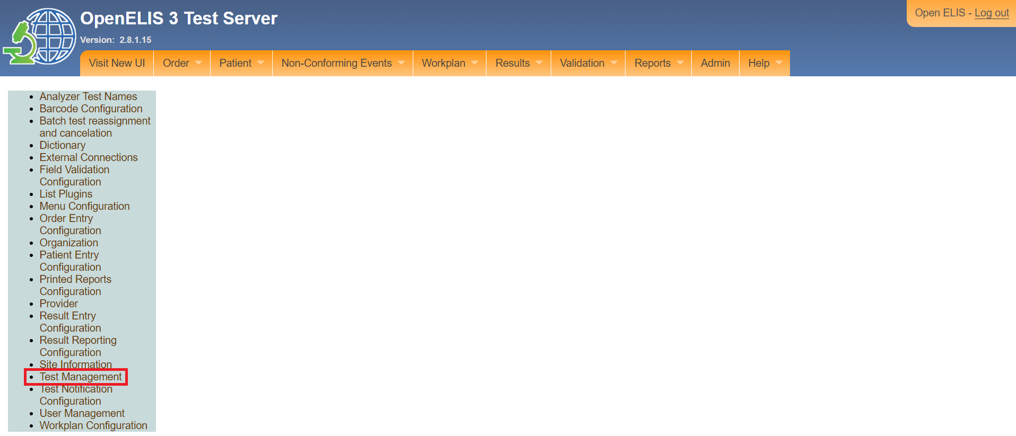

*Click on test management*

Note: The test menu configuration page will be displayed. The page has two sections namely; **Spelling Corrections** and **Test Organization**.

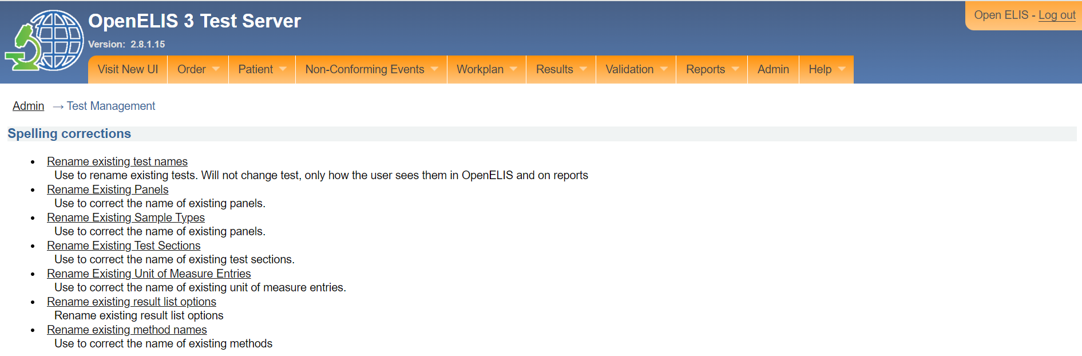

*Spelling corrections*

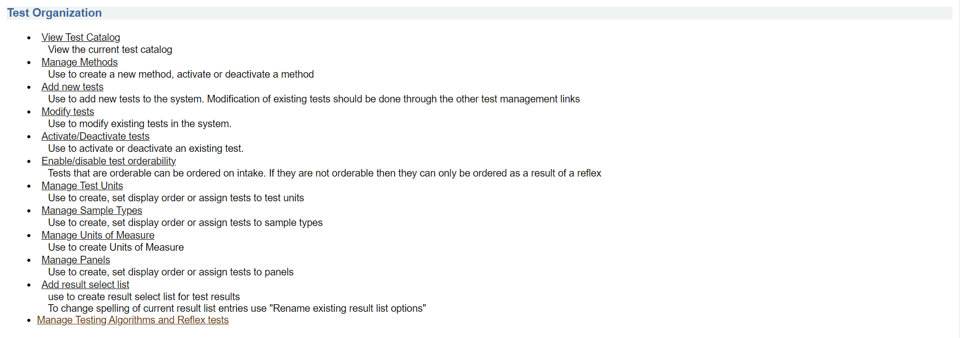

*Test organization*

# **PART 4 A: SPELLING CORRECTIONS**

## **How to rename existing test names.**

A test can be renamed due to spelling error or when the name of the test has changed. The person assigned administrator privileges to access the OpenELIS Global administrator module can rename an existing test.

1. To rename an existing test name, click on rename existing test name under the spelling correction section. The test rename entry page will be displayed

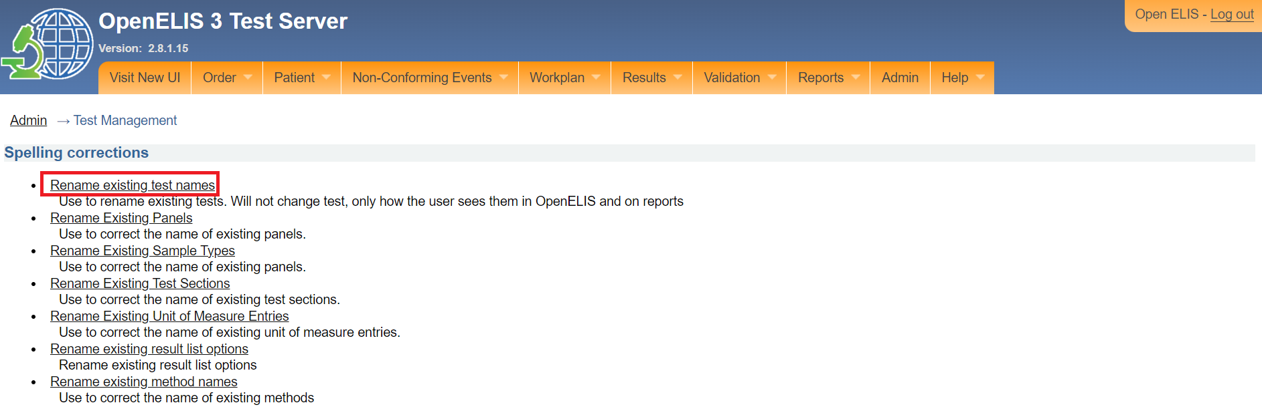

*Click on rename existing test names*

1. Click on the name of the test you would like to edit. The edit page will be displayed which allows you to edit the name.

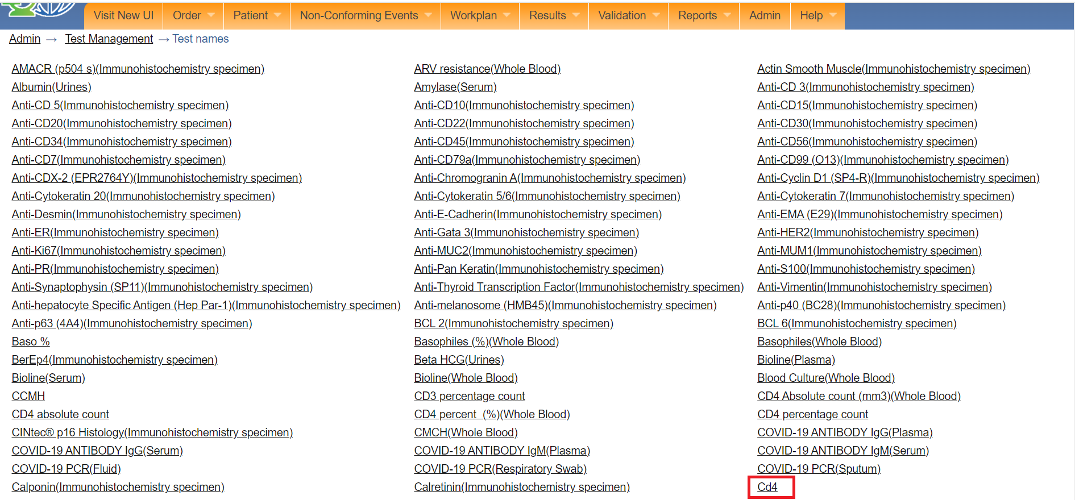

*Click on a test*

Note: the edit page has four text fields that you will be required to fill in order to capture the following; name of the test in English, name of the test in French, name of the test on the report in English, and name of the test on the report in English. If you do not have access to the name in English, you can enter a substitution element but it may be that it will not comply with the guidelines for laboratory information systems. Refer to your accrediting agency.

1. Type the name in the fields. In this illustration, the current name for the test is **Cd4**. the letter **d** is incorrect. To correct this, the new name has been typed as **CD4**.

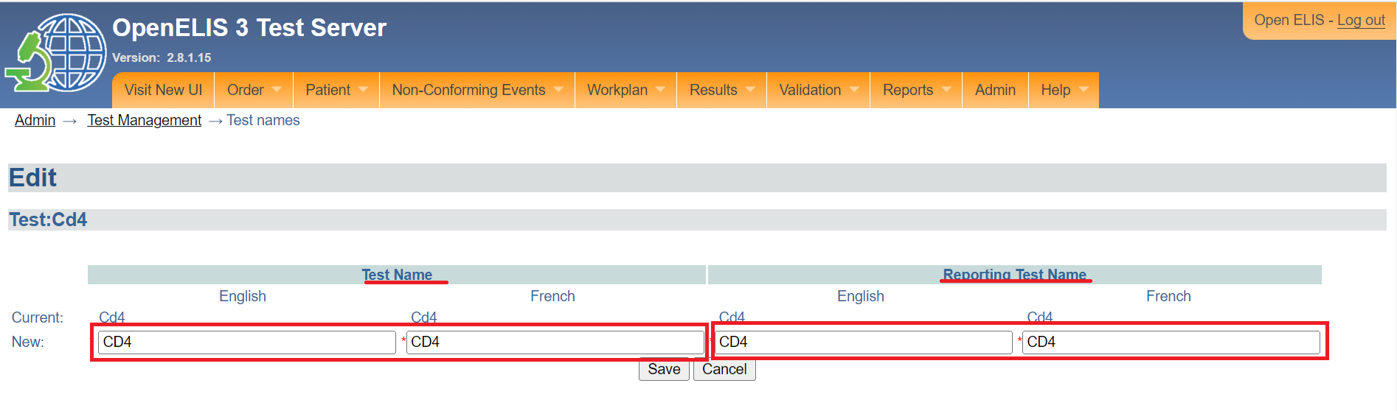

*Type new name*

1. Click on the Save button. Clicking on the **Cancel** button will cancel the editing.

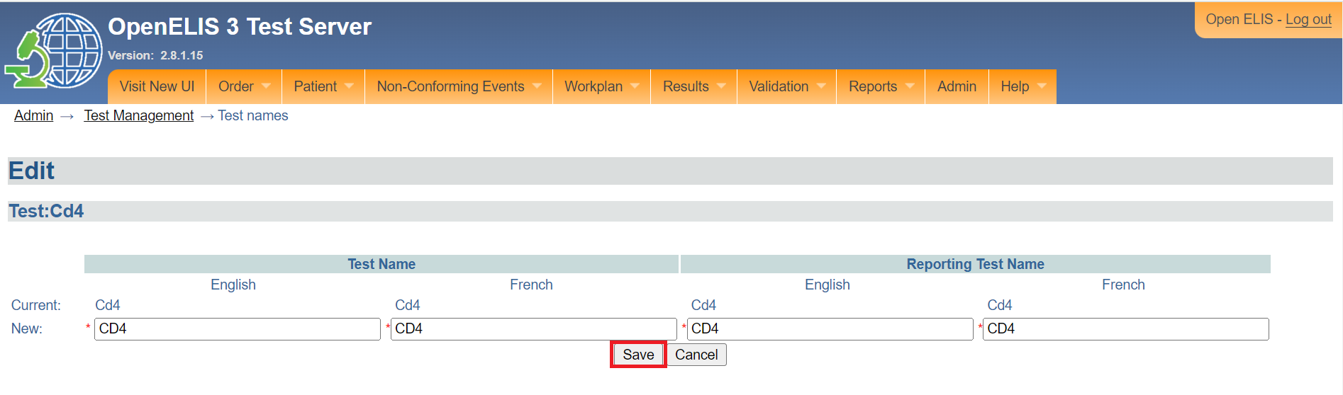

*Click save*

1. Upon clicking on the **Save** button, confirm the names entered in each text field and click on the **Accept** button. The reject button will revert back to the test name editing page.

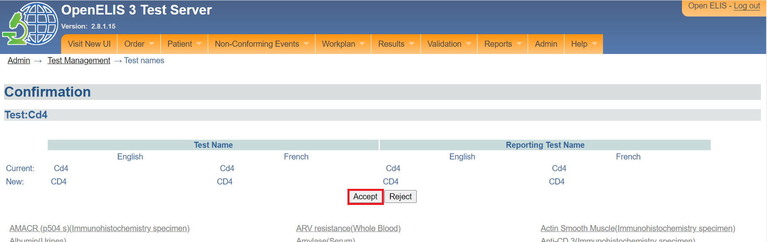

*Click accept*

The name of the test will be updated successfully.

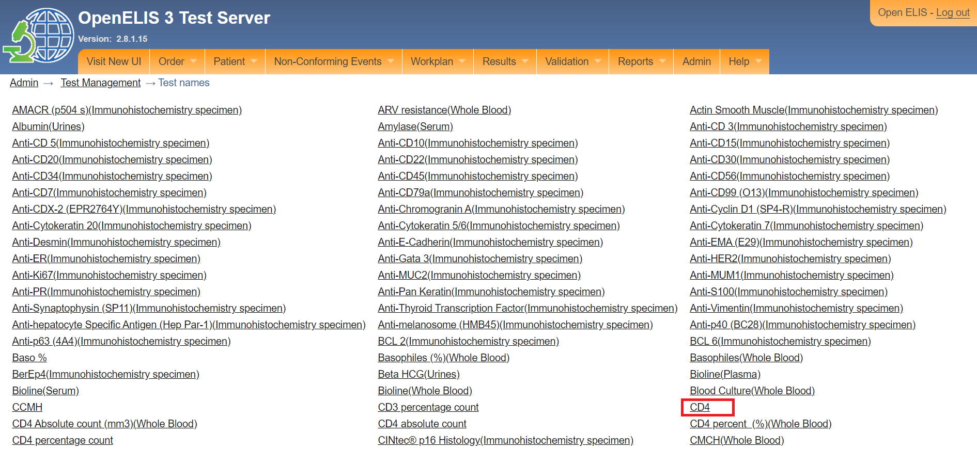

*Test name updated*

## **How to rename an existing panel.**

A panel can be renamed due to spelling error or when the name of the test has changed. The person assigned administrator privileges to access the OpenELIS Global administrator module can rename an existing test.

1. To rename an existing panel name, click on rename existing panel name under the spelling correction section. The panel rename entry page will be displayed

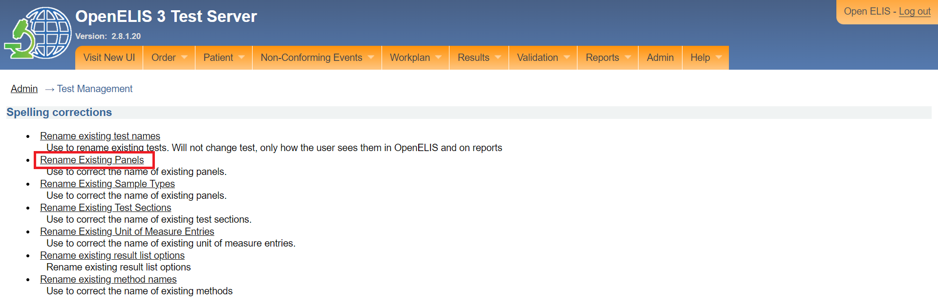

*Click on rename existing panel*

1. Click on the name of the panel you would like to edit. The edit page will be displayed which allows you to edit the panel name. Fields marked with an asterisks (*) are mandatory. In this illustration, the **NFS** panel is clicked.

Note: if, however, you want to CANCEL the modification, CLICK on the **Finished**" button.

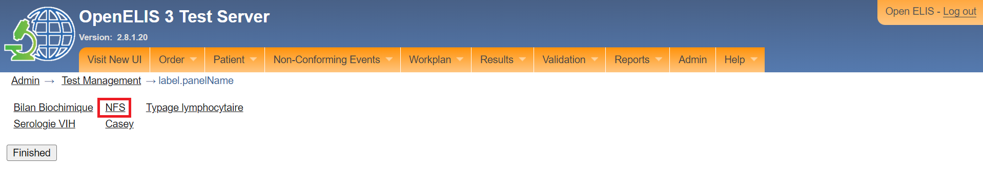

*Click on panel*

1. Type the English name for the panel.

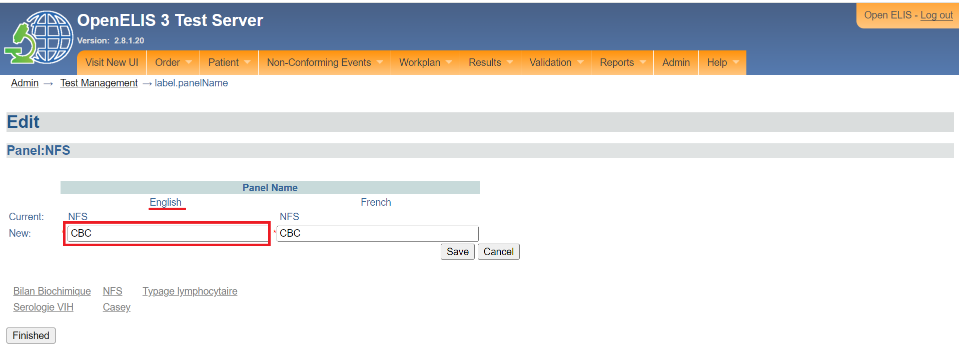

*Type English name for panel*

1. Type the French name for the panel.

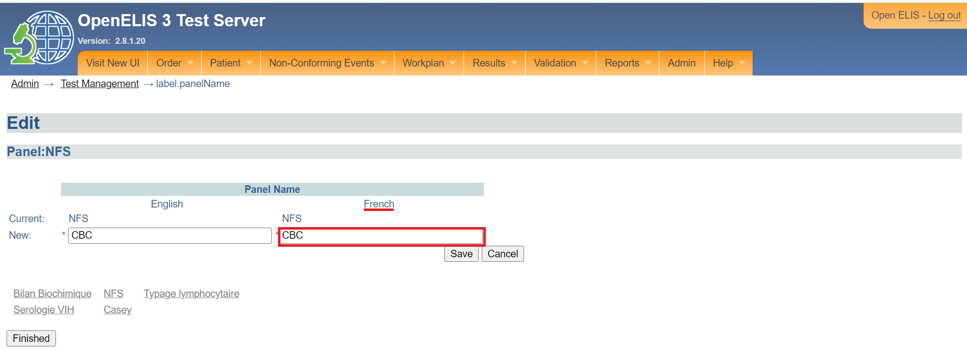

*Type French name for panel*

**Note:** If you do not have access to the name in English, you can enter a substitution element but it may be that it will not comply with the guidelines for laboratory information systems. Refer to your accrediting agency.

1. Click Save. The **confirmation** page will be displayed

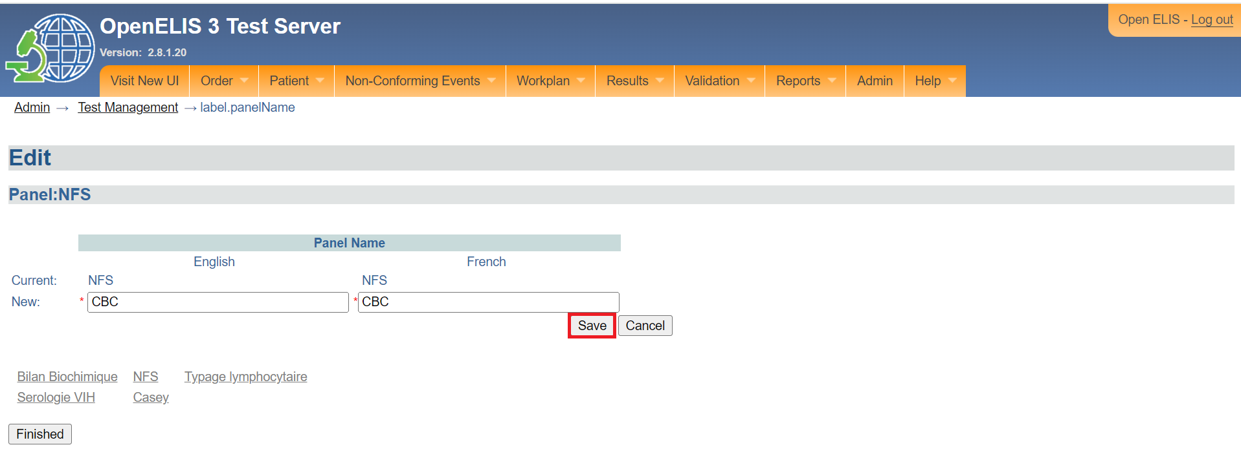

*Click save*

1. Click on the **Accept** button. The panel will be renamed successfully. Otherwise, click on the reject button to reject the confirmation.

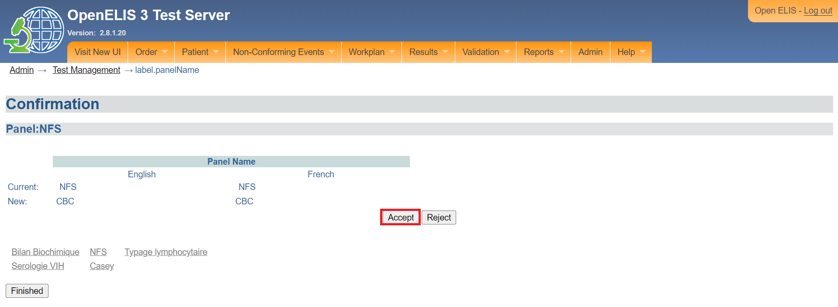

*Click accept*

1. Click on the **Finished** button.

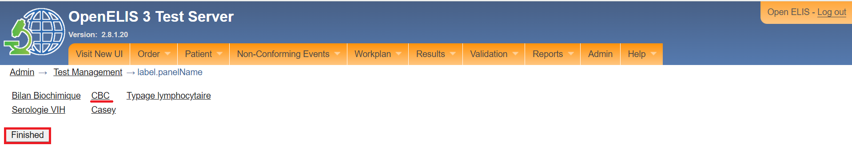

*Click finished.*

Note: The renamed panel will be displayed upon selecting the respective sample by the laboratory end users.

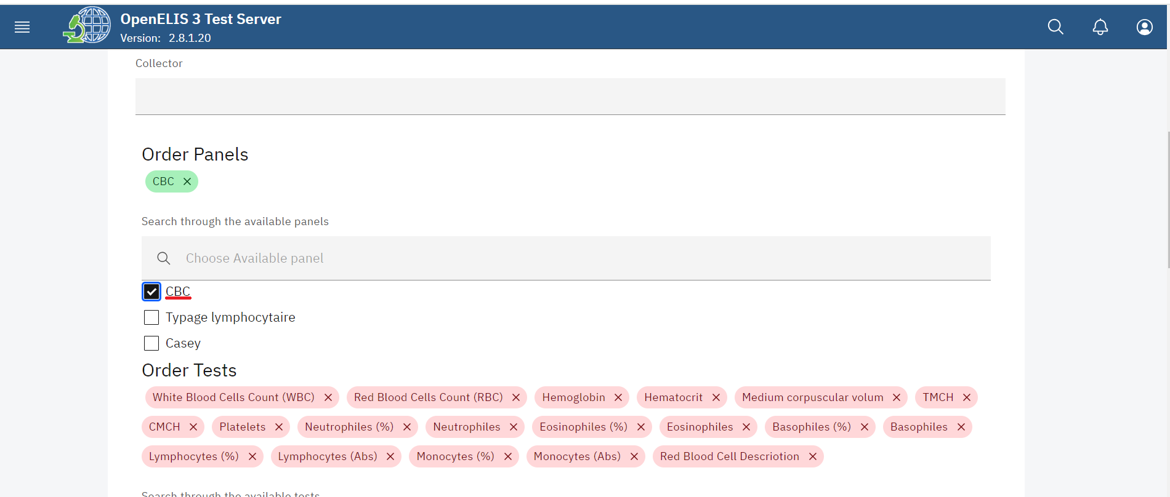

*CBC panel*

## **How to rename existing sample types.**

A sample can be renamed due to spelling error or when the name of the sample has changed. The person assigned administrator privileges to access the OpenELIS Global administrator module can rename an existing sample.

1. To rename an existing sample name, click on rename existing sample name under the spelling correction section. The sample rename entry page will be displayed.

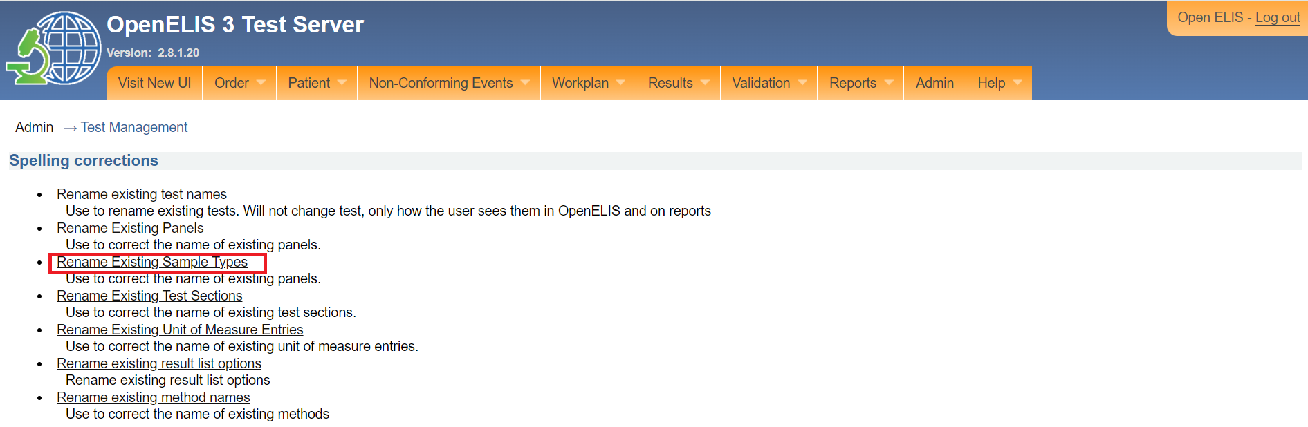

*Click on rename existing test sample type*

1. Click on the name of the sample you would like to edit. The edit page will be displayed which allows you to edit the sample name. Fields marked with an asterisks (*) are mandatory. In this illustration, the **Sang total** panel is clicked.

Note: if, however, you want to CANCEL the modification, CLICK on the **Finished**" button.

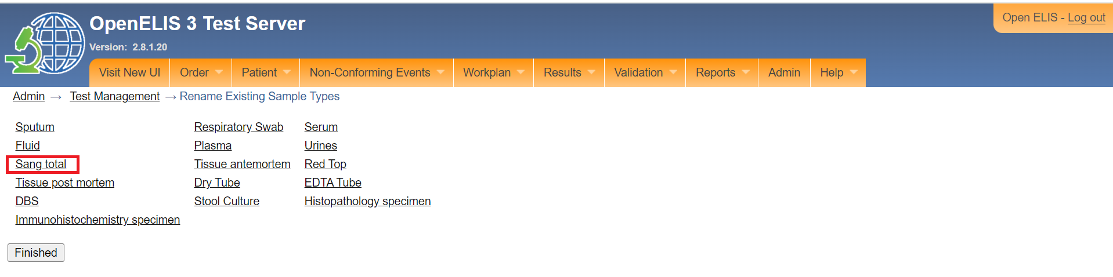

*Click on sample*

1. Type the English name for the sample.

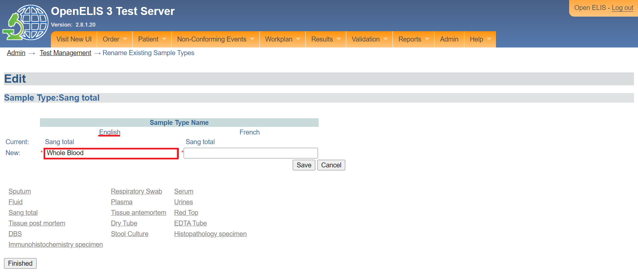

*Type English name for sample*

1. Type the French name for the sample.

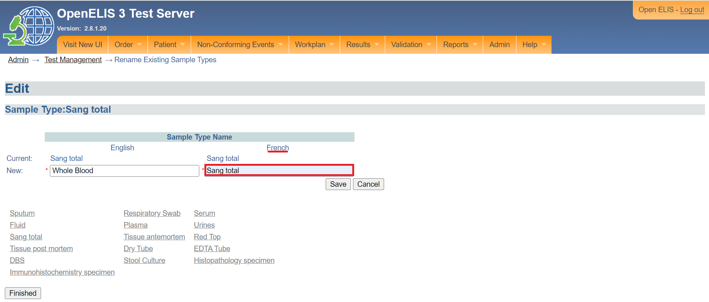

*Type French name for sample*

**Note:** If you do not have access to the name in English, you can enter a substitution element but it may be that it will not comply with the guidelines for laboratory information systems. Refer to your accrediting agency.

1. Click Save. The **confirmation** page will be displayed.

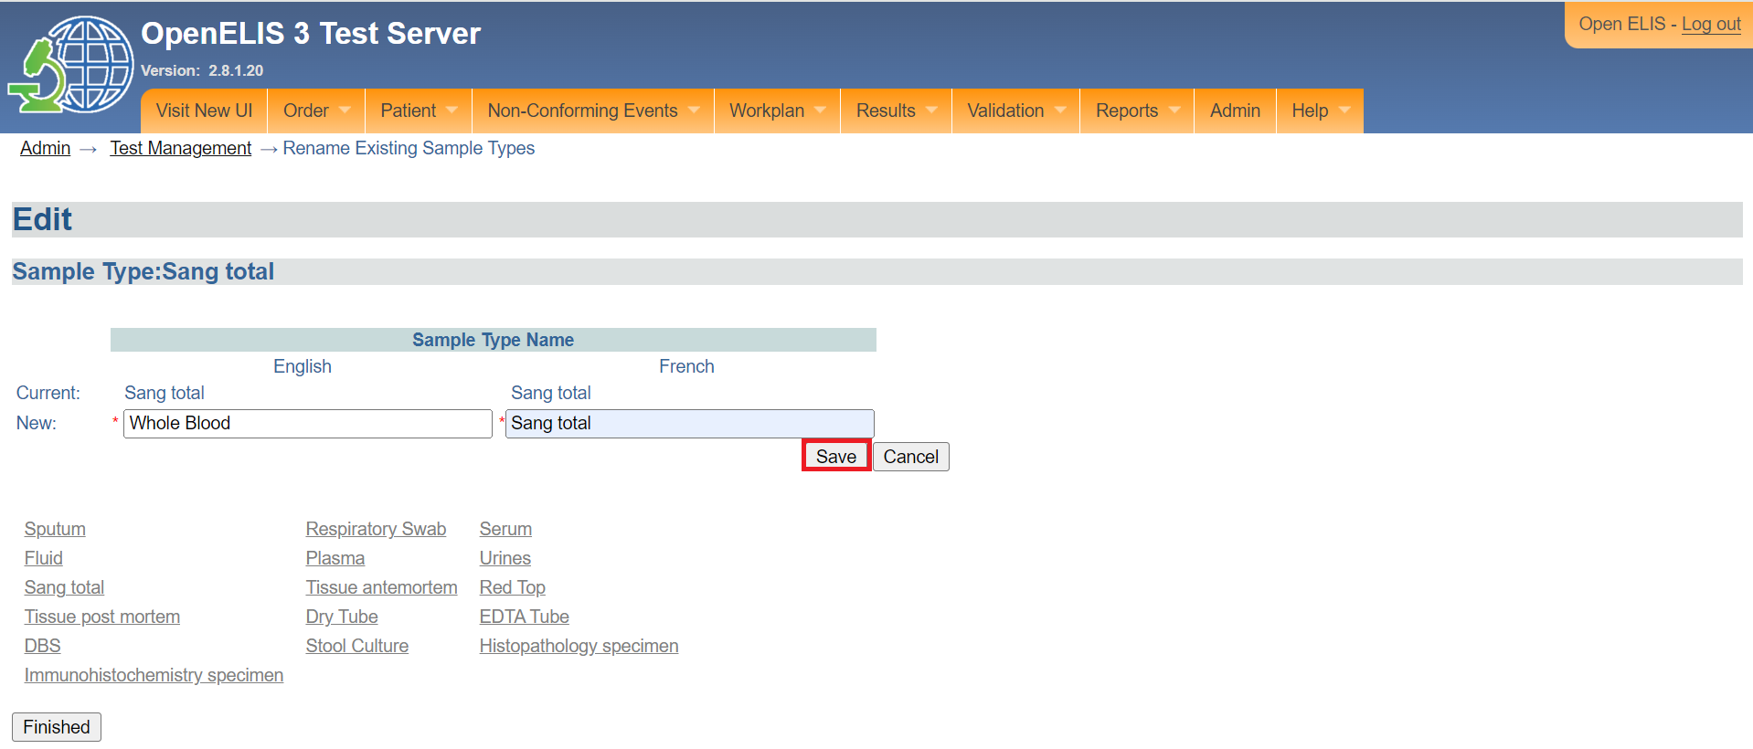

*Click save*

1. Click on the accept. Otherwise, click on the reject button to reject the confirmation. The panel will be renamed successfully.

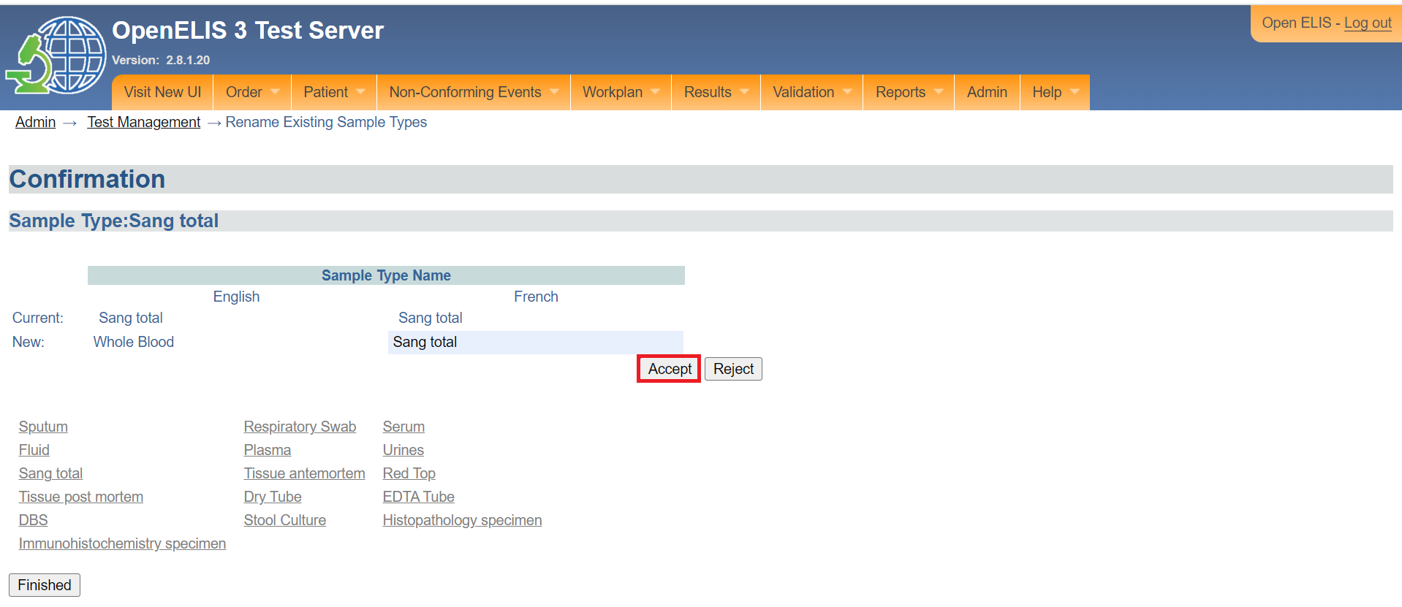

*Click accept*

1. Click on the **Finished** button.

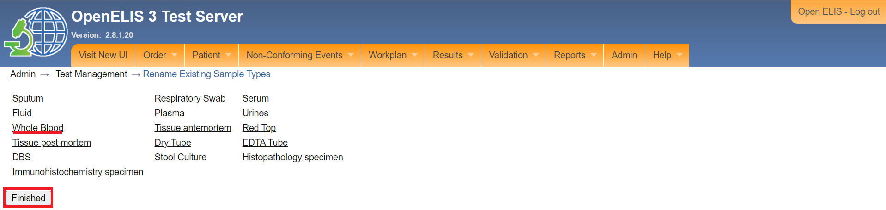

*Click finished.*

Note: The renamed sample will be displayed upon selecting the respective sample by the laboratory end users.

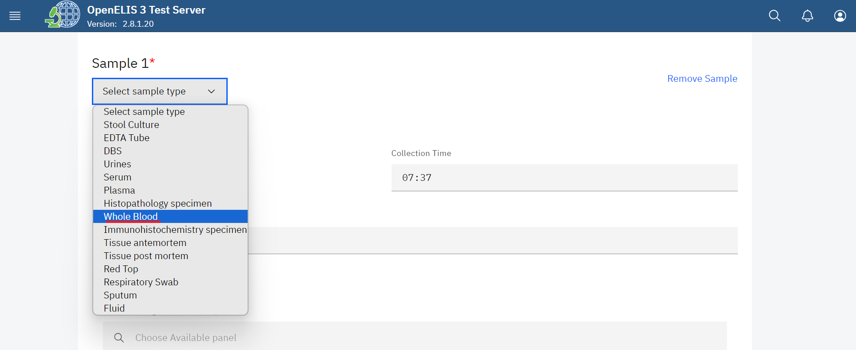

*Whole blood sample*

## **How to rename test sections.**

1. To rename an existing test section, click on rename existing section name under the spelling correction section. The section rename entry page will be displayed.

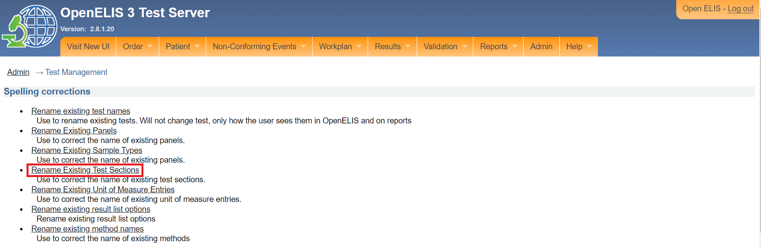

*Click on rename existing test sections*

1. Click on the name of the section you would like to edit. The edit page will be displayed which allows you to edit the section name. Fields marked with an asterisks (*) are mandatory. In this illustration, thesection **Hermatology** is clicked.

Note: if, however, you want to CANCEL the modification, CLICK on the **Finished**" button.

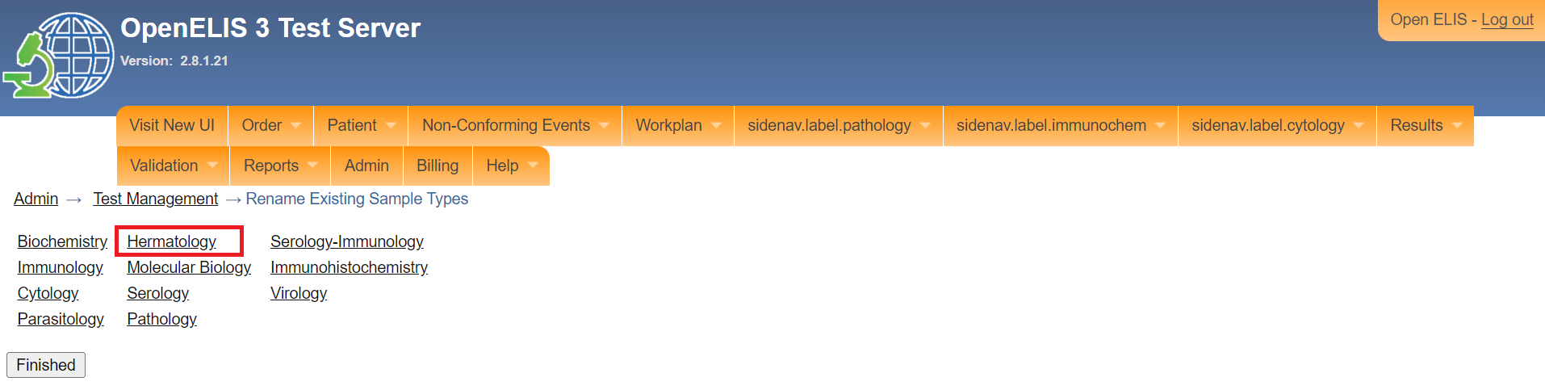

*Click on a section*

1. Type the English name for the section

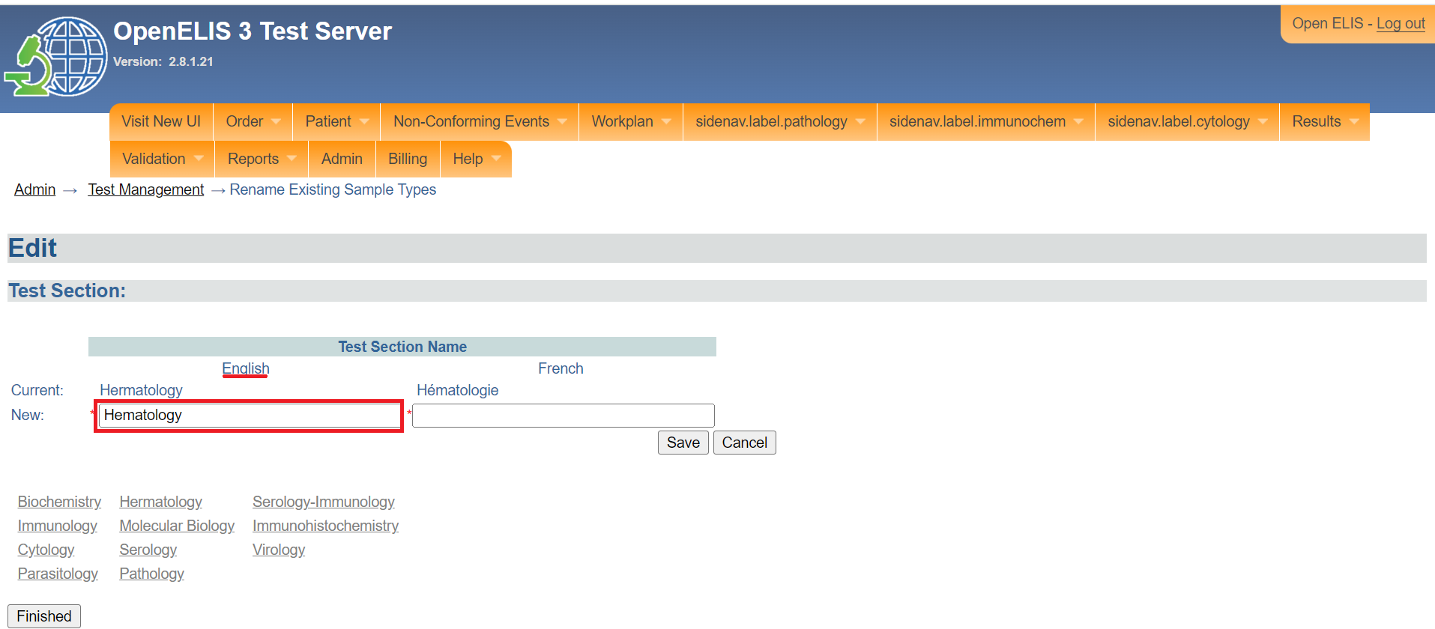

*Type the English name for section*

1. Type the French name for the section.

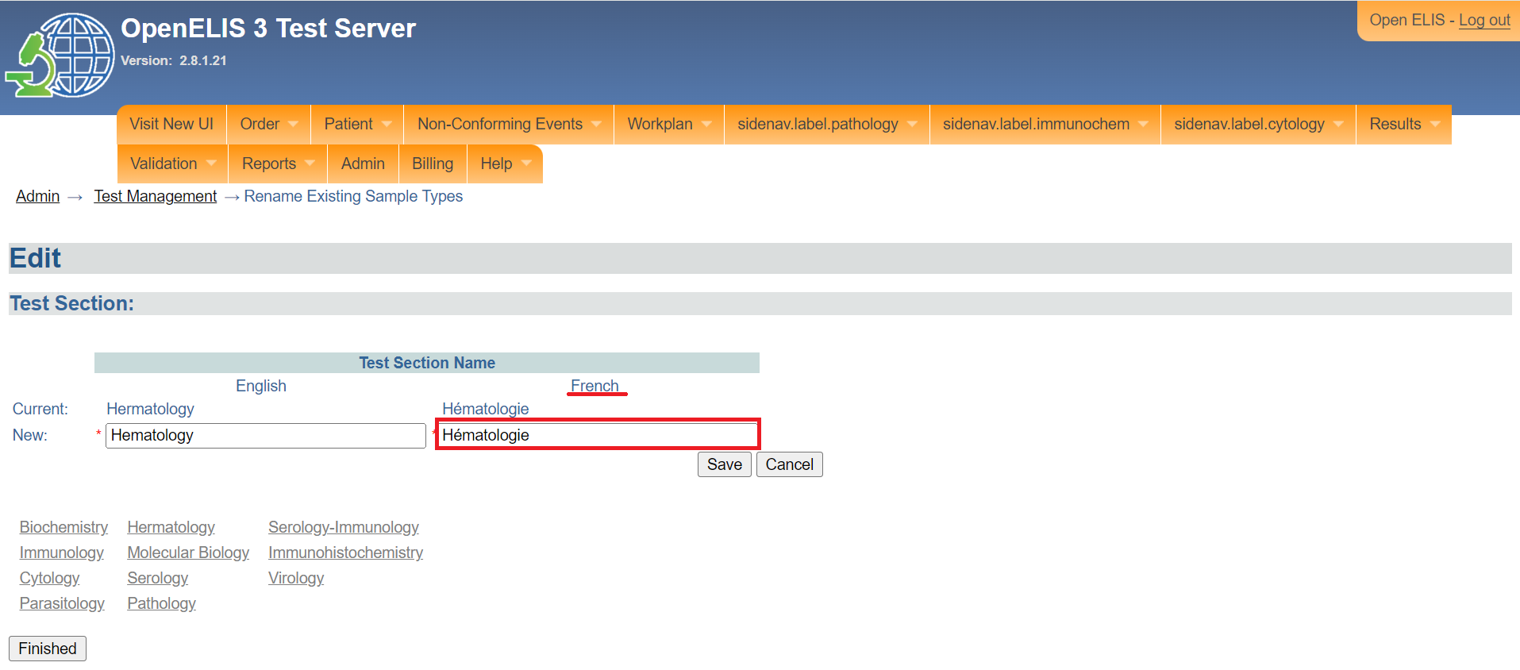

*Type the French name for section*

**Note:** If you do not have access to the name in English, you can enter a substitution element but it may be that it will not comply with the guidelines for laboratory information systems. Refer to your accrediting agency.

1. Click Save. The **confirmation** page will be displayed.

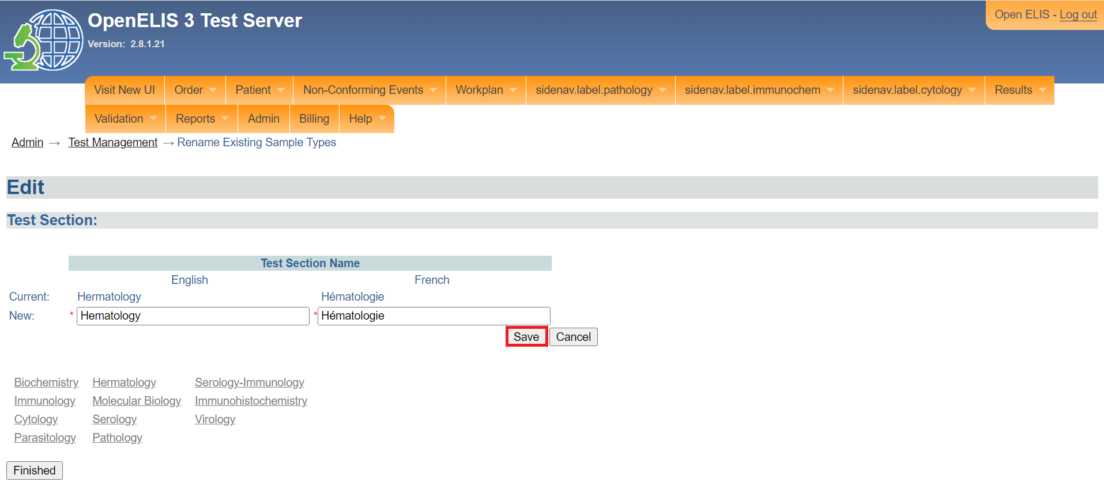

*Click save*

1. Click on the accept.The panel will be renamed successfully. Otherwise, click on the reject button to reject the confirmation.

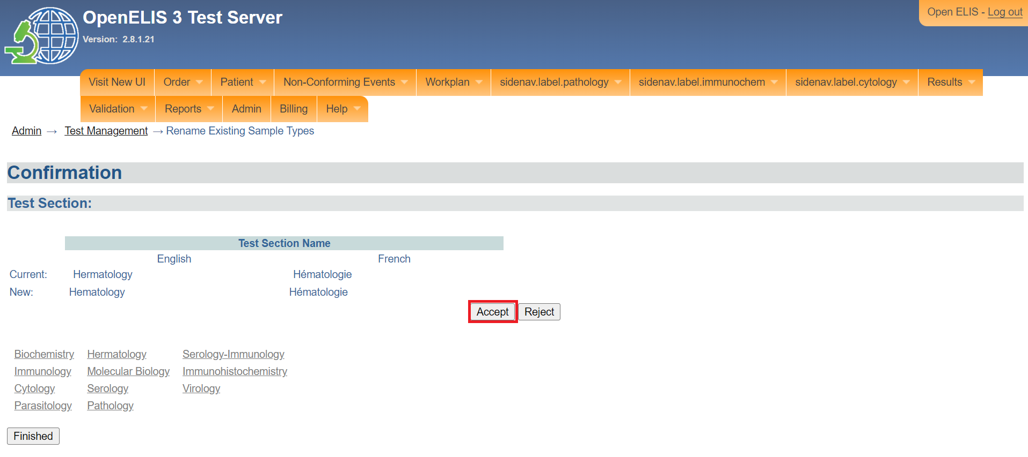

*Click accept*

1. Click on the **Finished** button.

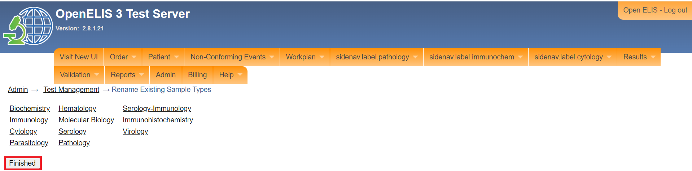

## **How to rename existing unit of measure entries.**

1. To rename a unit of measure, click on rename existing unit of measure entries under the spelling correction section. The section rename entry page will be displayed.

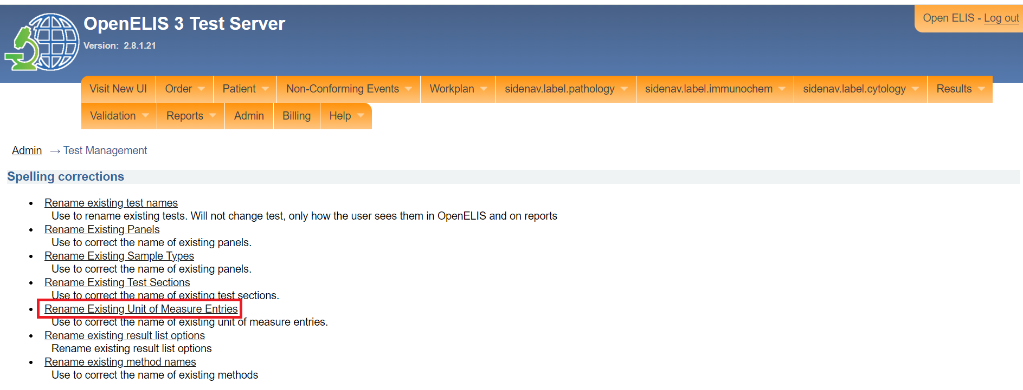

*Click on rename existing unit of measure entries*

1. Click on the unit of measure entry you would like to edit. The edit page will be displayed which allows you to edit the name for the unit entry. Fields marked with an asterisks (*) are mandatory. In this illustration, **PPM** is clicked.

Note: if, however, you want to CANCEL the modification, CLICK on the **Finished**" button.

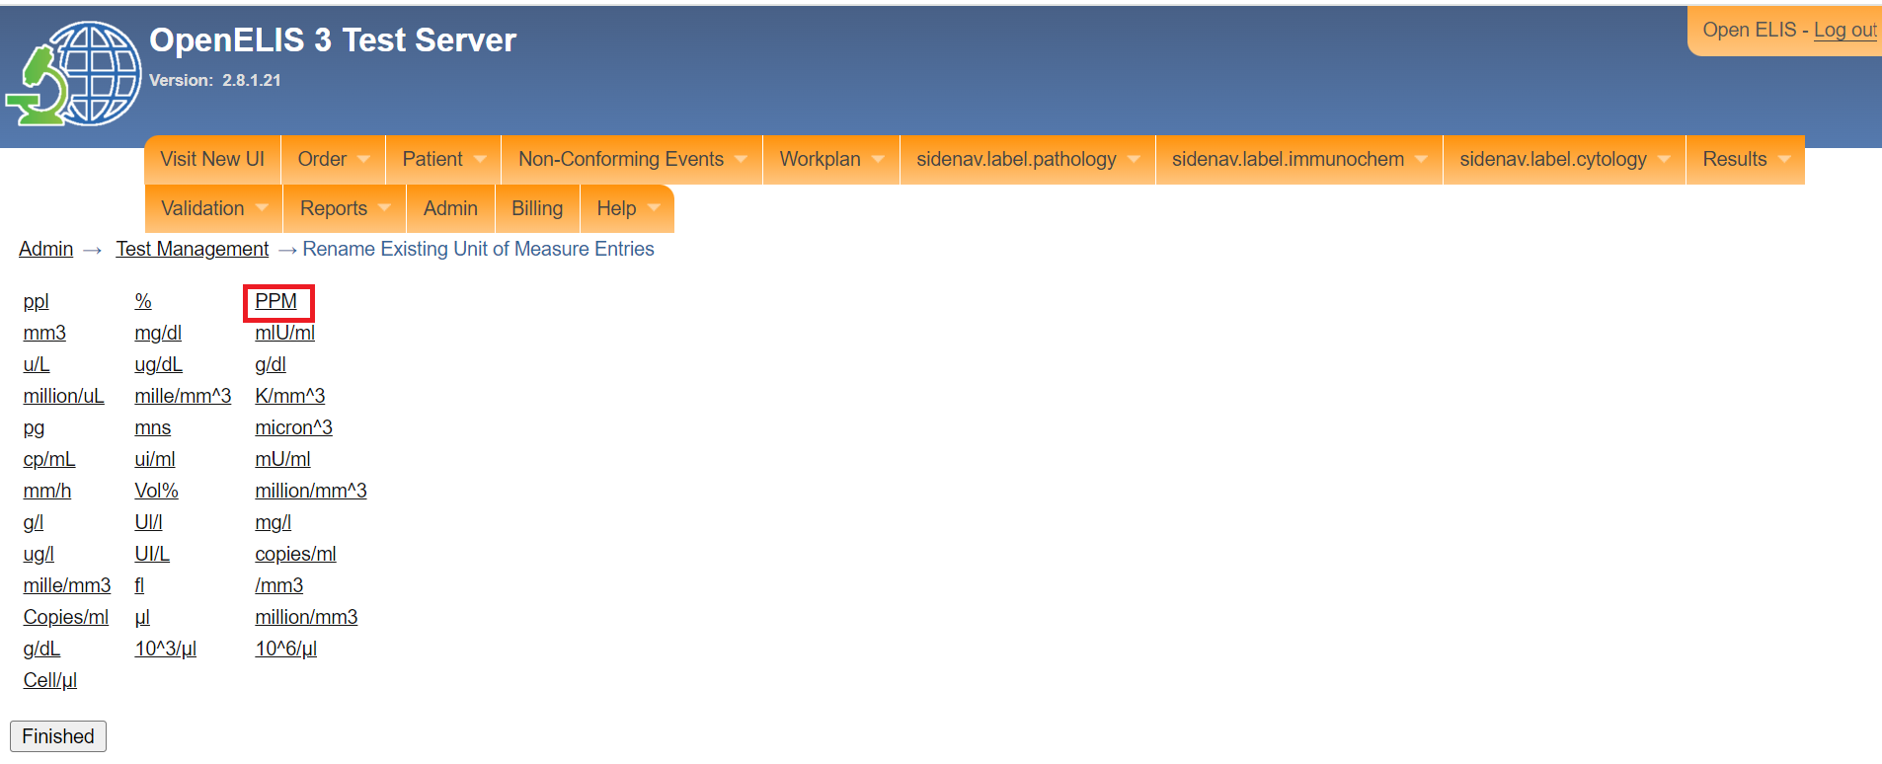

*Click on an entry*

1. Type the new name for the entry.

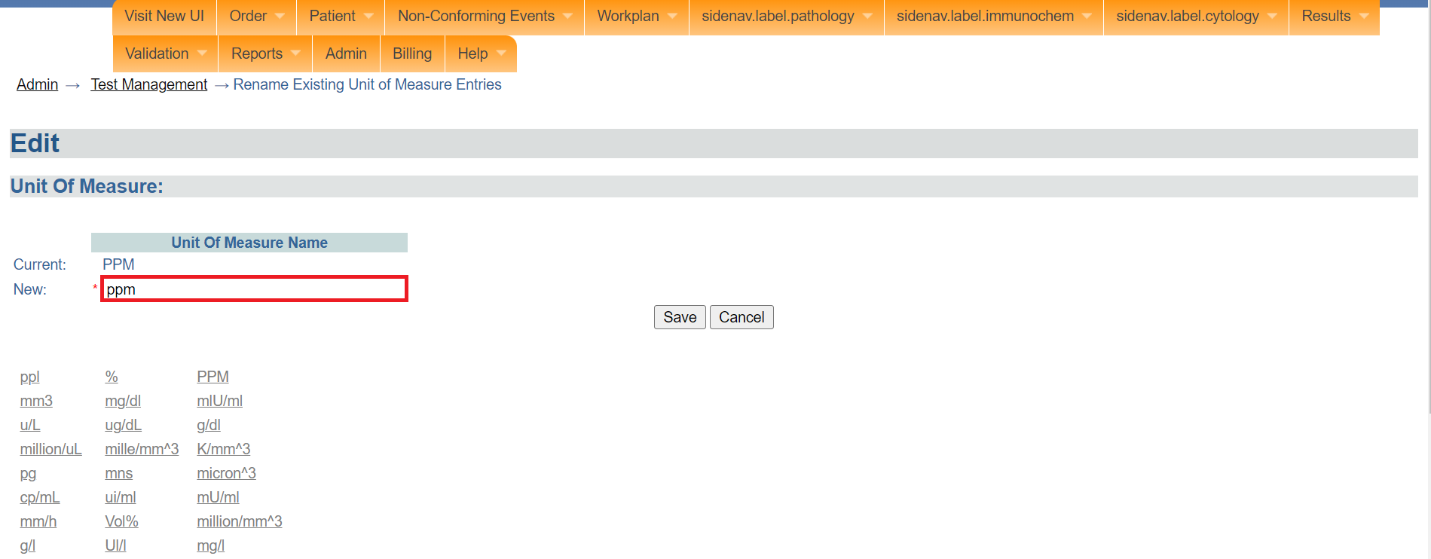

*Type the name for the entry*

1. Click Save. The **confirmation** page will be displayed.

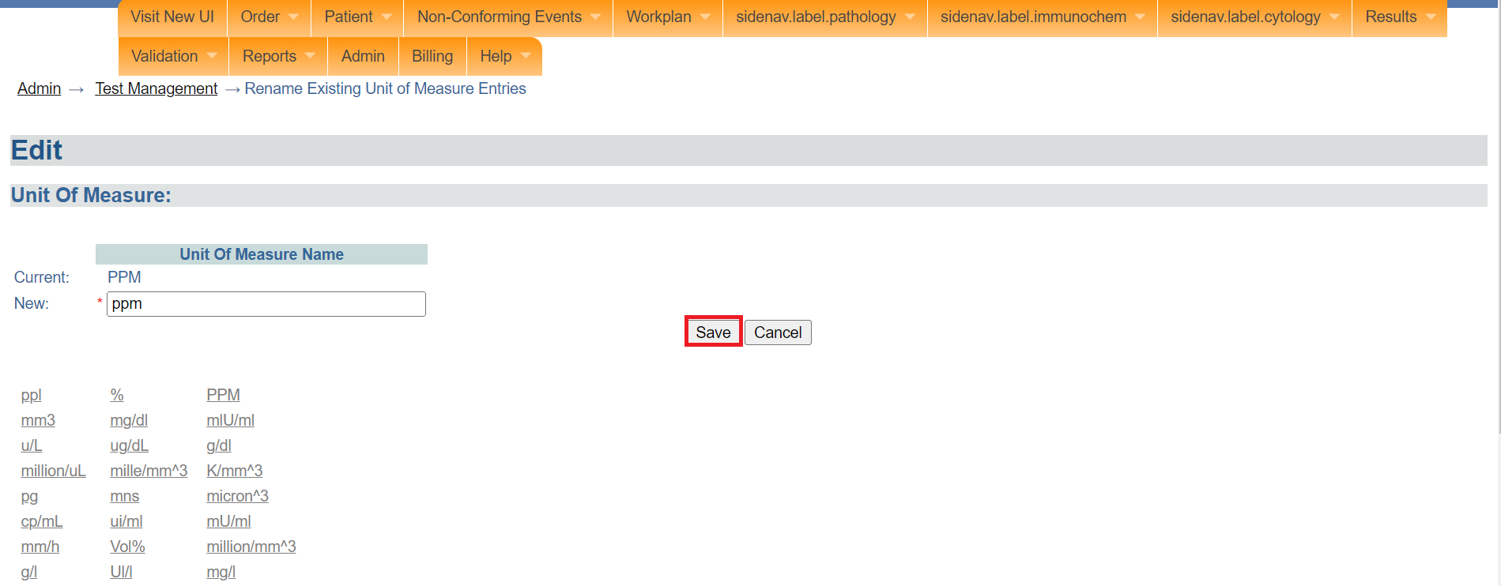

*Click save*

1. Click on the accept.The entry will be renamed successfully. Otherwise, click on the reject button to reject the confirmation.

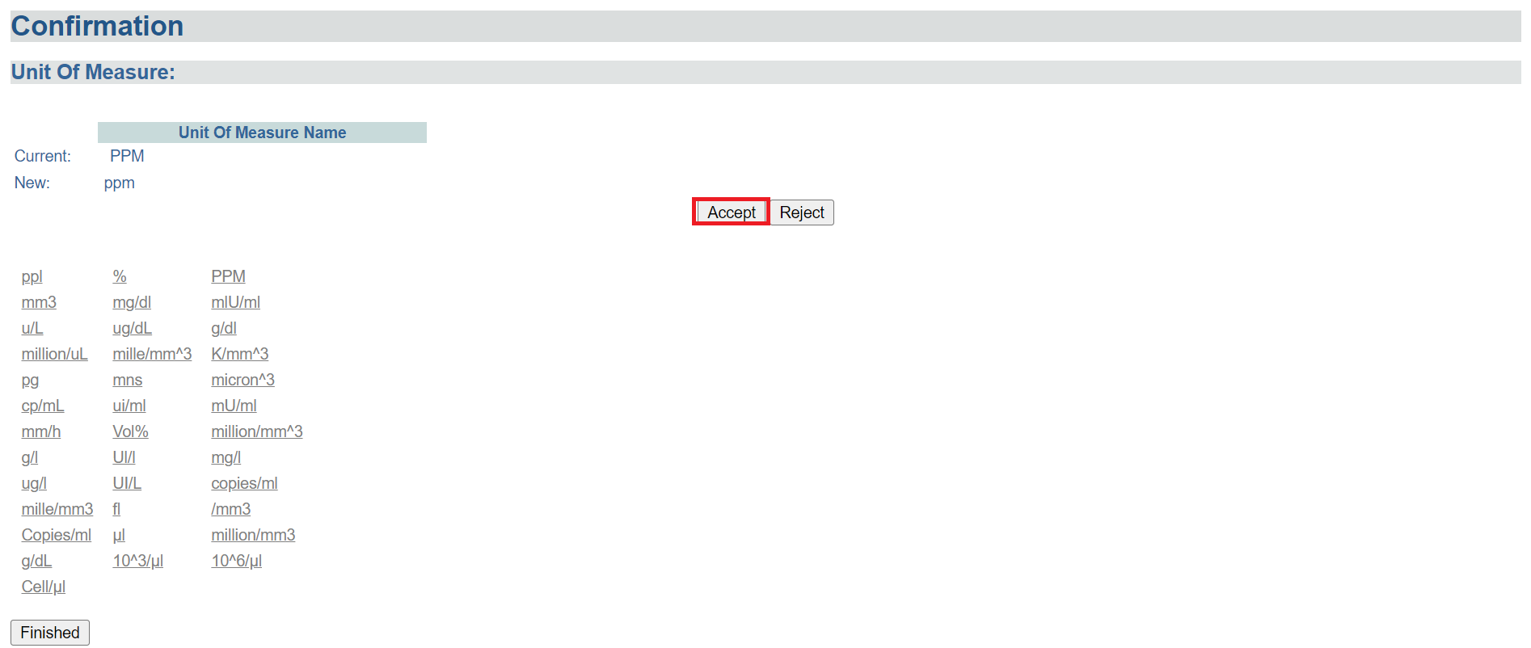

*Click accept*

1. Click on the **Finished** button.

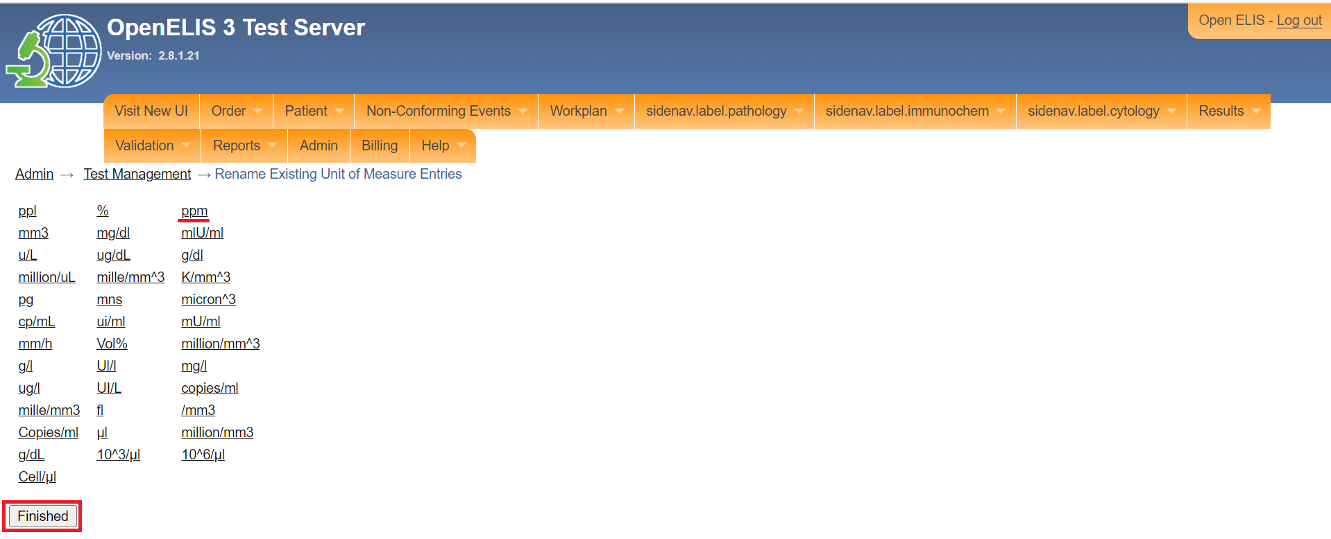

*Click finished*

## **How to rename existing result list options.**

1. To rename the result list options click on rename existing result list options under the spelling correction section. The result list options page will be displayed.

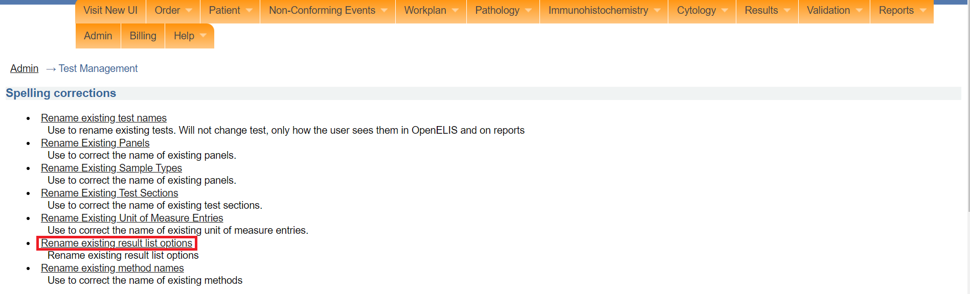

*Click on rename existing result list options*

1. Click on the name of the result list option you would like to edit. The edit page will be displayed which allows you to edit the result list option name. Fields marked with an asterisks (*) are mandatory. In this illustration, the **hiv1**  is clicked.

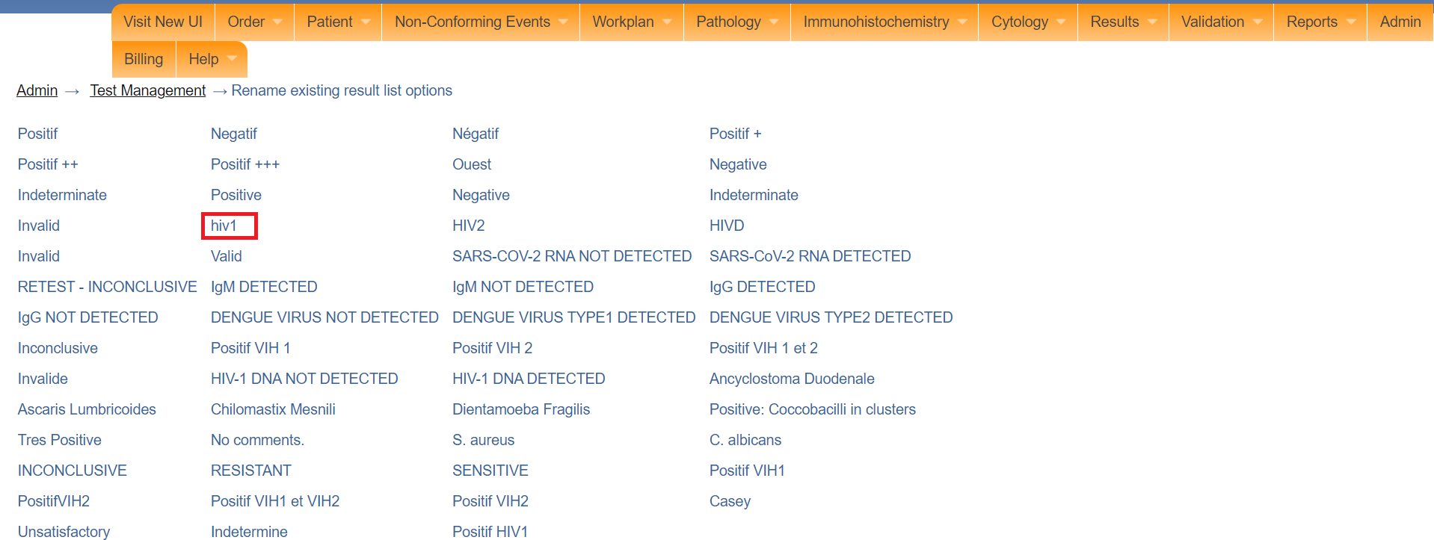

*Click on a result list option*

1. Type the English name for the result list option.

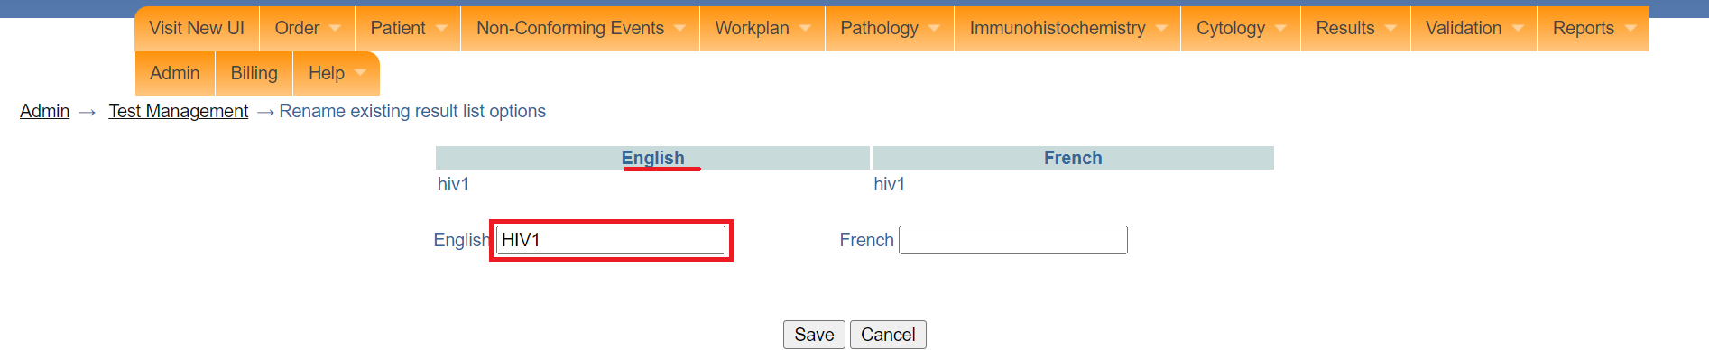

*Type English name for result list option*

1. Type the French name for the result list option

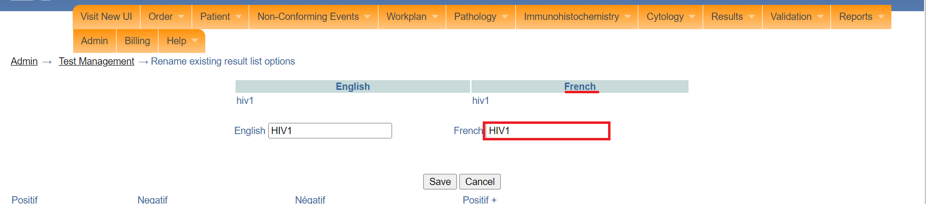

*Type French name for result list option*

**Note:** If you do not have access to the name in English, you can enter a substitution element but it may be that it will not comply with the guidelines for laboratory information systems. Refer to your accrediting agency.

1. Click on the **Save** button. However, if you want to CANCEL the renaming, click on the “**Cancel**" button.

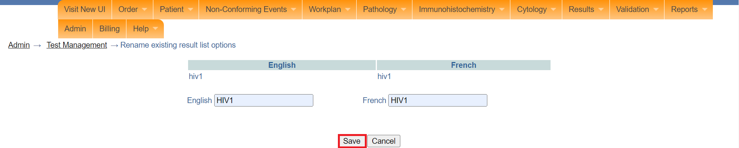

*Click save*

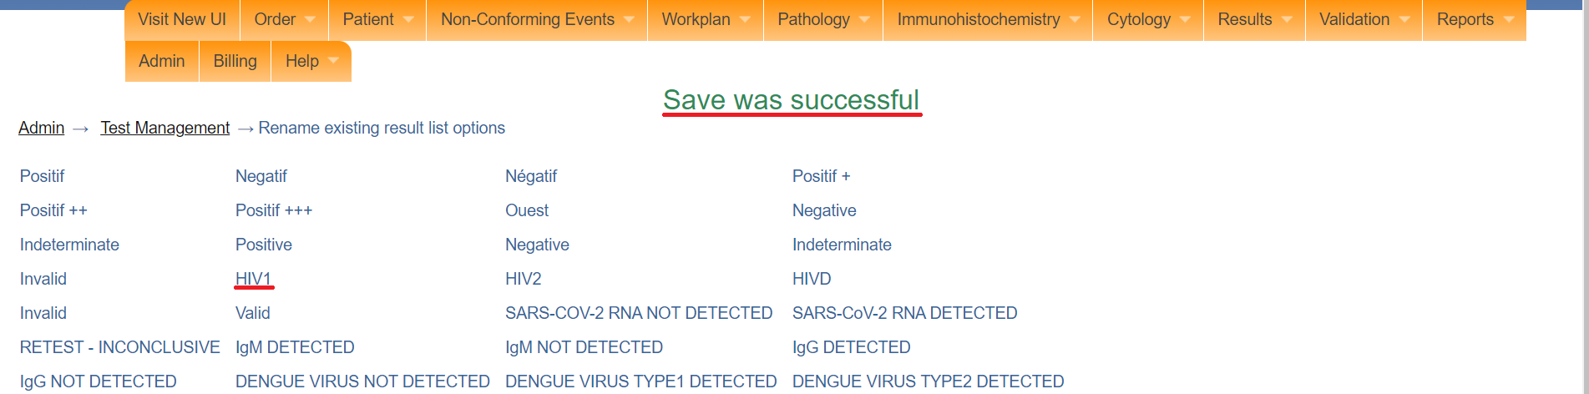

*Existing result list option renamed*

## **How to rename existing methods name.**

1. To rename existing methods name, click on existing methods name under the spelling correction section. The result list options page will be displayed.

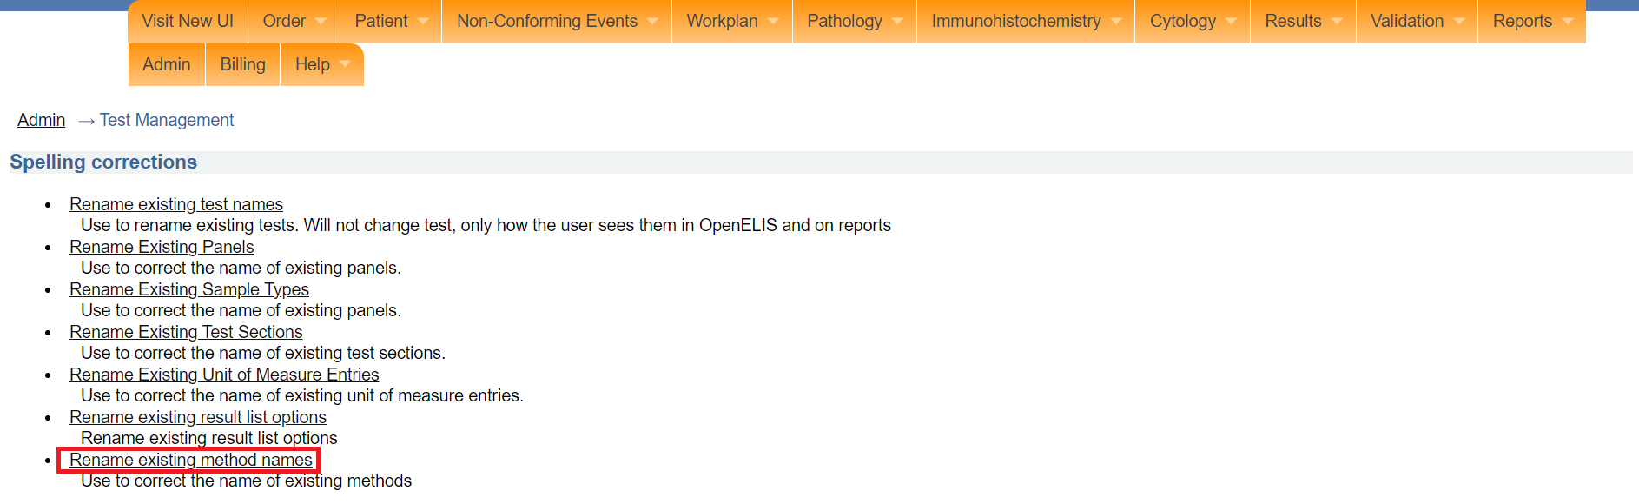

*Click on rename existing method names*

1. Click on the name of the method you would like to edit. The edit page will be displayed which allows you to edit the method name. Fields marked with an asterisks (*) are mandatory. In this illustration, the **pcr** is clicked.

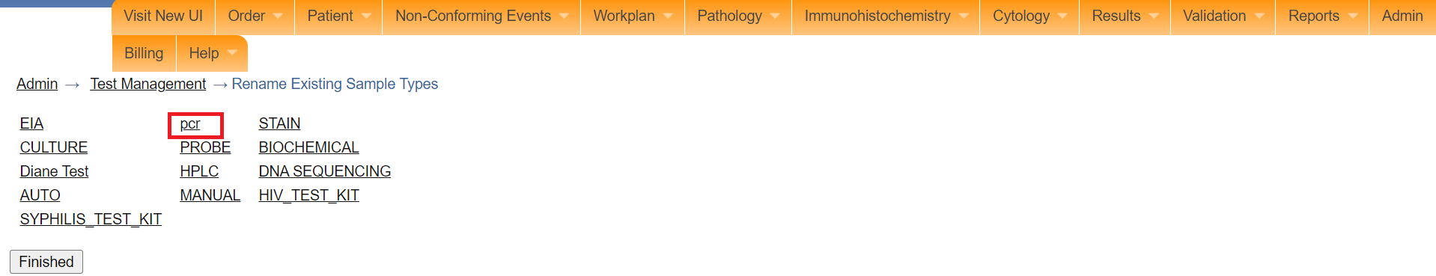

*Click on a method*

Note: if, however, you want to CANCEL the modification, CLICK on the **Finished**" button.

1. Type the English name for the method.

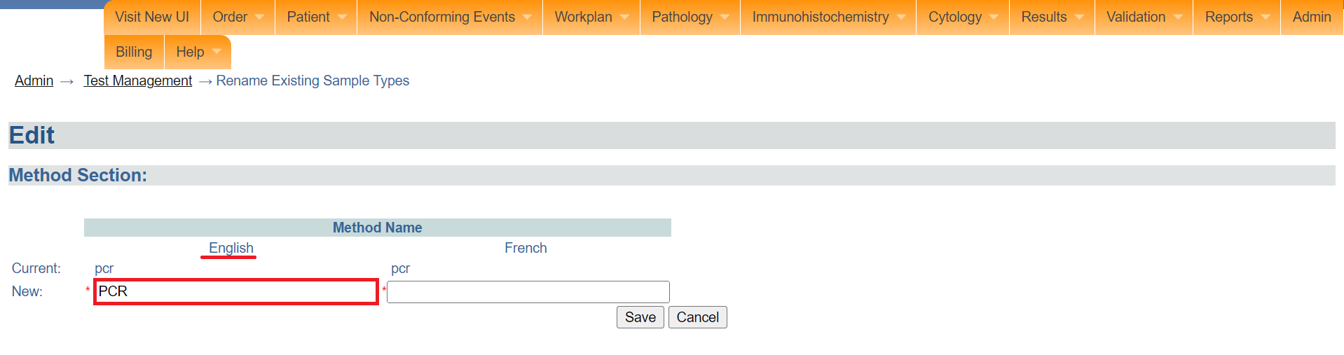

*Type English name for method*

1. Type the French name for the method.

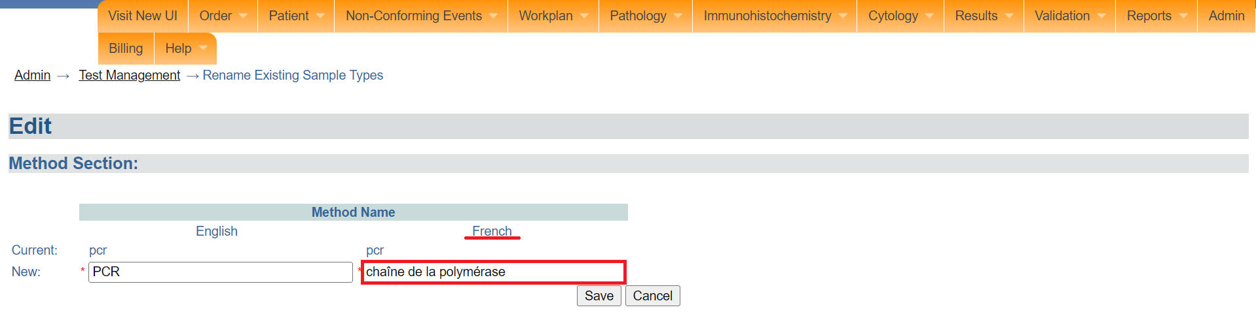

*Type French name for method*

**Note:** If you do not have access to the name in English, you can enter a substitution element but it may be that it will not comply with the guidelines for laboratory information systems. Refer to your accrediting agency.

1. Click **Save**. The **confirmation** page will be displayed.

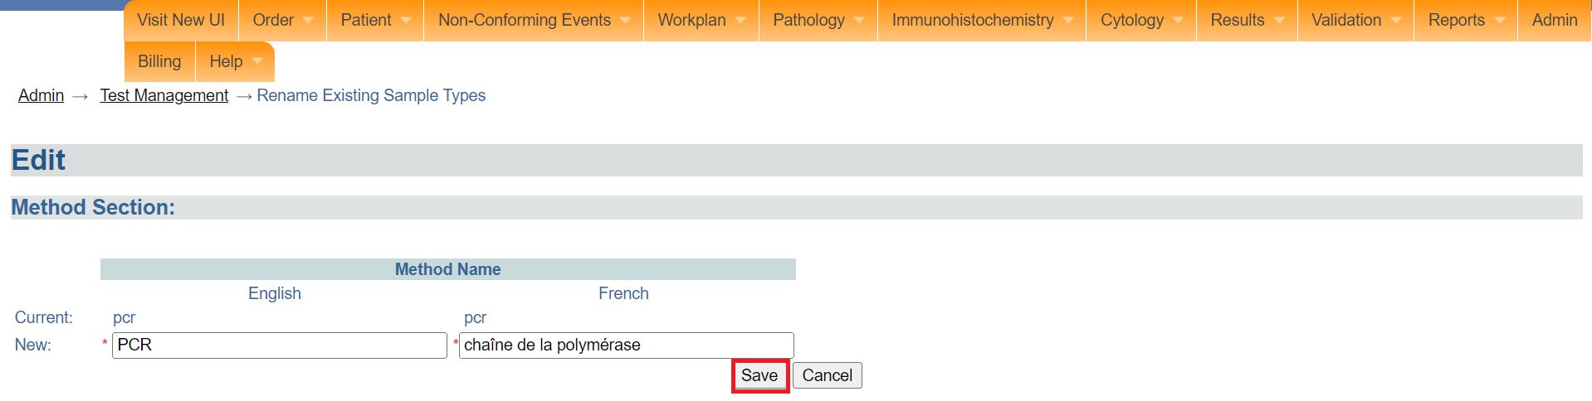

*Click save*

1. Click on the **Accep**t button The method will be renamed successfully.. Otherwise, click on the reject button to reject the confirmation.

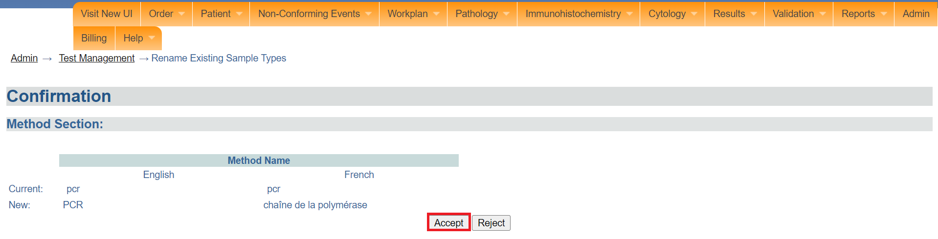

*Click accept*

1. Click on the **Finished** button.

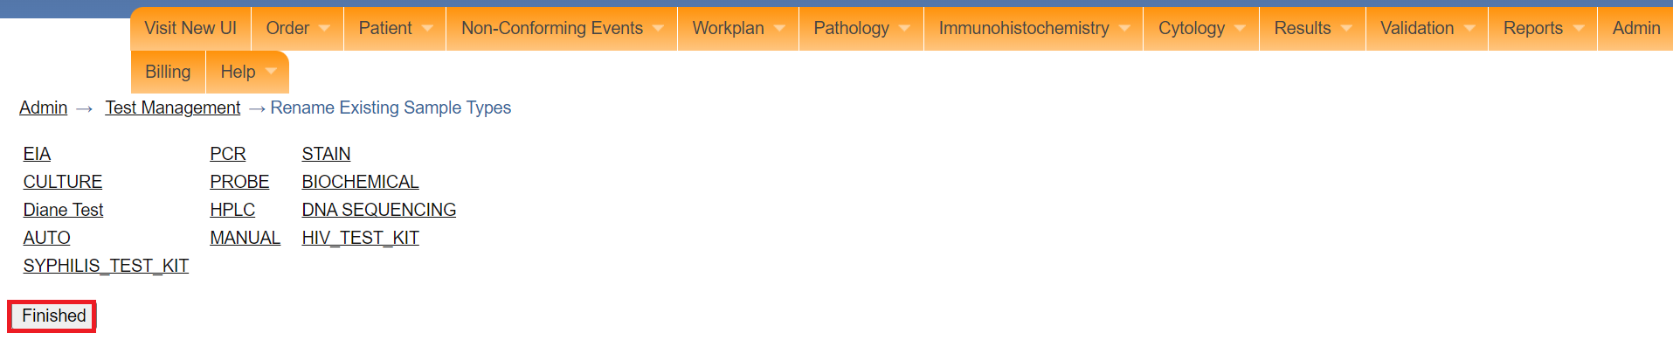

*Click finished.*

# **PART 4 B: TEST ORGANIZATION**

## **How to view the test catalog**

1. The test catalog is used for reading, searching and conducting audits of testing catalog. To access View Test Catalog, Follow steps 1 and 2 under [how to access the OpenELIS administrator module](https://docs.google.com/document/d/1oPIYxrLgoBi4prx2-Anhe1fm4x23_QQanpE_DqAVaVA/edit?pli=1#heading=h.but495evqliv).
2. Click on **view test catalog** under **test organization.**

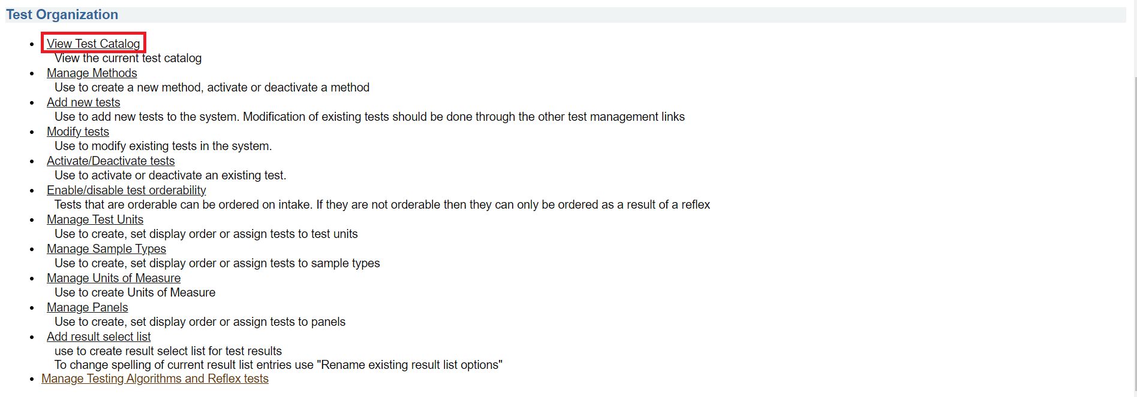

*Click view test catalog*

1. Upon clicking on **view test catalog**, click on the show **Guide checkbox** to consult the definitions of terms used in the test catalog. The guide will appear on the same page.

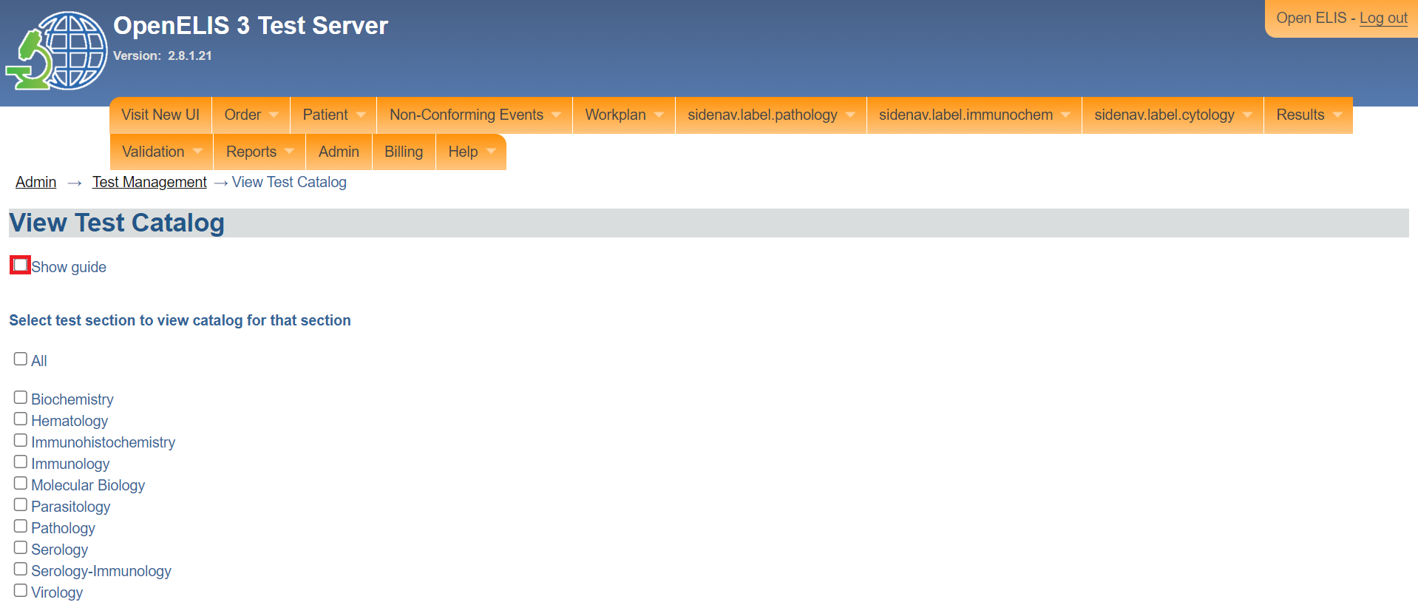

*Click show guide*

Note: To close the guide, uncheck the show guide checkbox.

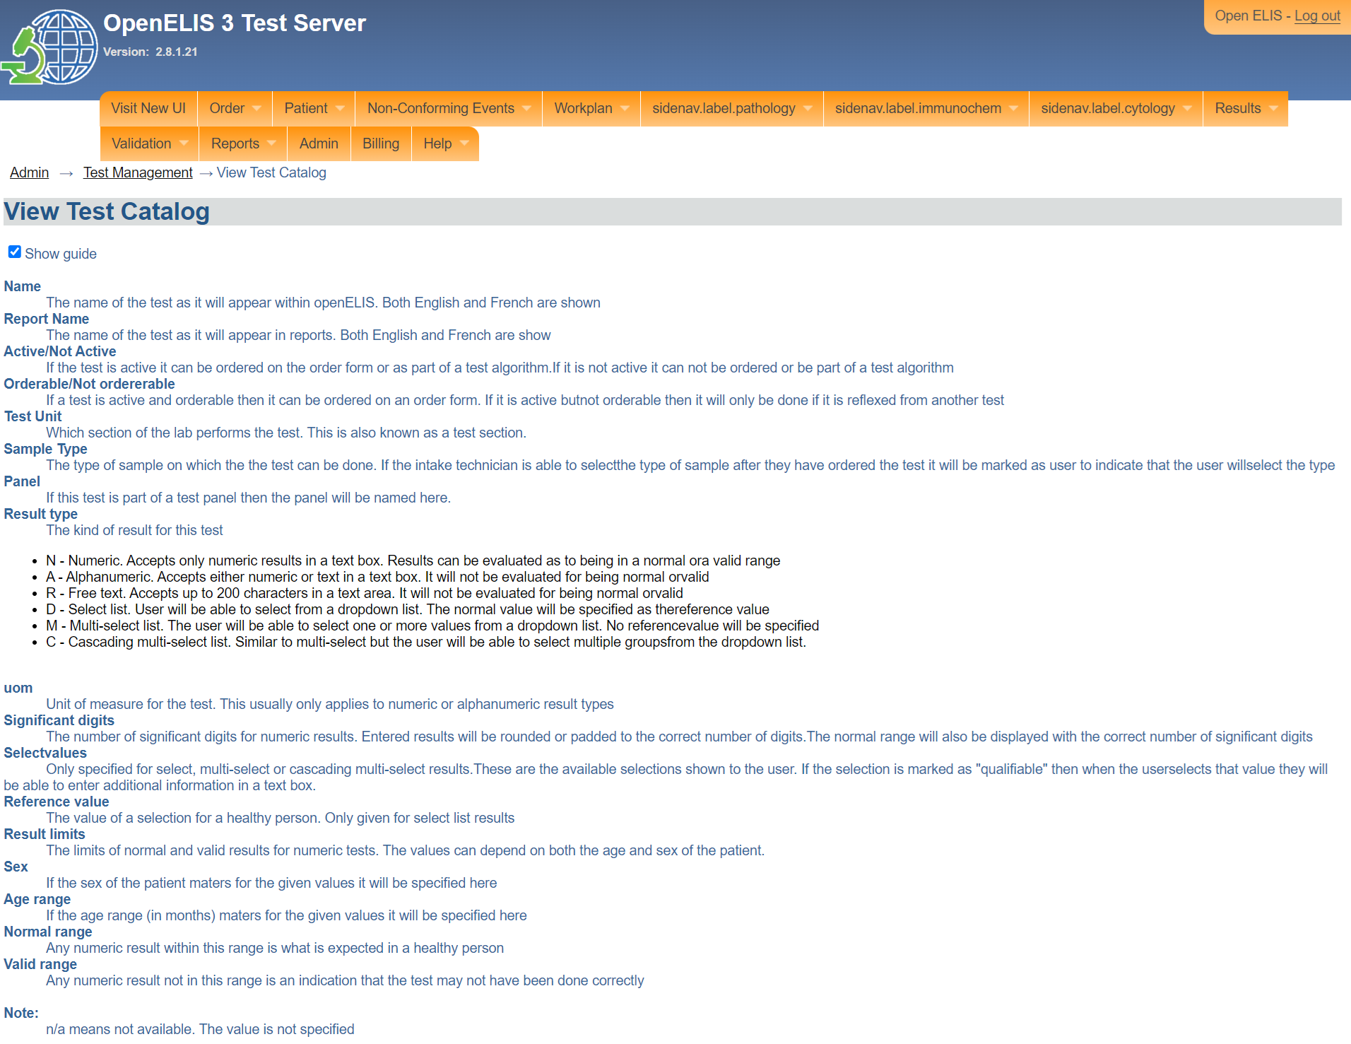

*View test catalog*

1. To view a catalog for a test, click on a checkbox corresponding to the test you want to see. In this illustration, the checkbox for the Molecular **Biology** test has been clicked.

Note: The list of tests and specifications appear on the same page. The specifications for each test are:

* 1. Test Name
  2. Name in English and in French
  3. Name of reports
  4. Unit of Measure
  5. Test unit
  6. Sample Type
  7. Panel
  8. Result type
  9. Significant digits
  10. Reference Value
  11. Limits results by gender and age
      1. normal range
      2. valid range

Note: The illustration below shows HIV VIRAL LOAD test catalog.

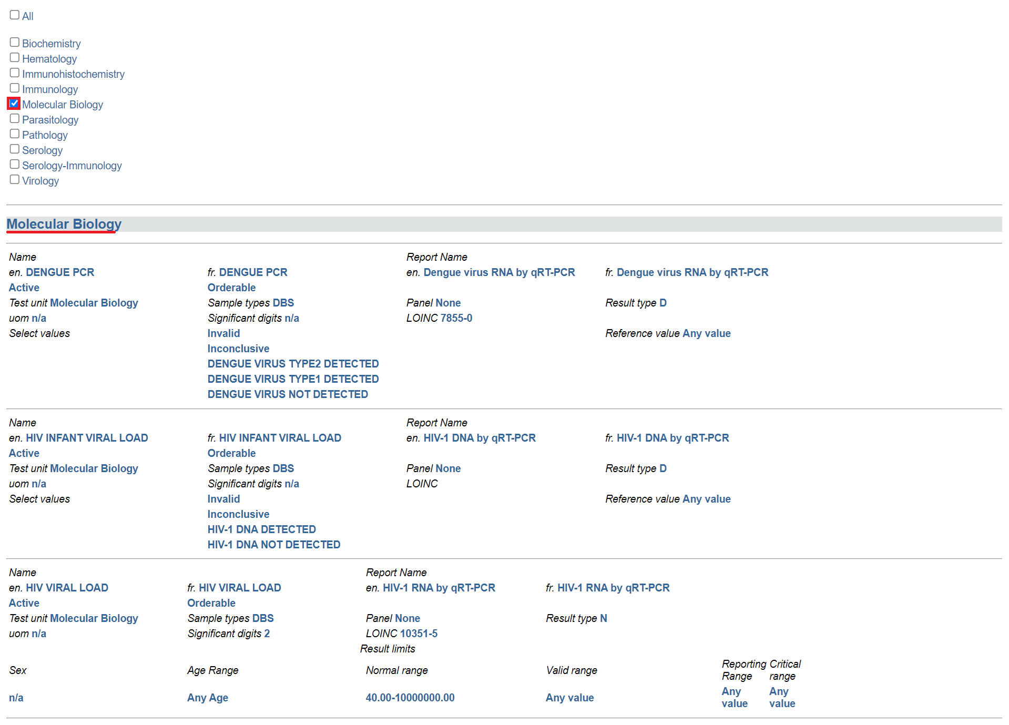

*View molecular biology test catalog*

Note: To learn more about the definition of the parameters for a test, consult the guide. In these illustrations, the significance for HIV VIRAL LOAD digit is set at 2 hence two decimal points.

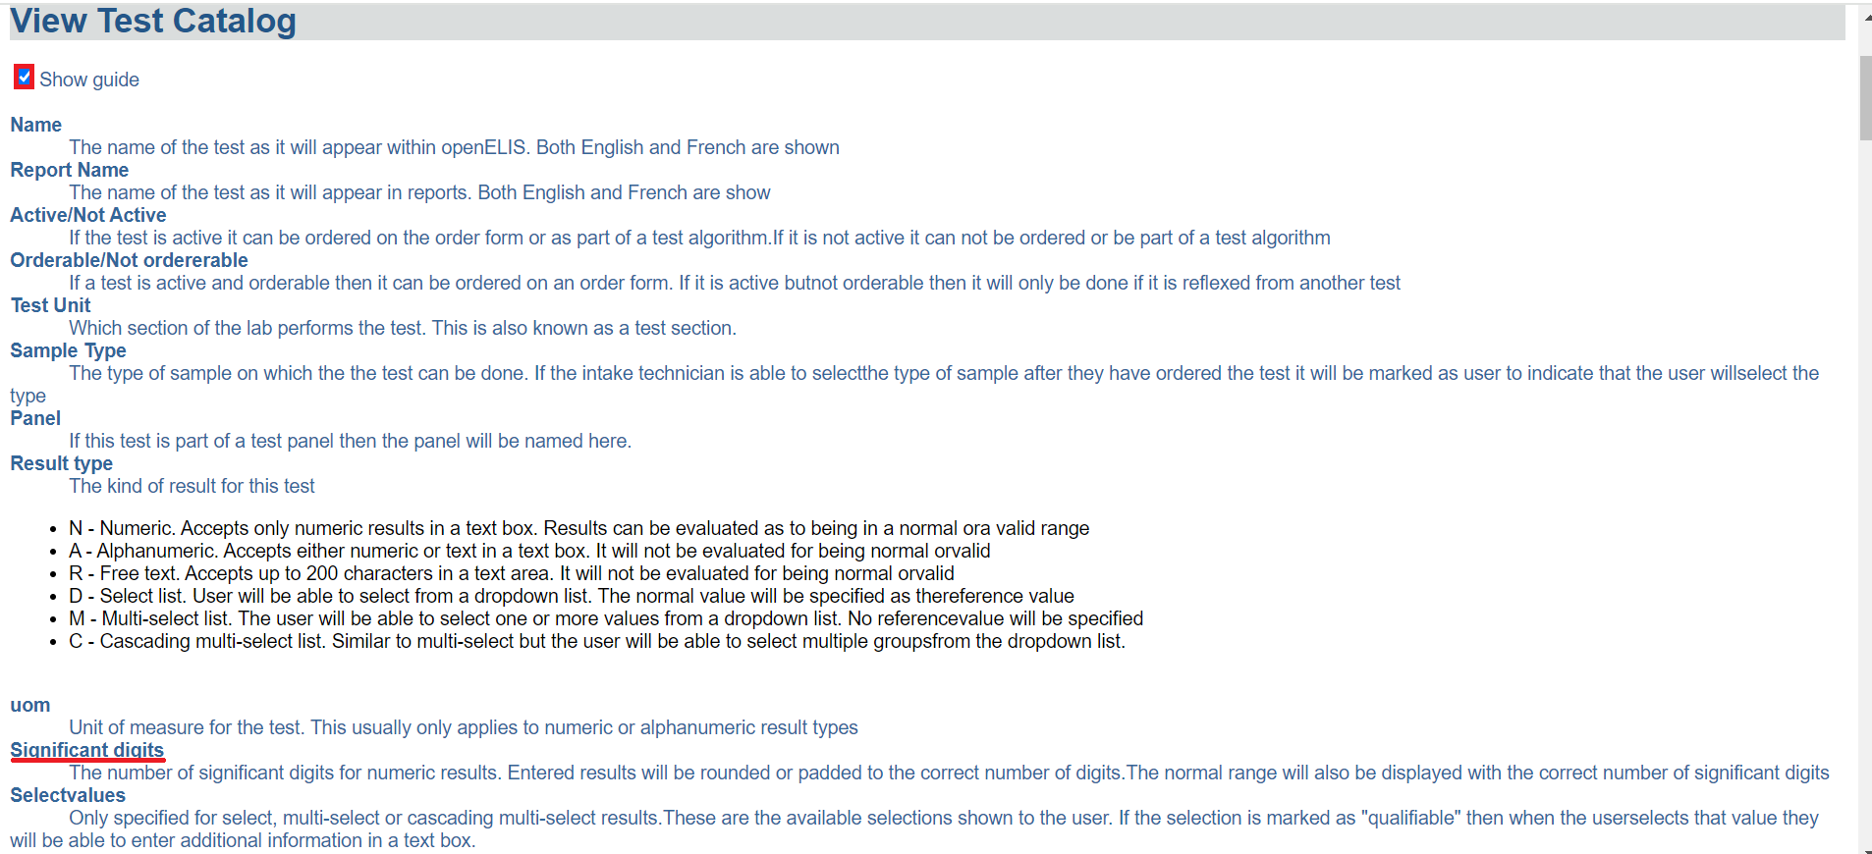

*Definition of the parameters*

Note: The All checkbox when clicked will select all the tests and display the respective test catalogs.

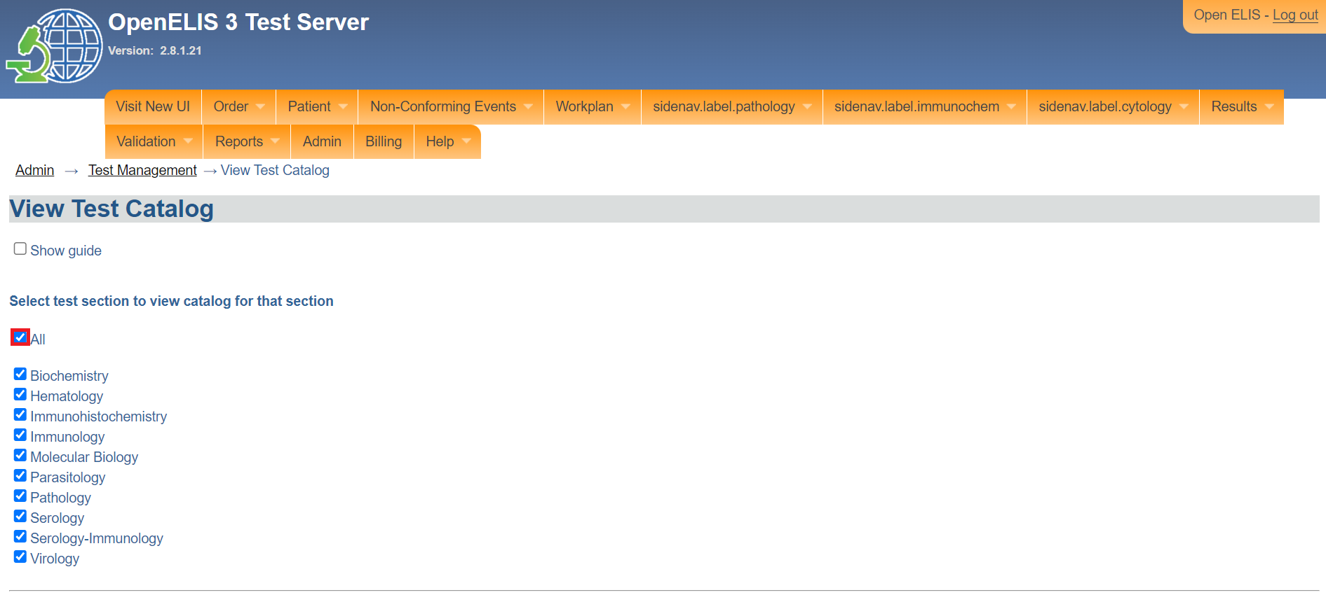

*View all test catalogs*

## **Manage methods**

1. The **manage method** is used to create a new method, activate or deactivate a method. Click on the menu item ,to access the manage method page. To access Manage Method, Follow steps 1 and 2 under [how to access the OpenELIS administrator module](https://docs.google.com/document/d/1oPIYxrLgoBi4prx2-Anhe1fm4x23_QQanpE_DqAVaVA/edit?pli=1#heading=h.but495evqliv).
2. Click on **Manage Methods** under **test organization.**

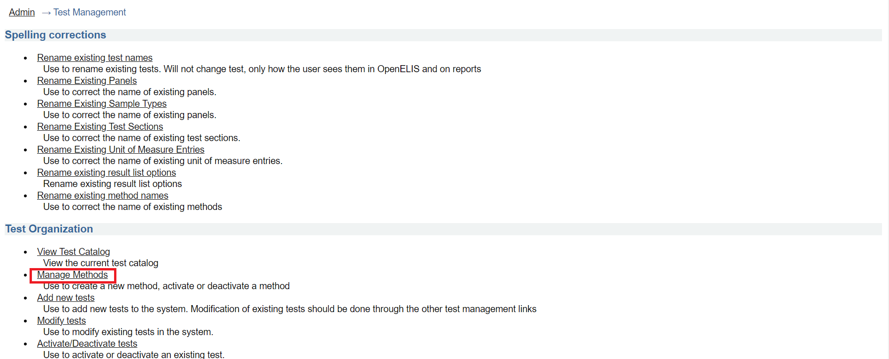

*Click on manage methods*

1. Click on under the method management page.

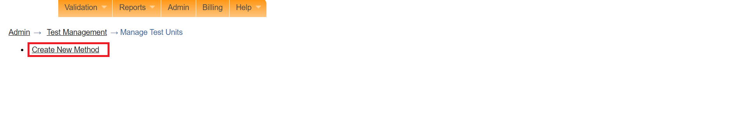

*Click new method*

## **How to add a new test**

1. To access Manage Method, Follow steps 1 and 2 under [how to access the OpenELIS administrator module](https://docs.google.com/document/d/1oPIYxrLgoBi4prx2-Anhe1fm4x23_QQanpE_DqAVaVA/edit?pli=1#heading=h.but495evqliv). Click on add new test under the **test organization** section.

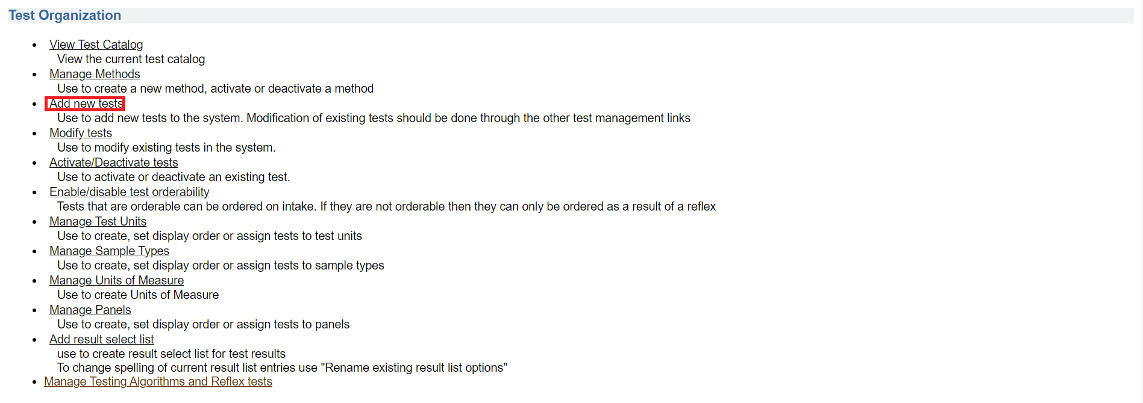

*Click add new tests*

Note: Upon clicking on **add new test**, the test add page will be displayed. Fields marked with asterisks * are mandatory. Therefore, this form cannot be saved without filling these fields. To learn more about the definitions of terms used in the test catalog, check the  **Show guide** checkbox.

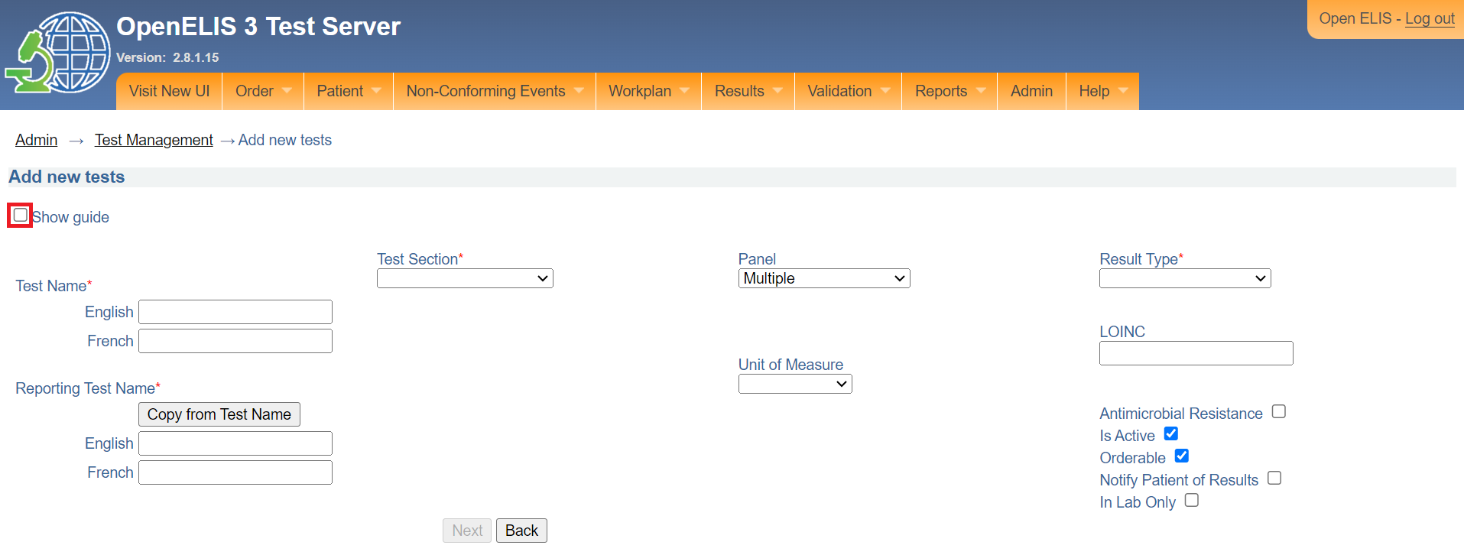

*Show guide checkbox*

To close the guide, uncheck the **Show guide** checkbox

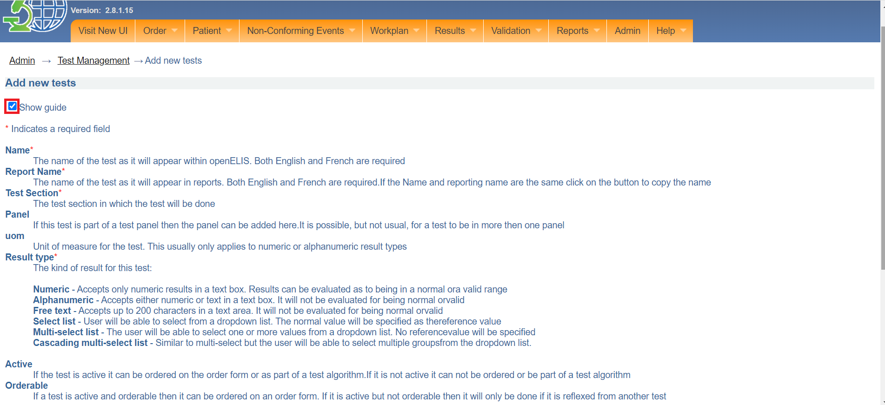

*Definition of terms*

1. Fill in the English and French names for the test.

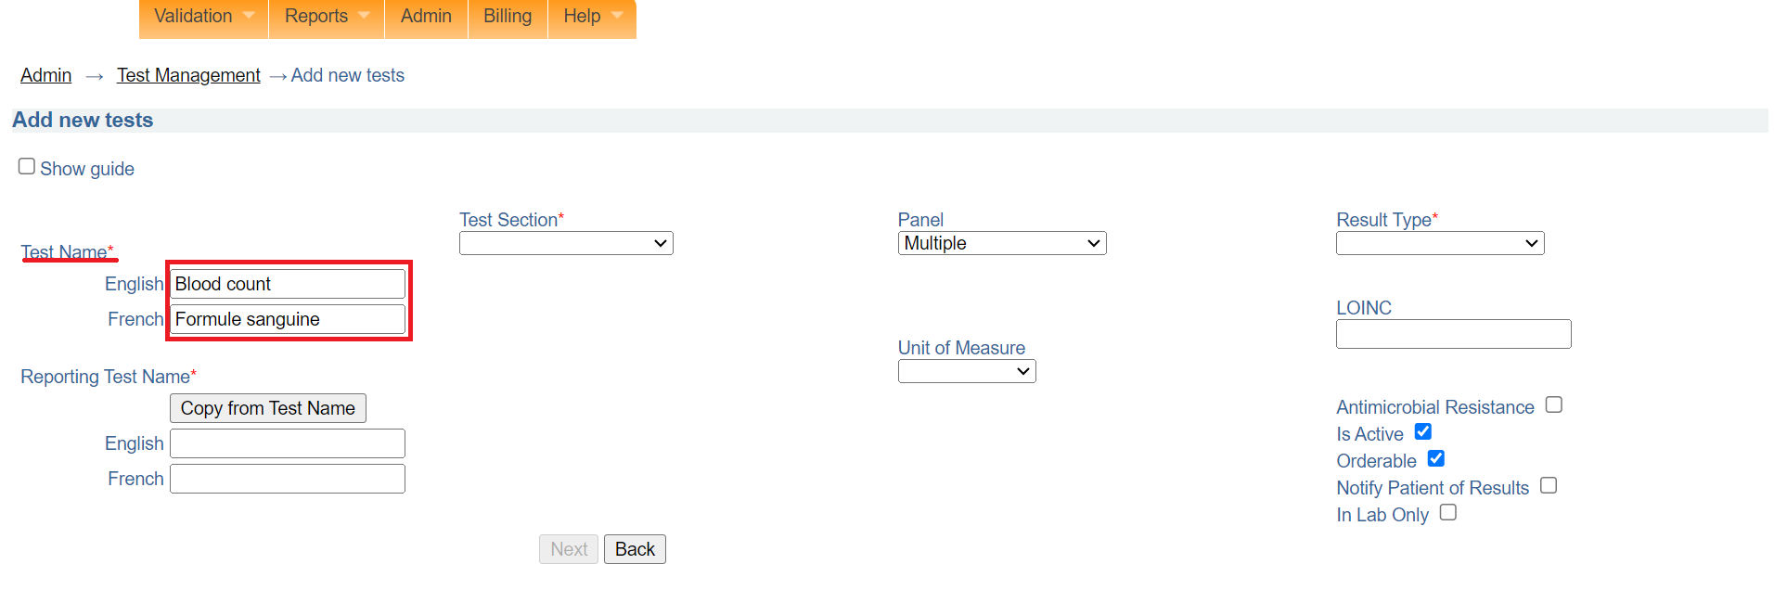

*Test names*

1. Select a Test Section from the dropdown menu. In this illustration, **Hematology** is selected

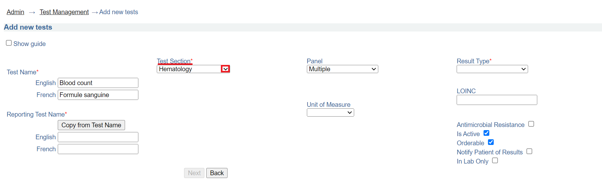

*Test section*

1. Select a panel for the test if the test should belong to a panel. In this illustration, CBC is selected. To remove a selected panel, click on the "X" next to the panel.

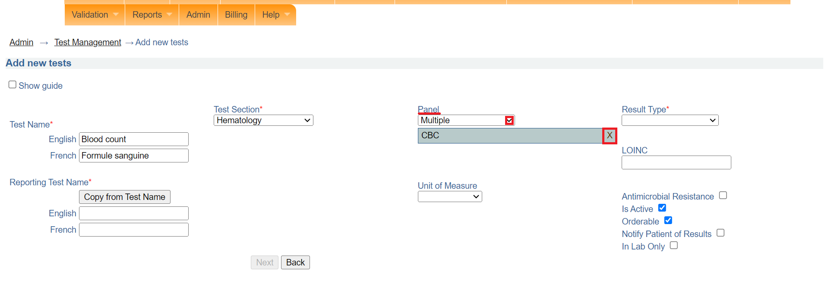

*Select panel*

1. Select the result type from the drop down menu. In this illustration, numeric is selected.

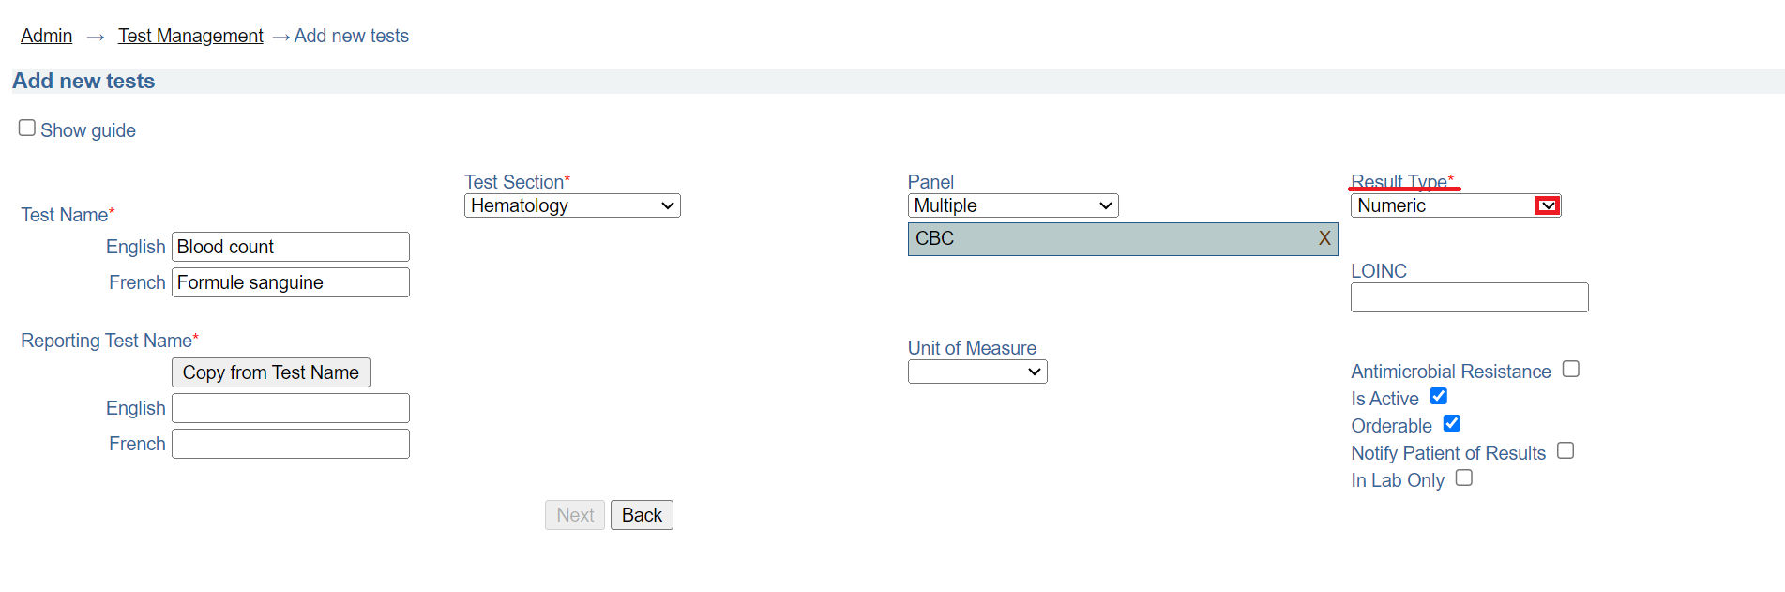

*Result type*

1. Select the unit of measure for the test. In this illustration, parts per million (ppm) is selected.

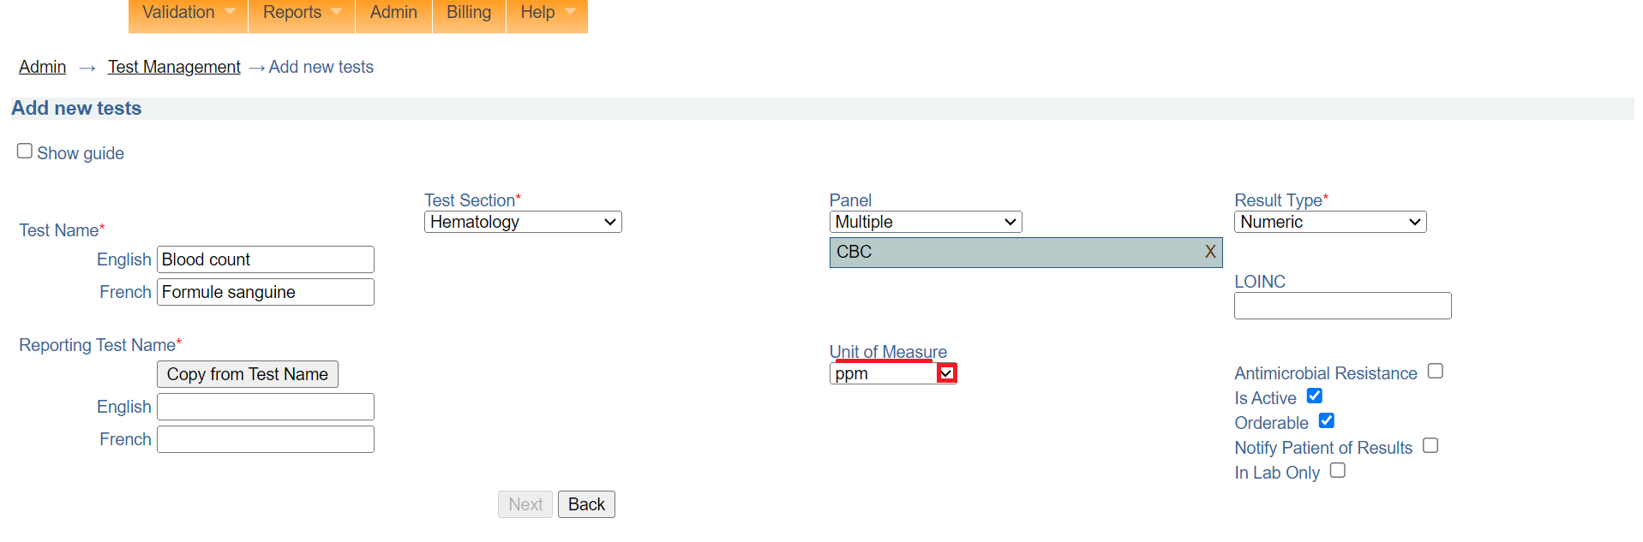

*Unit of measure*

1. Click on the **Copy from Test Name** button under **Reporting Test Name** to automatically fill in the reporting test name in English and French.

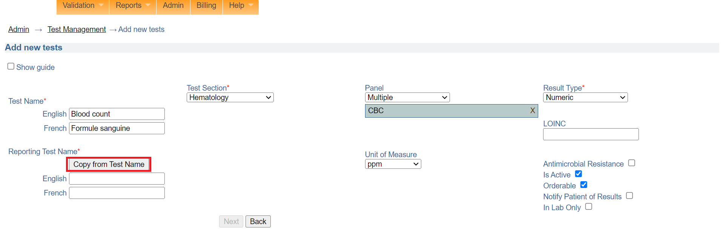

*Copy from test name*

Note: The **Is Active** and **Orderable** checkboxes are selected by default. This means that the test can be associated with an order and that the test can be put on an order form

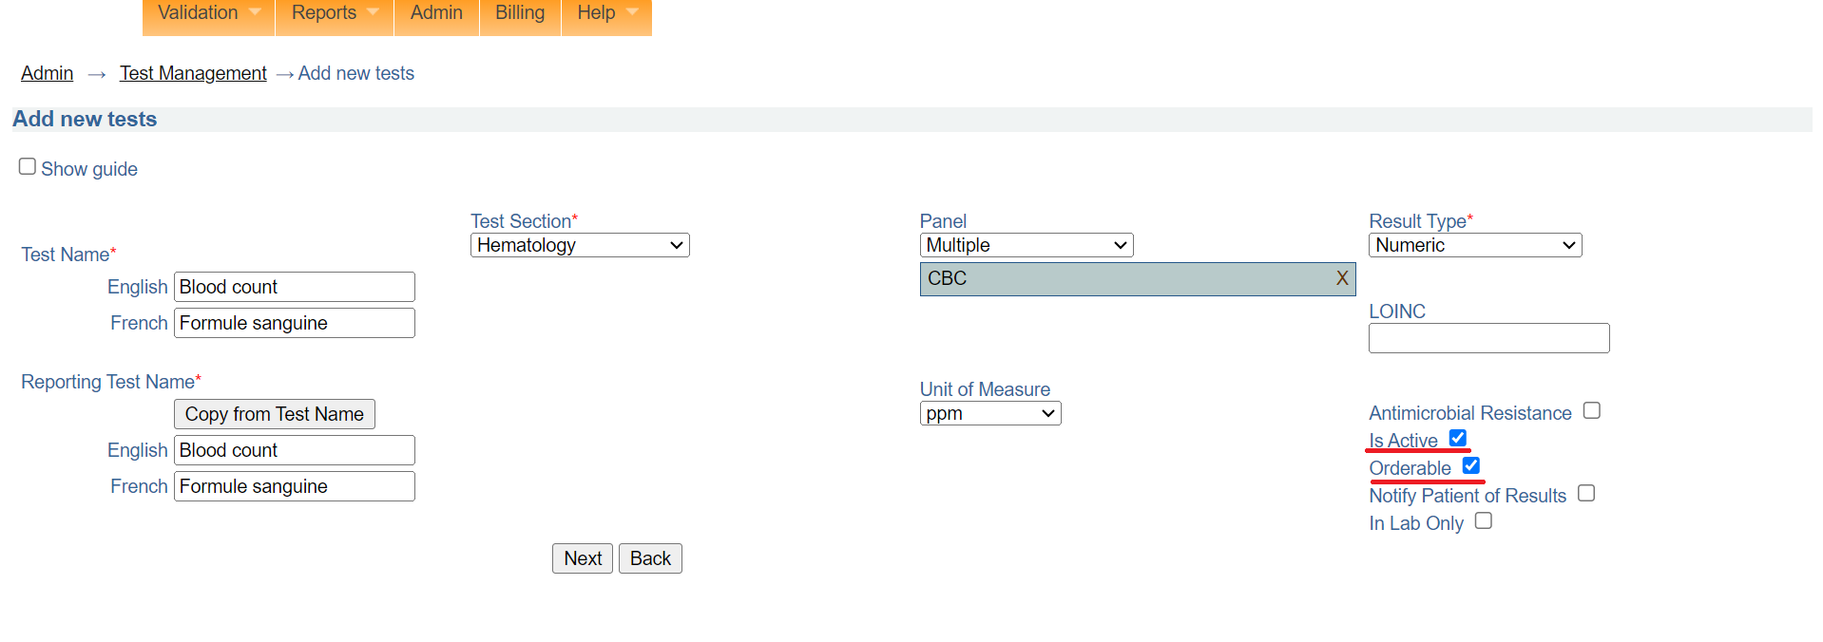

*Test is active and orderable*

1. Click on the **Next** button. Otherwise, click the **Back** button to cancel.

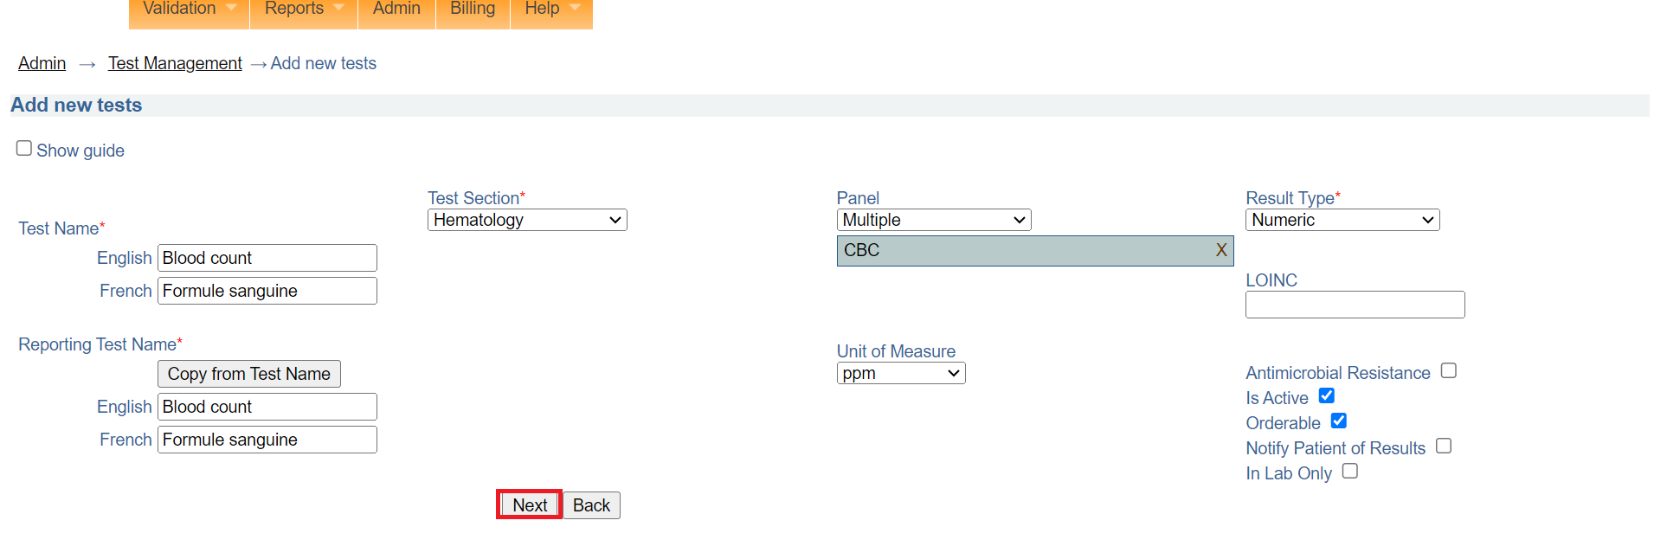

*Click next*

1. Select the sample type for the test from the dropdown menu. In this illustration, serum is selected.

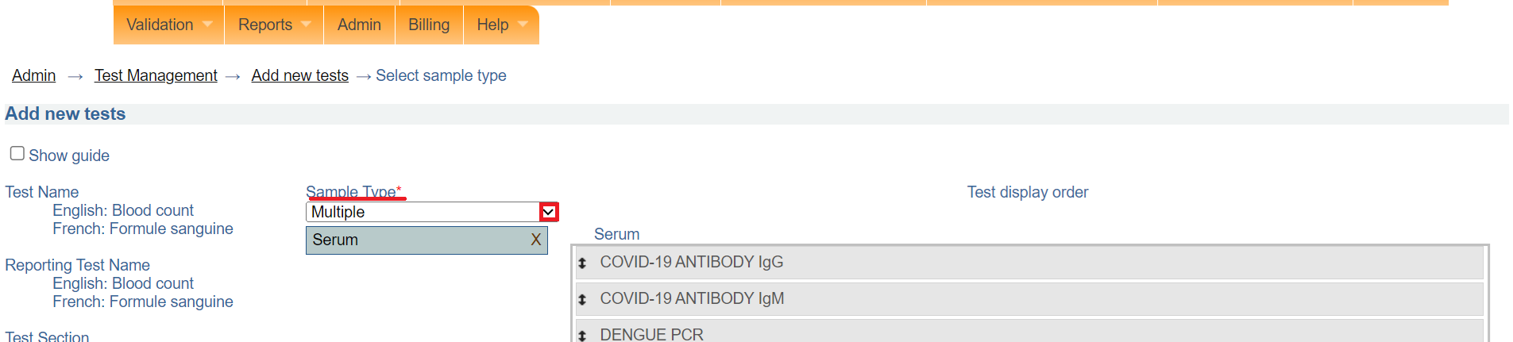

*Select sample type*

Note: You can order the display of the test by dragging the position.

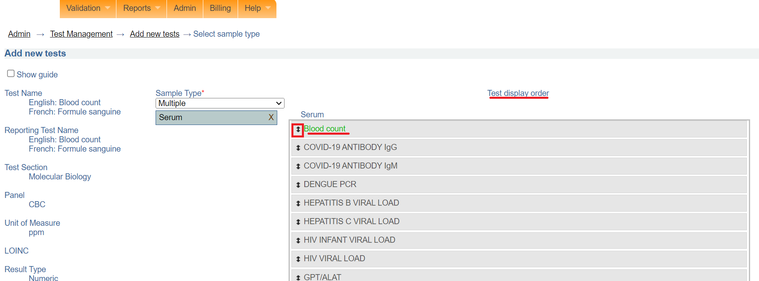

*Test display order*

1. Click on the **Next** button. Otherwise, click the **Back** button to cancel. Upon clicking on the next button, a section for setting the range for the test will be displayed on the same page.

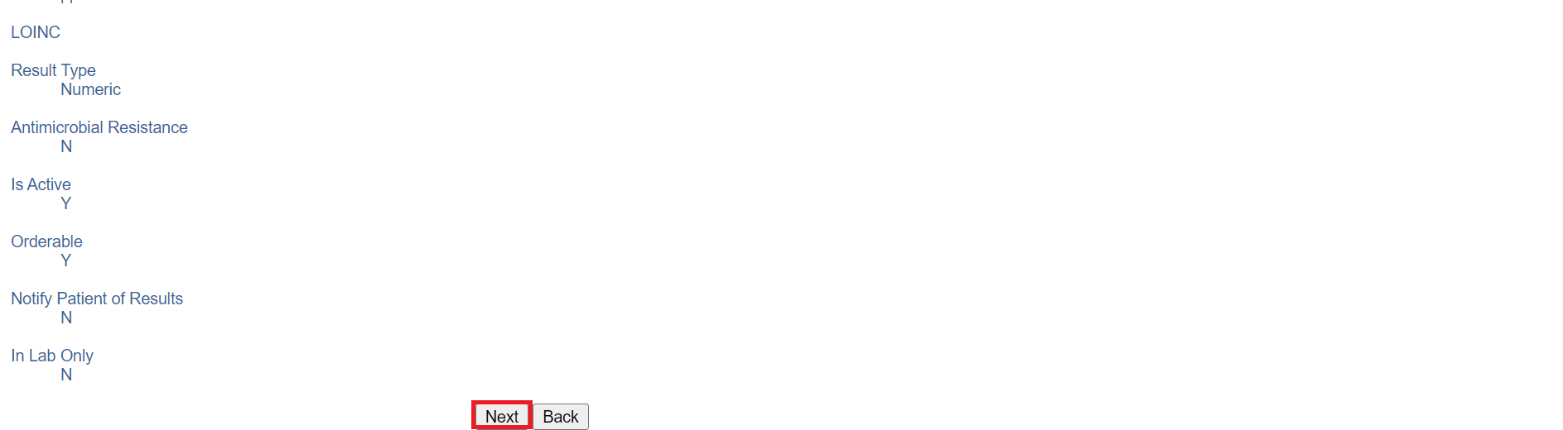

*Click next*

### **How to add range for a test**

The range panel is used to set the normal range, reporting range, valid range and critical range for the results of the newly created test. You have the option to set the sex dependency for either female or male. In this illustration age is used to set the range.

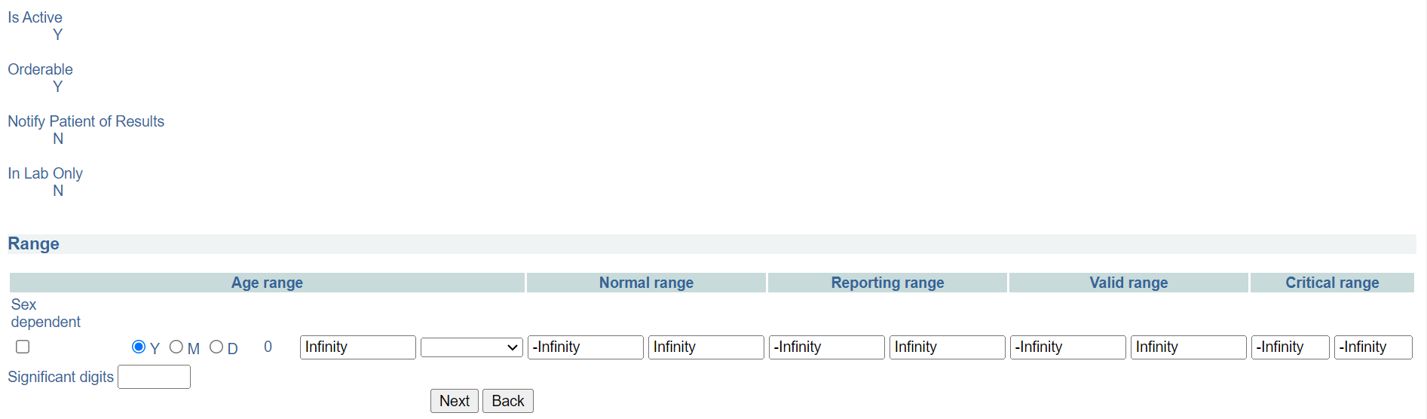

*Range panel*

1. In this illustration, the age range has been set as 10 years for both male and females.

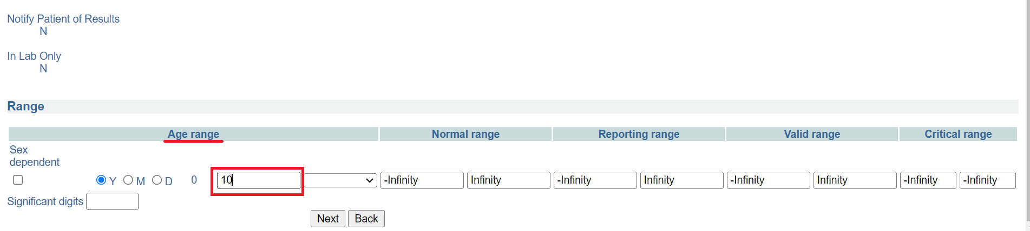

*Set age range*

Note: the age range is now set between 0-10 for both male and female.

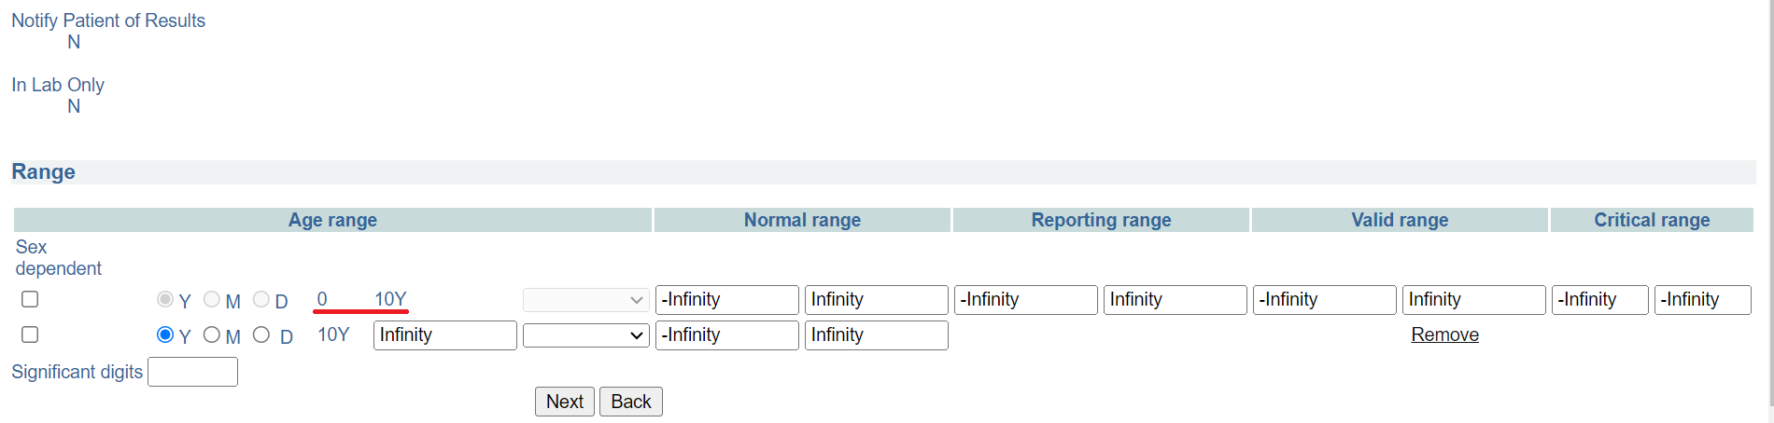

*Age range 0-10*

1. Set the normal range for the test. In this illustration, the range is set between 5 and 10.

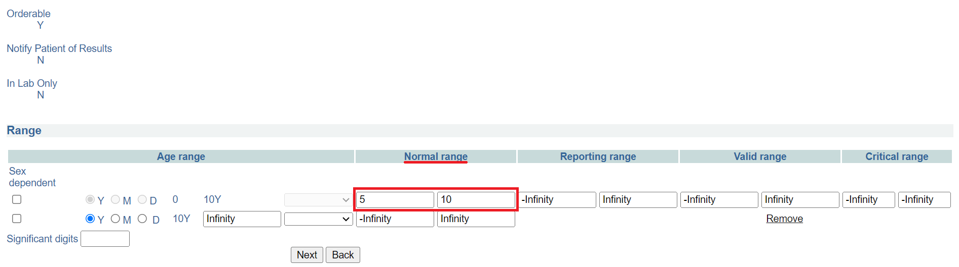

*Normal range*

1. Set the reporting range for the test. In this illustration, the range is set between 7 and 155.

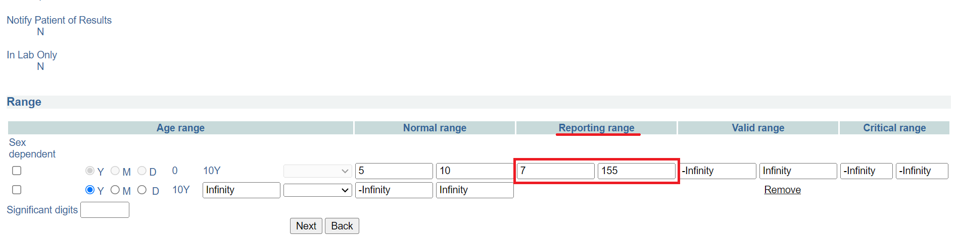

*Reporting range*

1. Set the valid range for the test. Ideally, this is the result you would expect to get from a live human. In this illustration, the range is set between 0 and 250. Essentially, this means the results cannot be below 0 and 250.

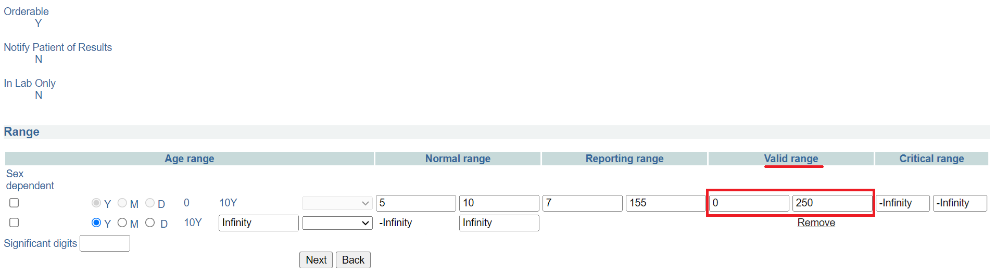

*Valid range*

1. Set the valid range for the test. In this illustration, the range is set between 140 and 150.

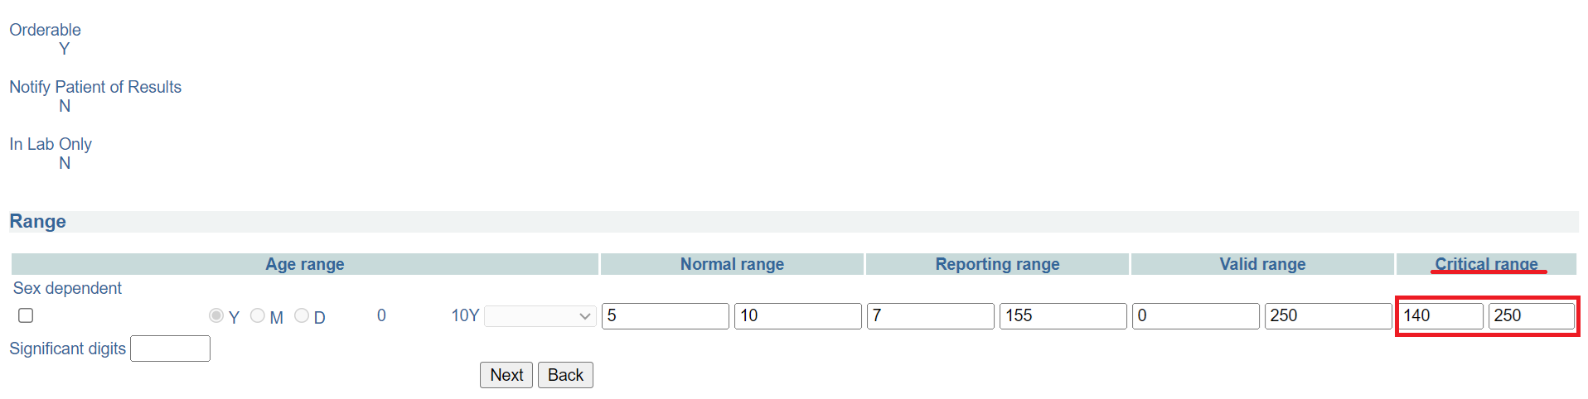

*Critical range*

Note: You can configure the normal range for different age brackets based on gender. In the illustration below the normal range for male is set between 8 and 25 for age above 10 years to infinity. Where as the the normal range for female is set between 7 and 30 for age 10 years to infinity

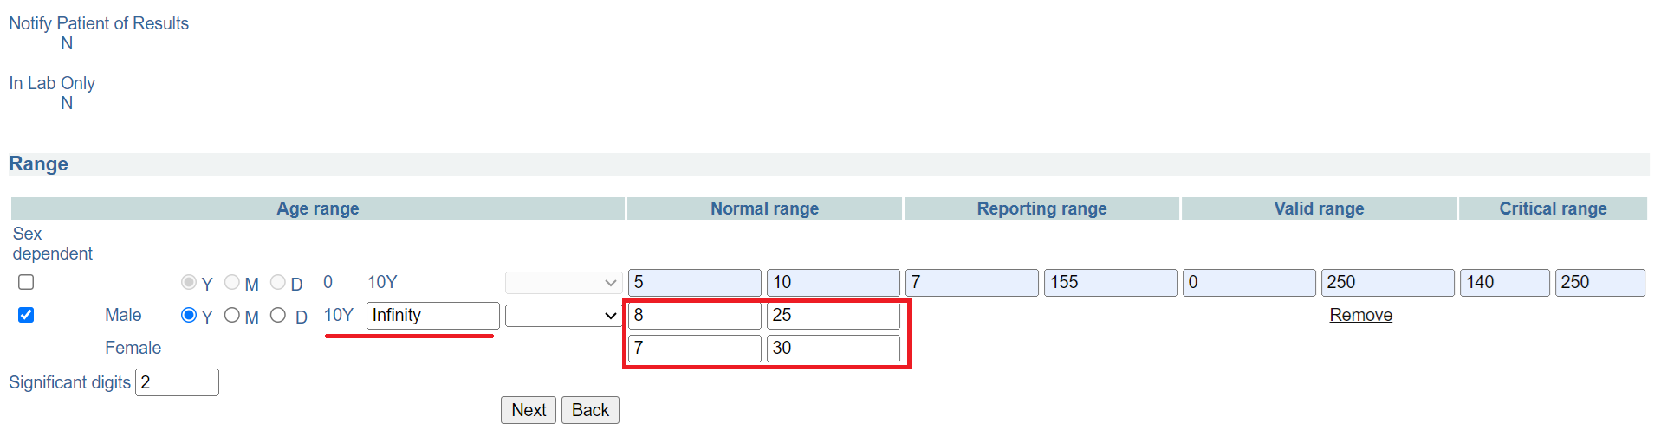

*Normal range age 10 years to infinity for male and female*

1. To set the significance digits, click on the show guide checkbox and consult the guide on the significant digits.

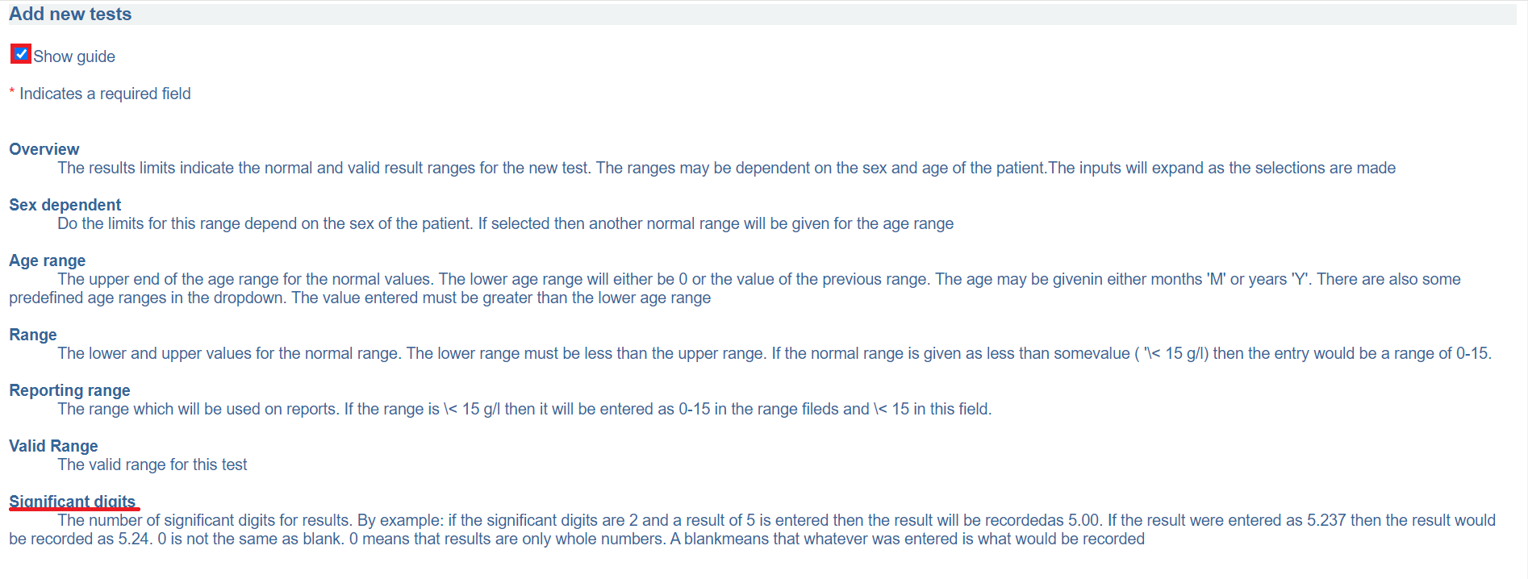

1. Set the significant digit. In this illustration the significant digit is set to 2.

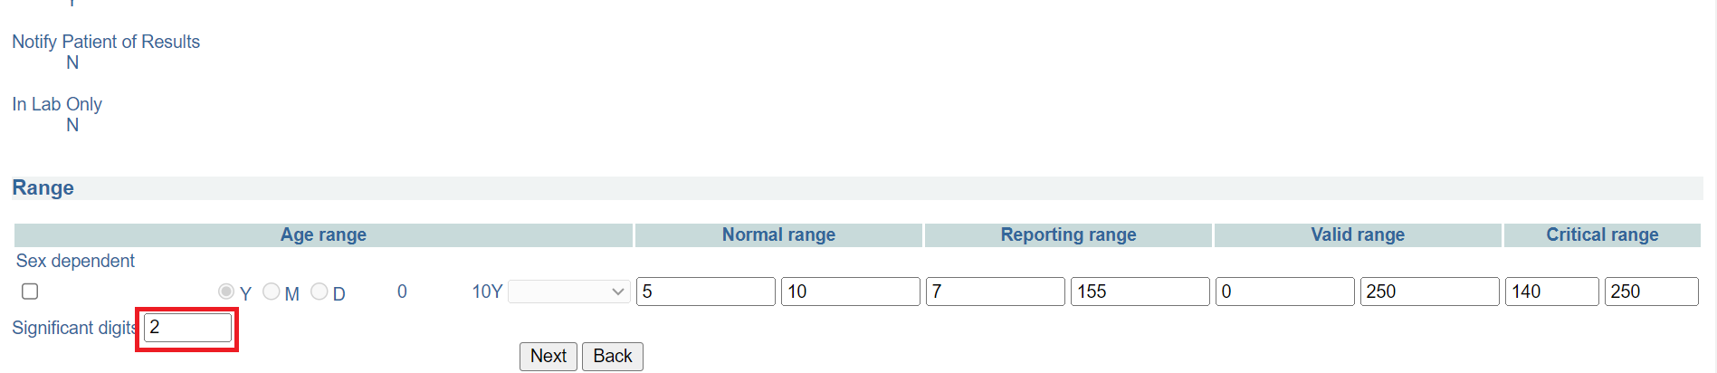

*Set significant digit*

1. Click on the **Next** button. Otherwise, click the **Back** button to cancel.

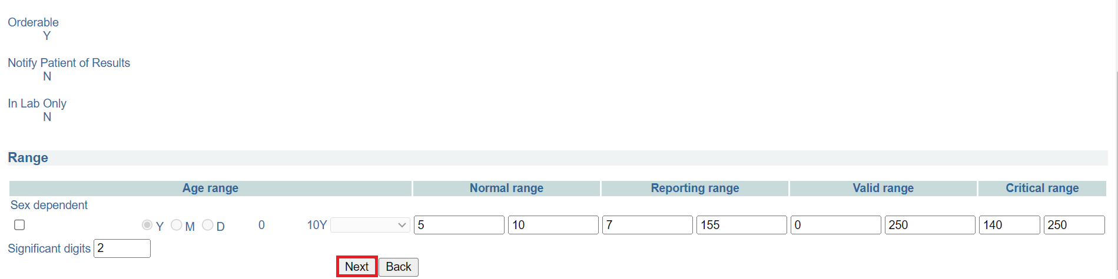

*Click next*

1. Click on the **accept** button. You will be navigated to the add new test page.

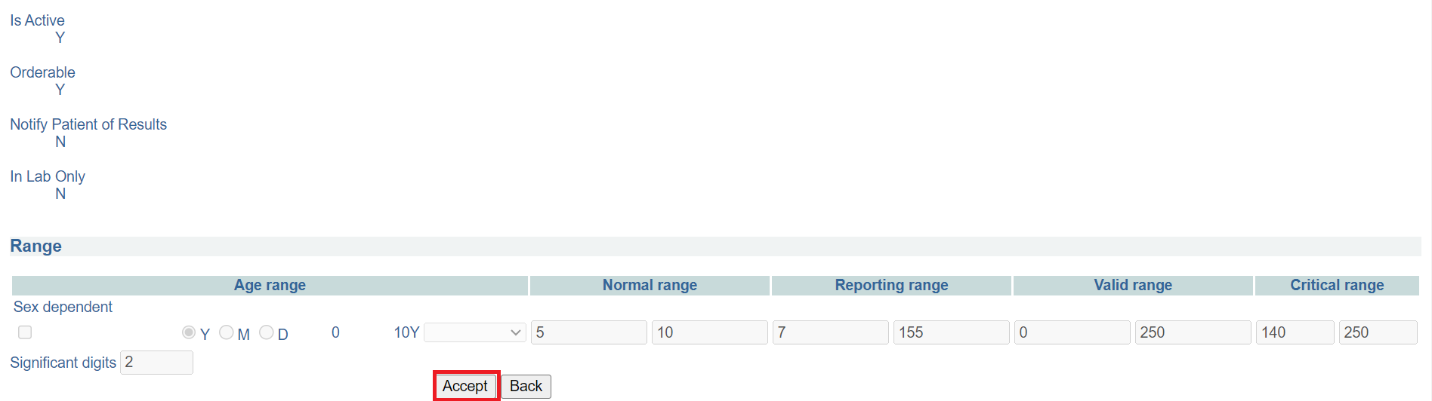

*Click accept*

## **How to modify a test**

1. You can modify existing tests in the system . To access the modify test option, Follow steps 1 and 2 under [how to access the OpenELIS administrator module](https://docs.google.com/document/d/1oPIYxrLgoBi4prx2-Anhe1fm4x23_QQanpE_DqAVaVA/edit?pli=1#heading=h.but495evqliv). Click on modify test under the **test organization** section.

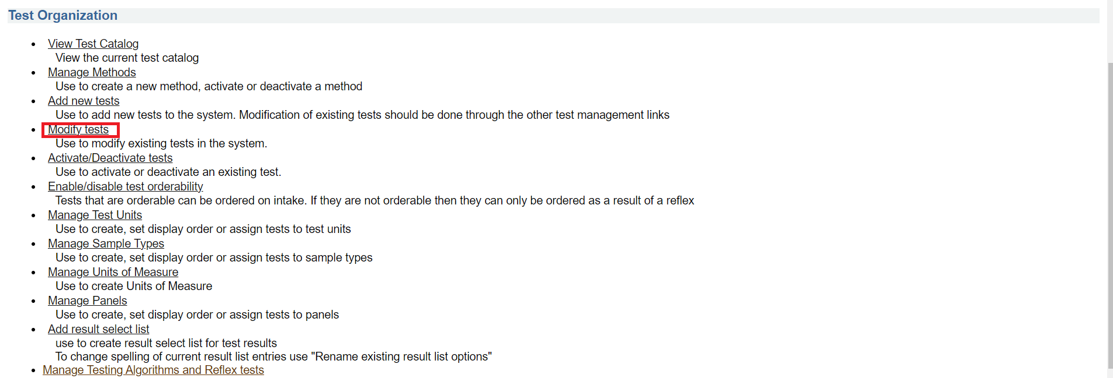

*Click modify test*

Note: Upon clicking on **modify test**, the test modification page will be displayed. To learn more about the definitions of terms used in the test modification page, check the  **Show guide** checkbox.

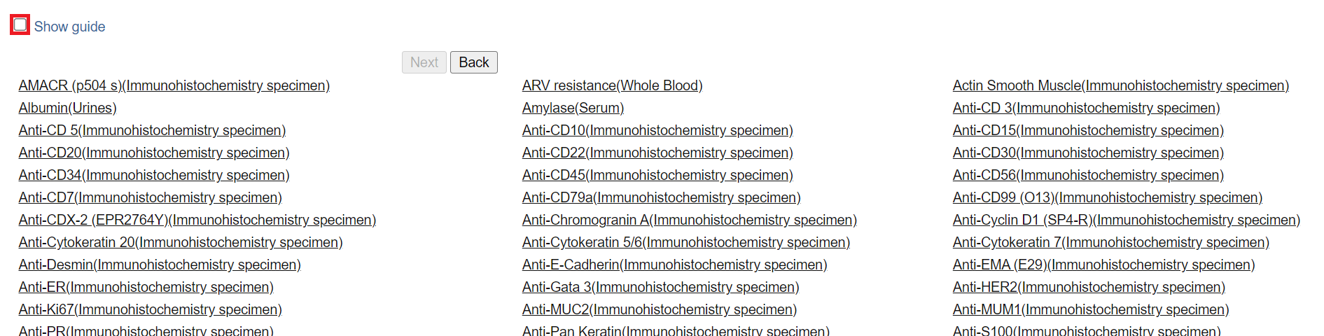

*Show guide checkbox*

To close the guide, uncheck the **Show guide** checkbox

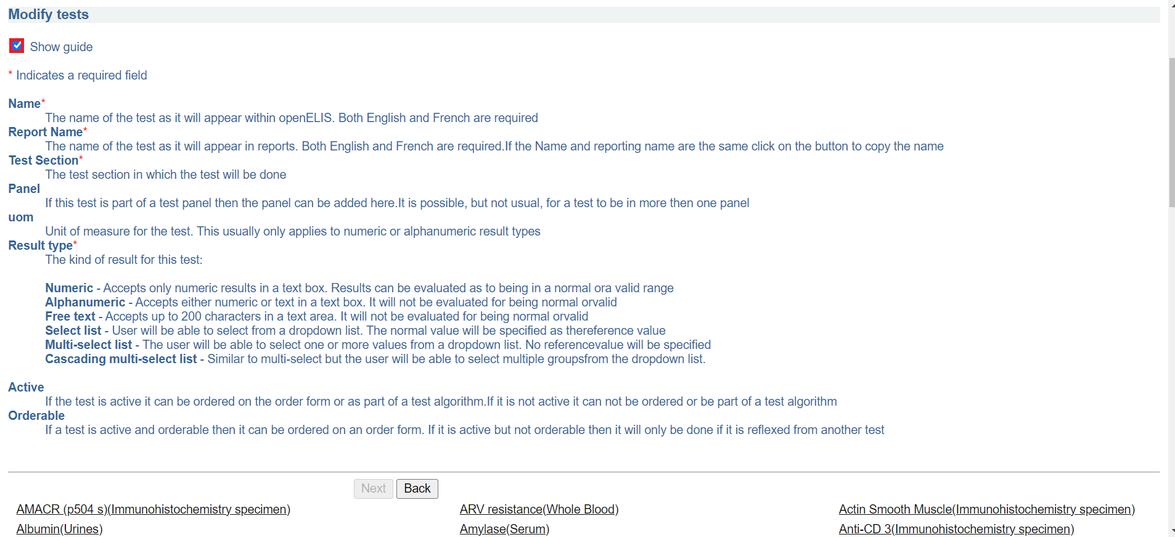

*Close guide*

1. To modify a test, click on the test from the list. In this illustration, Test(Red Top) is clicked. The test edit setion will be expanded on the same page.

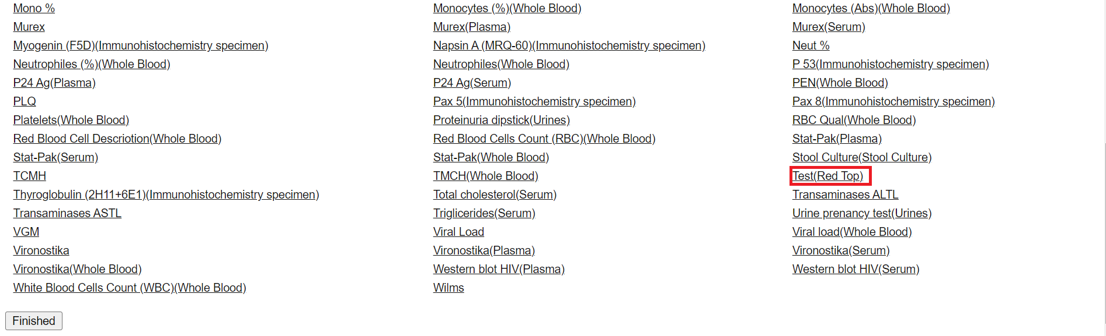

*Click on test to modify*

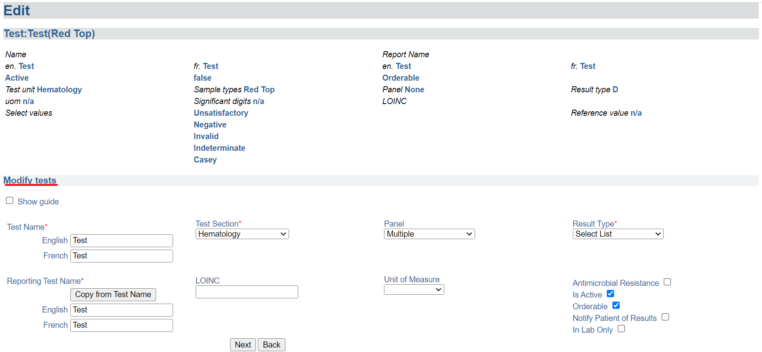

*Test modification section*

1. Edit the desired fields. In this illustration, the test is edited as Red top for both English and French names.

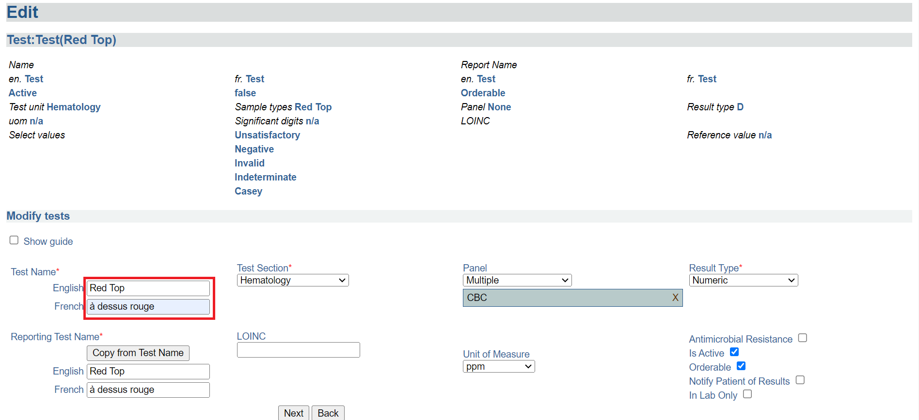

*Edit test*

Note: consideration should be taken in ensuring that the **panel**, **results type**, **unit of measure** fields are entered. **The Reporting Test Name** fields should also be fields upon editing the test by clicking on the The **Copy from Test Name** button.

1. Click on the Next button

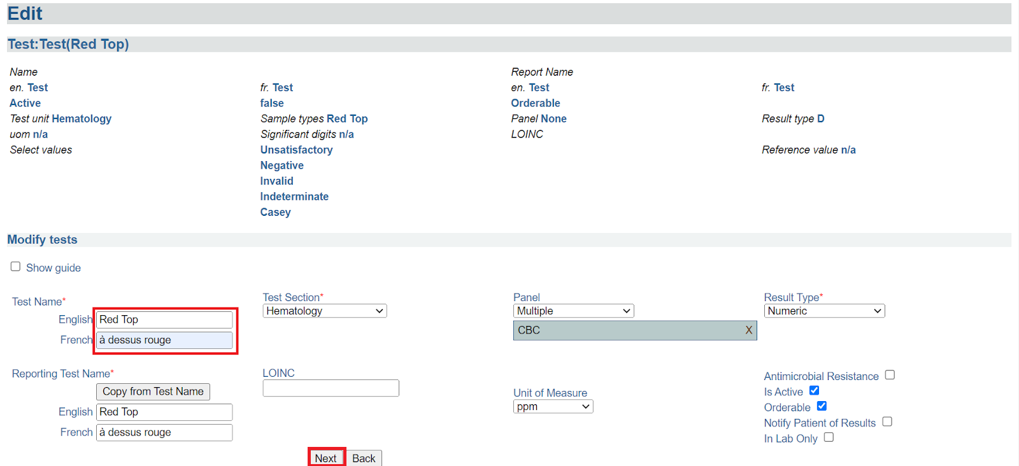

1. Click on the Edit results ranges button.see the how to add range for a test section on.

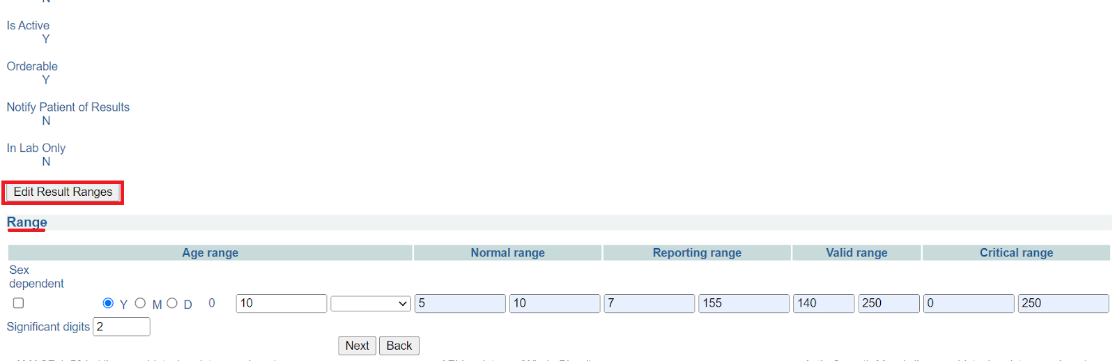

*Edit result range*

1. Click on the Next button.

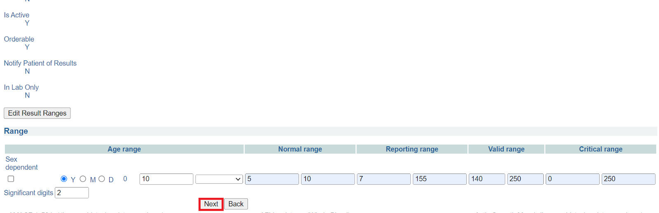

*Click next*

1. Click on the finished button at the bottom of the page.

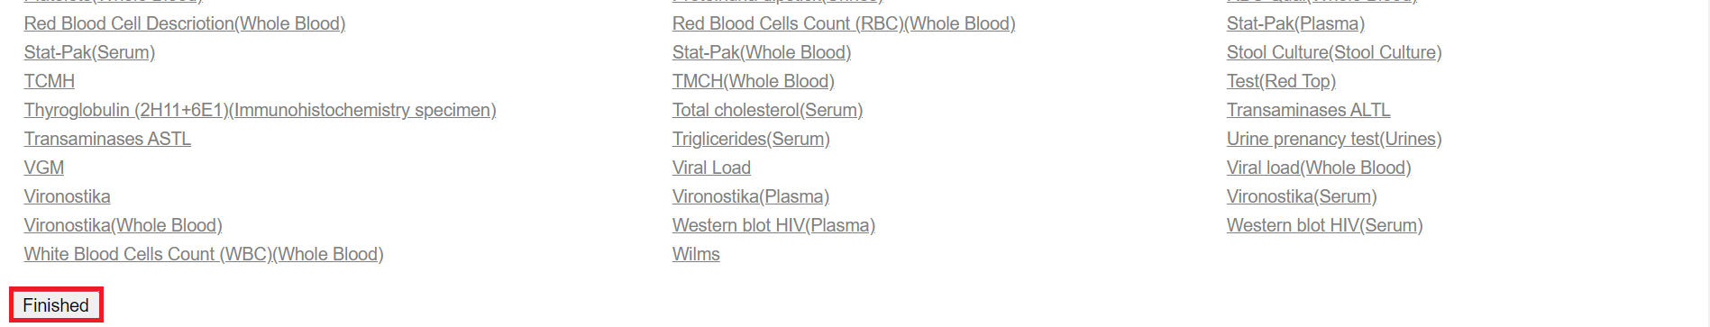

*Click finished*

## **How to activate or deactivate a test**

1. A test must be active for it to be used in laboratory orders. To activate a test, click on To access the add result select list, Follow steps 1 and 2 under [how to access the OpenELIS administrator module](https://docs.google.com/document/d/1oPIYxrLgoBi4prx2-Anhe1fm4x23_QQanpE_DqAVaVA/edit?pli=1#heading=h.but495evqliv). Click on **activate /deactivate tests** under the **test organization** section.

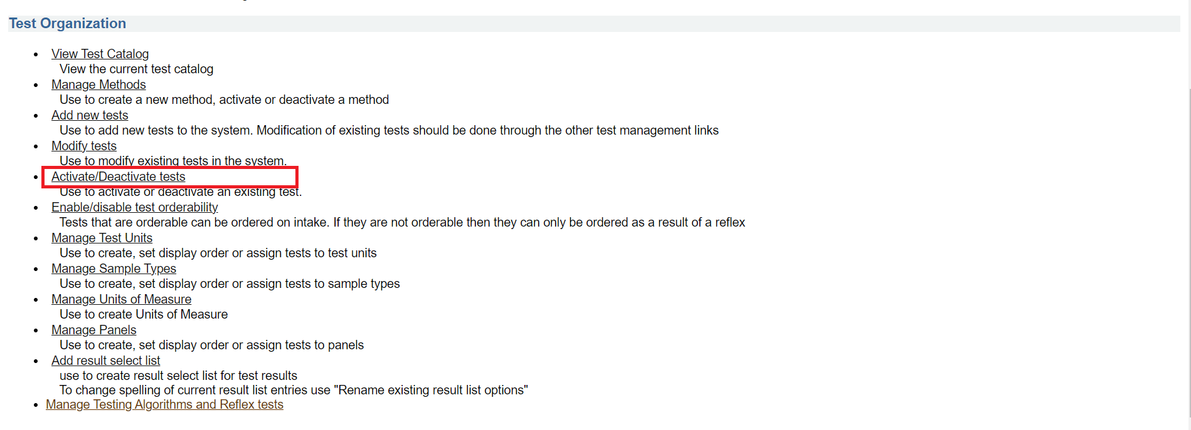

*Click activate/deactivate tests*

1. Upon clicking on activate /deactivate tests, the test activation page will be displayed. Active Tests: a checked box indicates an already active test. To activate a test, check the box.

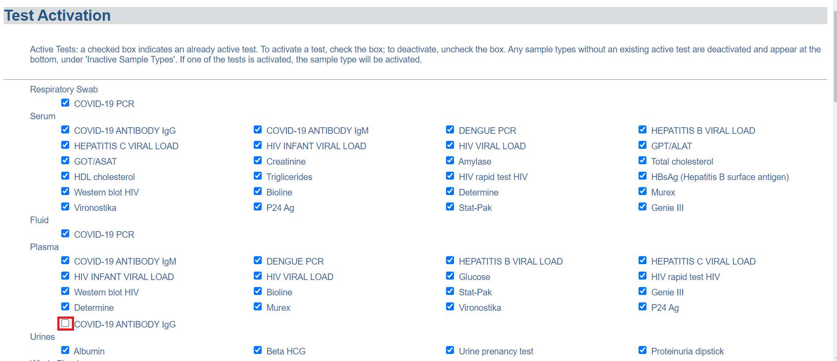

*click on a check box*

1. Click on the **save** button at the bottom of the page.

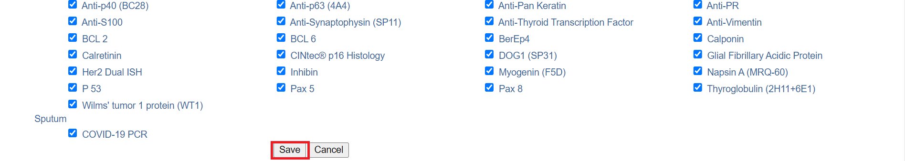

*Click save*

1. To sort the tests to indicate how they will be displayed, Click on the test to drag it to a desired position; this is optional. Otherwise, click on the **Next** button.

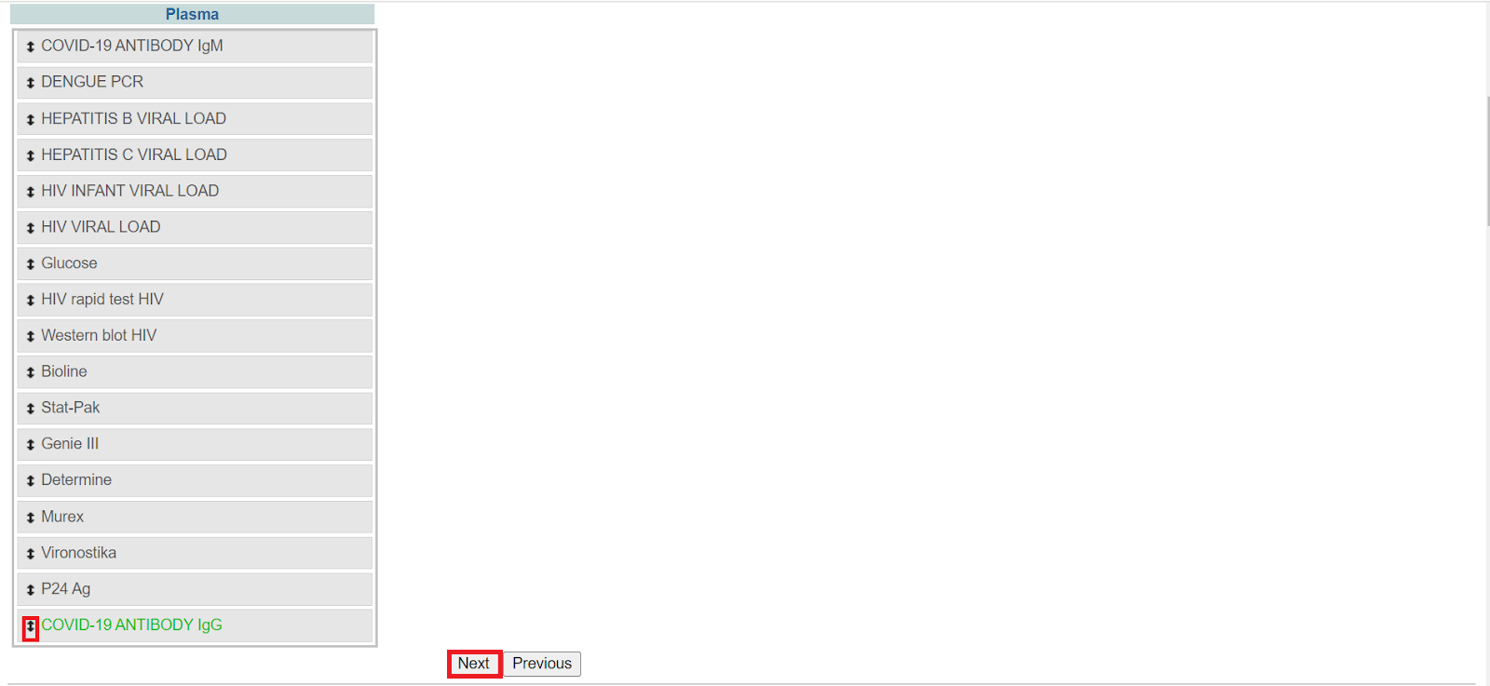

1. Verify the activation of the test by clicking on the **Accept** button. The test will be activated successfully.

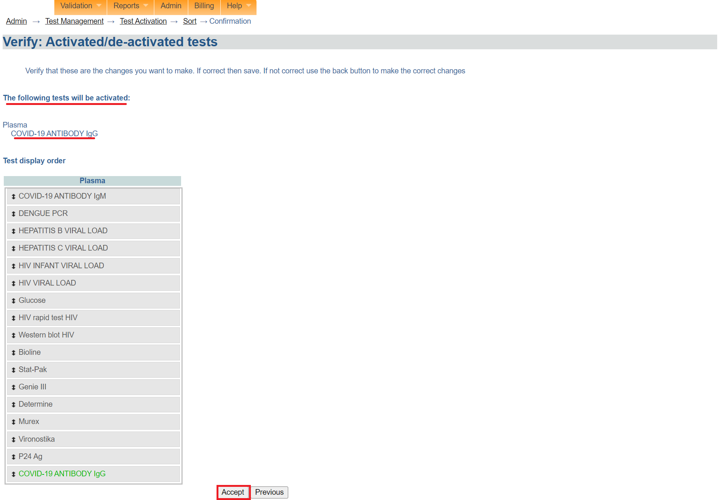

*Click accept*

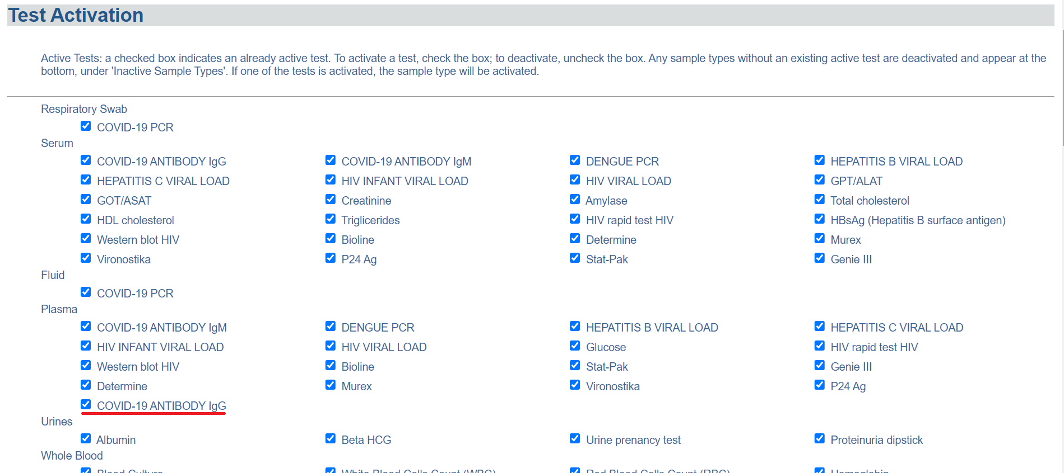

*Test activated*

1. To deactivate a test, click on a checkbox for an active test.

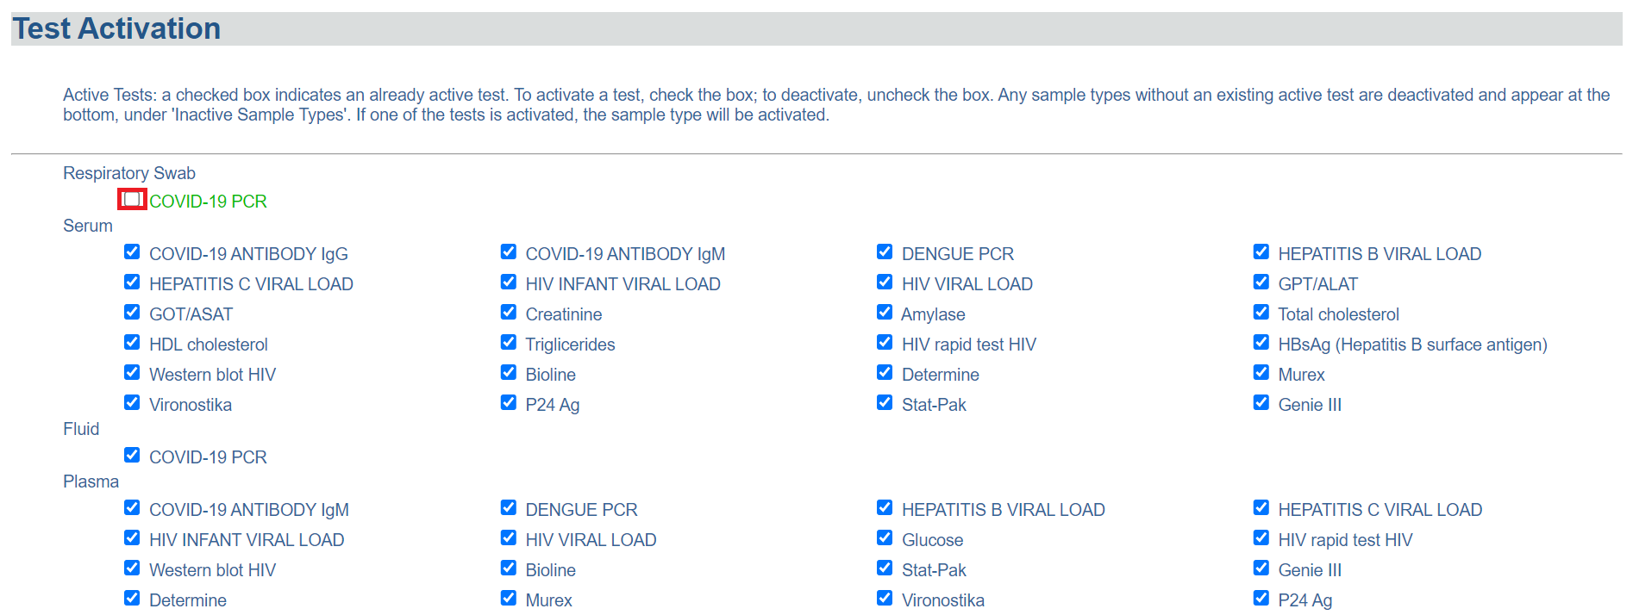

*Click on a checkbox for the test*

1. Click on the Save button at the bottom of the page.

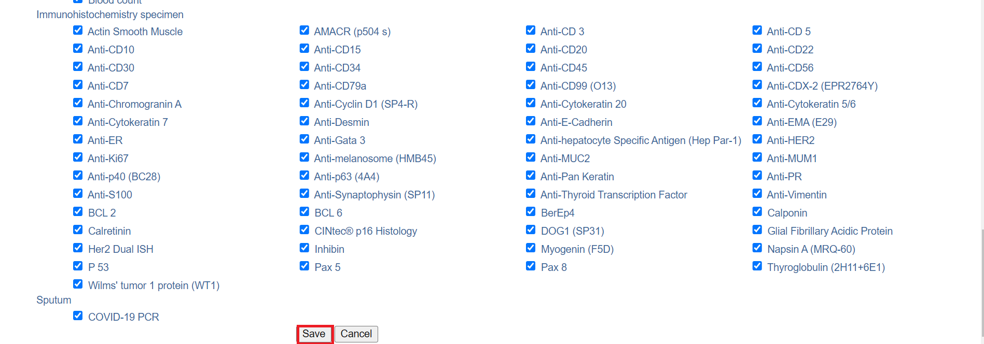

1. Verify the deactivation of the test by clicking on the **Accept** button.

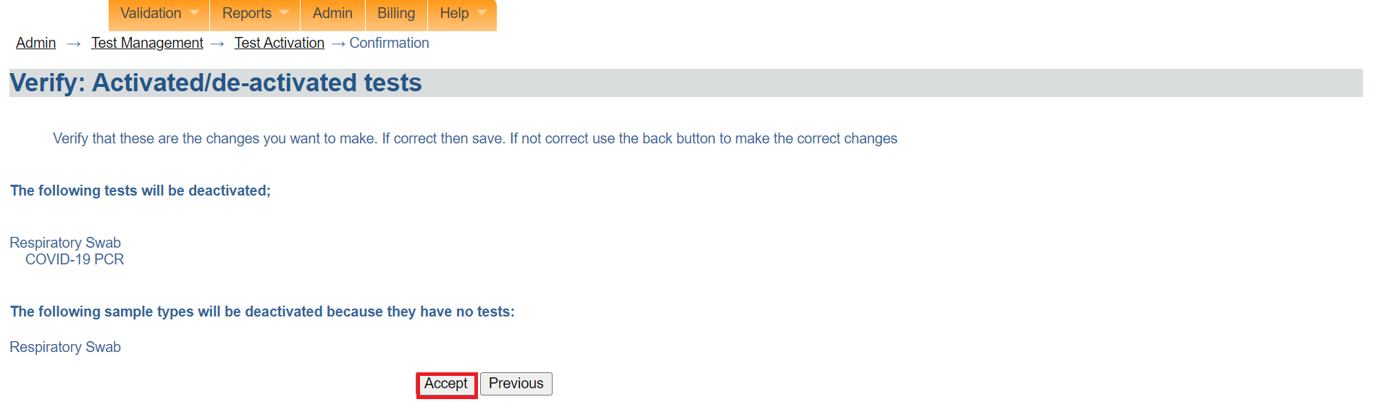

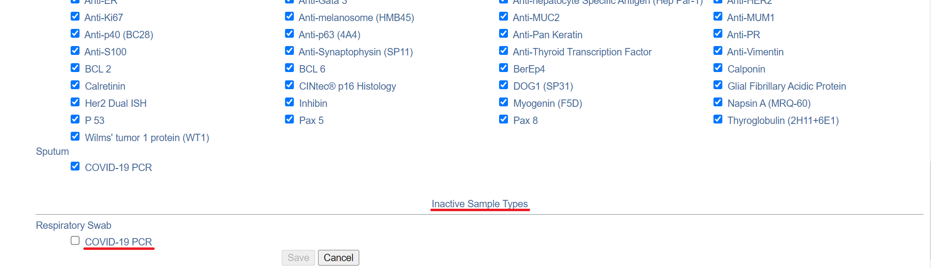

*Test deactivated successfully*

Note: Any sample types without an existing active test are deactivated and appear at the bottom, under 'Inactive Sample Types'. If one of the tests is activated, the sample type will be activated.

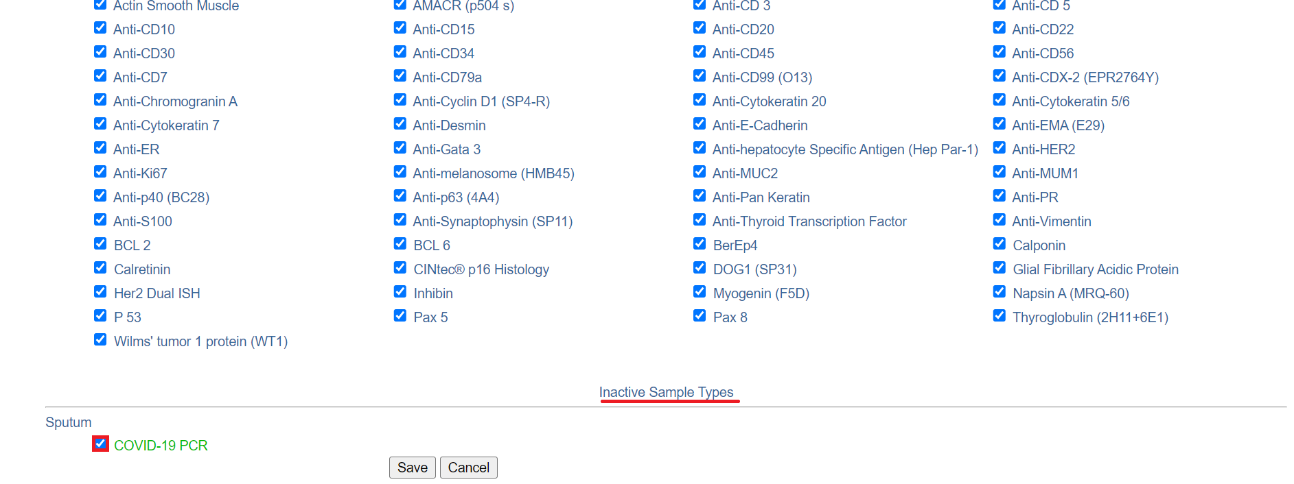

*Inactive sample*

## **How to enable or disable test orderability**

Tests that are orderable can be ordered on intake. If they are not orderable then they can only be ordered as a result of a reflex

1. To enable or disable test orderability, Follow steps 1 and 2 under [how to access the OpenELIS administrator module](https://docs.google.com/document/d/1oPIYxrLgoBi4prx2-Anhe1fm4x23_QQanpE_DqAVaVA/edit?pli=1#heading=h.but495evqliv). Click on enable or disable test orderability under the **test organization** section.

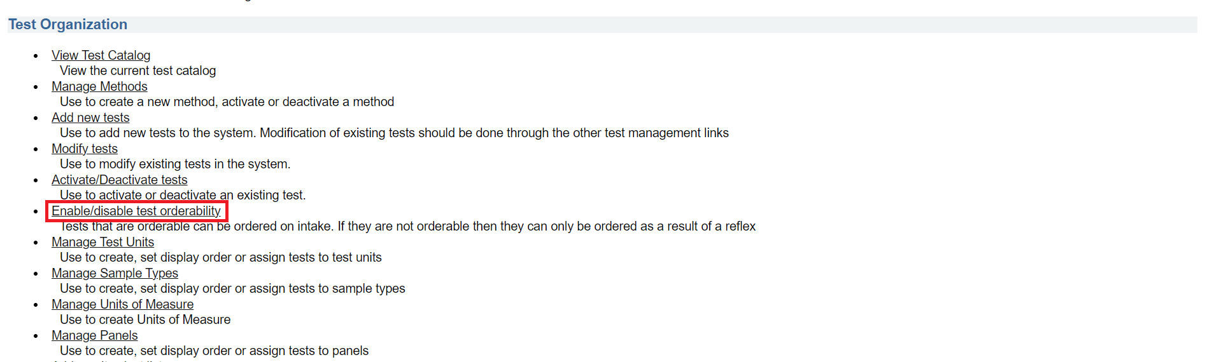

*Click on enable or disable test orderability*

Note: Test with checks are orderable, those without checks are not orderable. Change checks to change status. For a test to be able to be ordered on intake it must be both active and orderable. Tests which are active but not orderable may be requested as part of a test reflex.

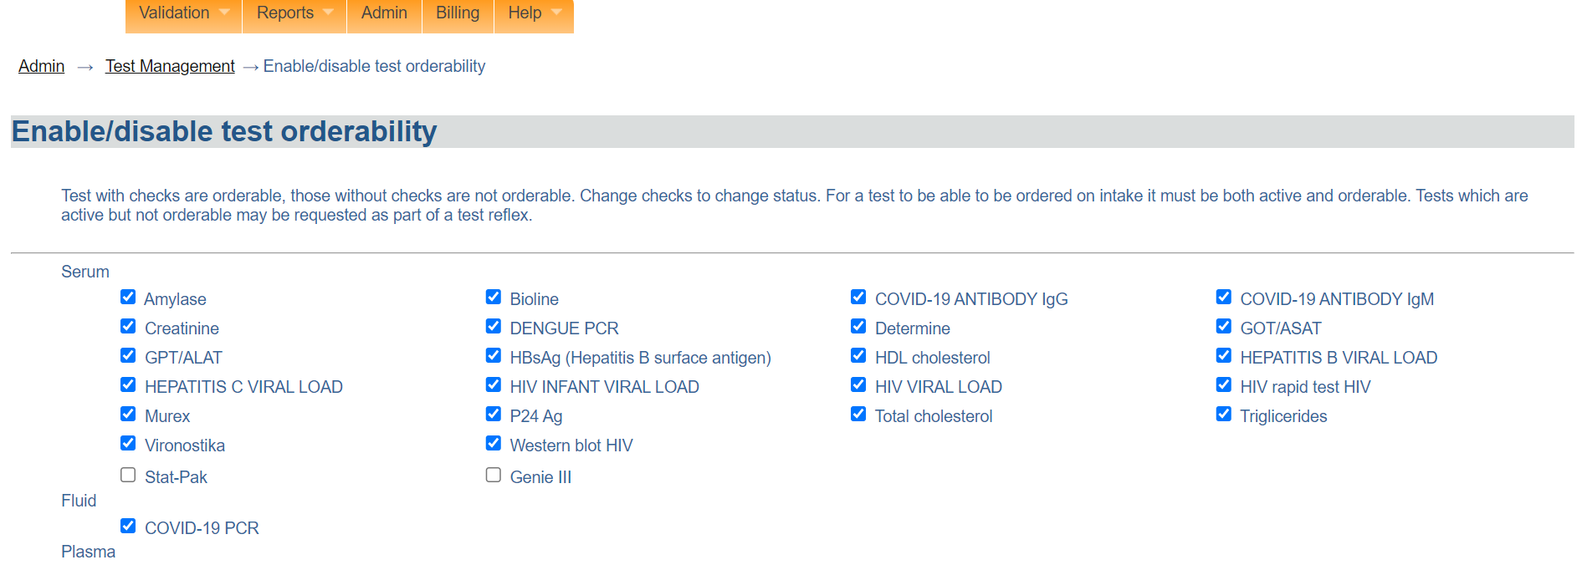

*Enable or disable test orderability page*

1. In this illustration, the orderability of the test **Stat-Pak** will be enabled by checking the checkbox.

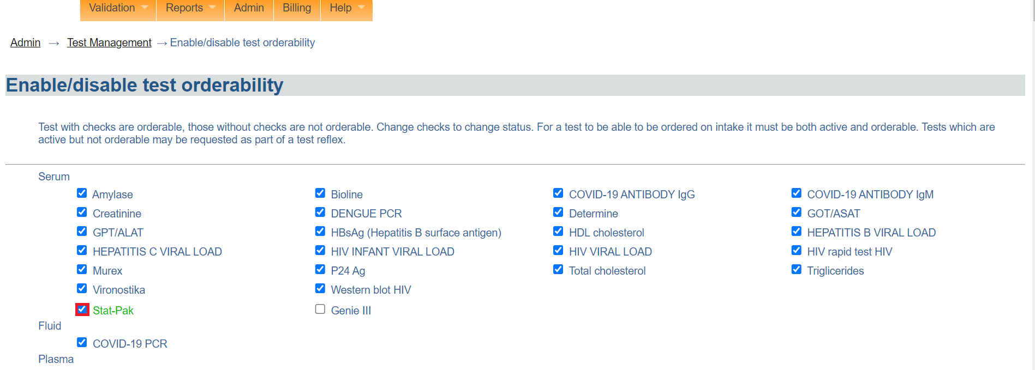

*Click on the test*

1. Click on the next button at the bottom of the page

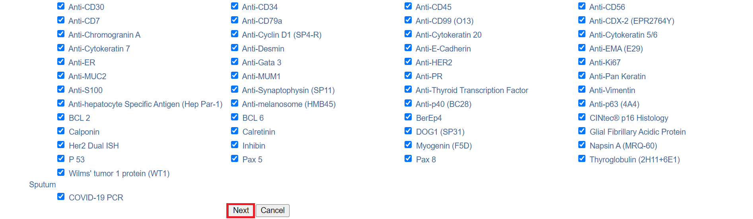

*Click next*

1. Click on the Accept button to verify that these are the changes you want to make. In test orderability will be enabled successfully.

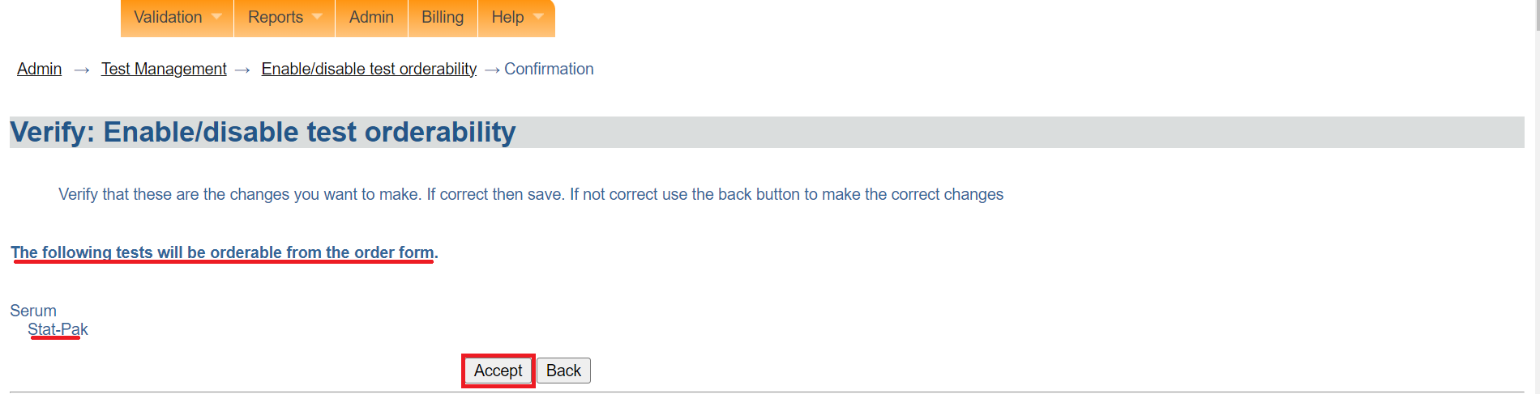

*Click accept*

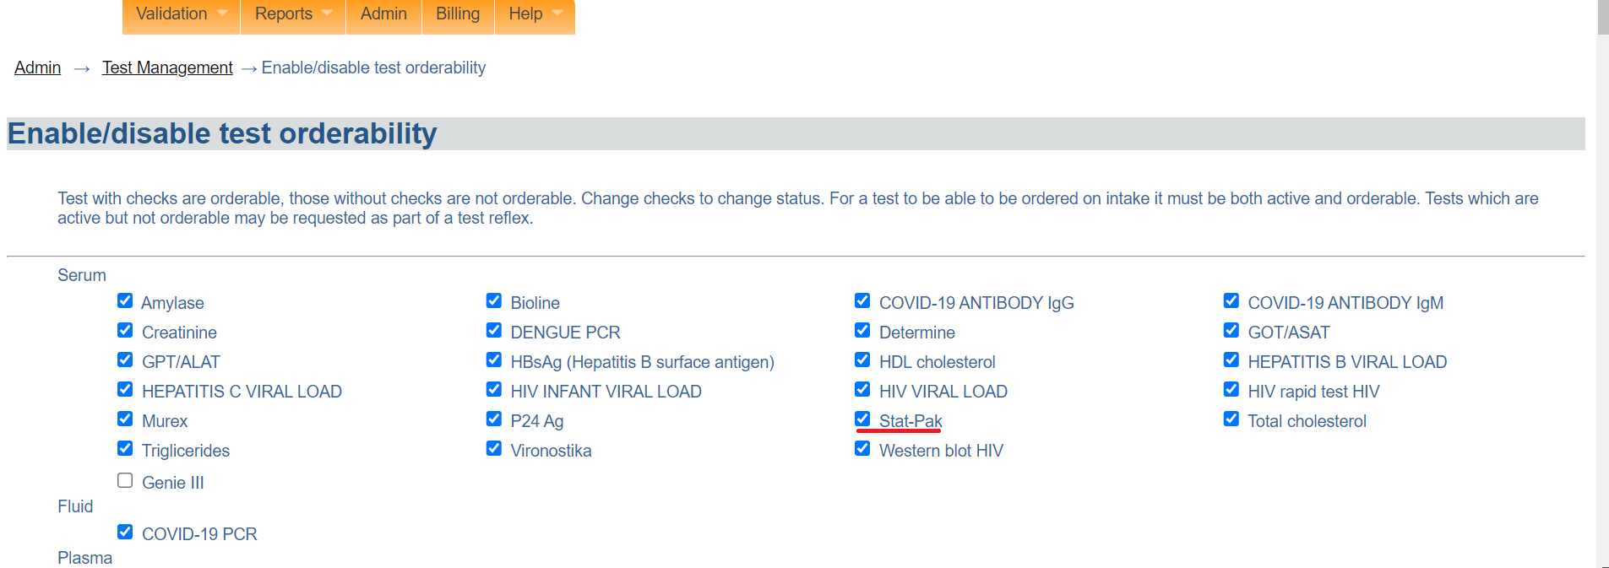

*Test orderability enabled*

1. To change the test orderability for a test, click on the checkbox of the desired test.

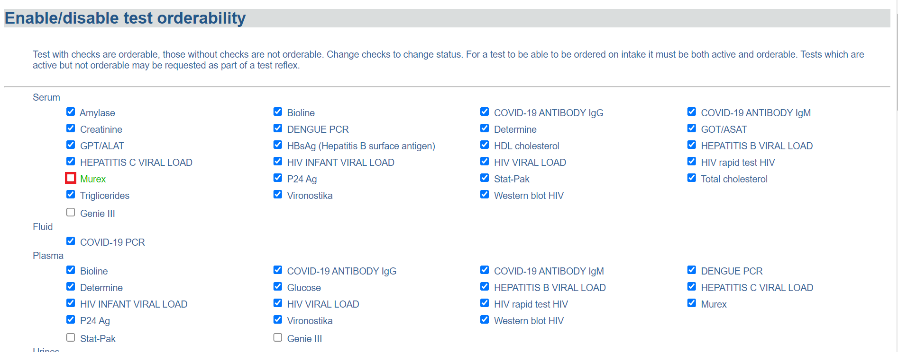

*Click on checkbox*

1. Click on the Next button.

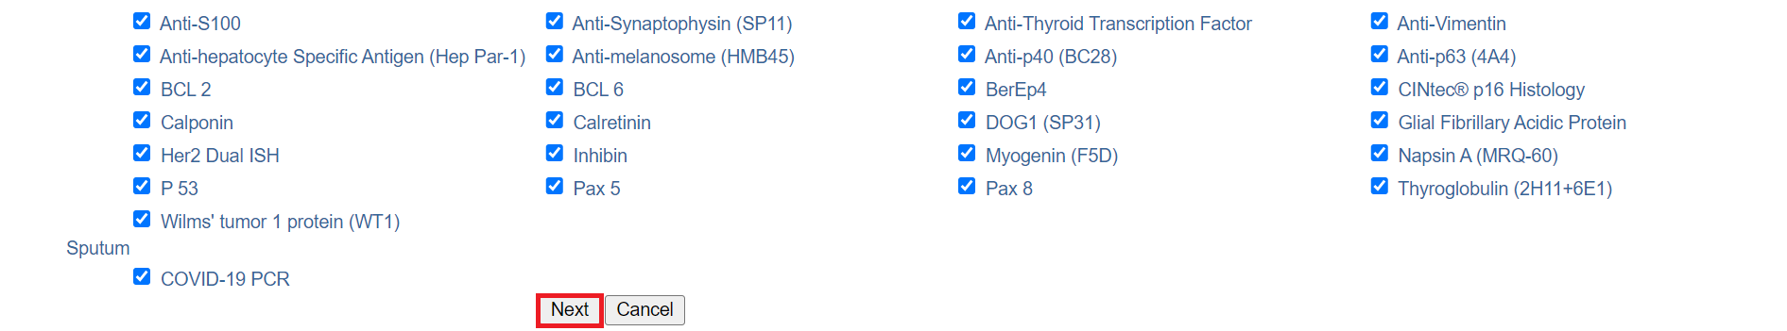

*Click next*

1. Click on the **Accept** button to verify that these are the changes you want to make. The test will be disabled successfully.

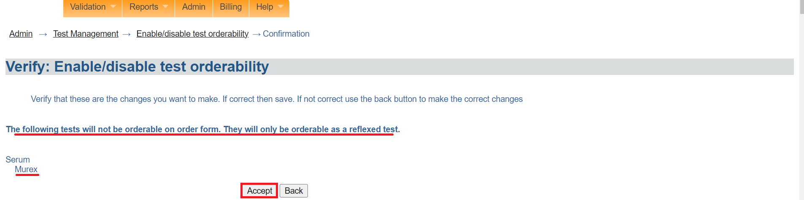

*Click accept*

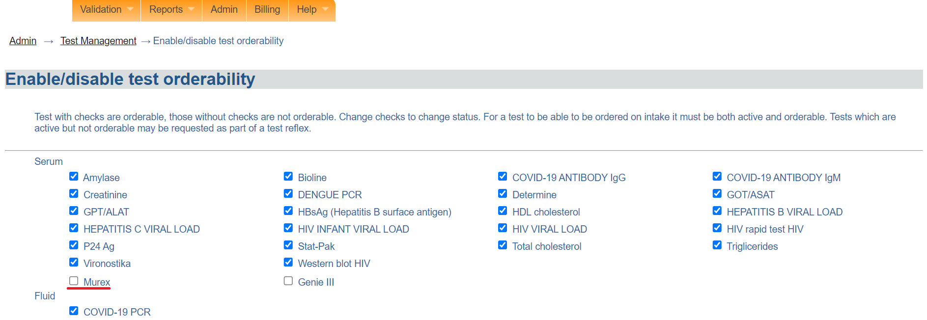

*Test disabled successfully*

## **Manage test units**

1. The manage test unit is used to create, set display order or assign tests to test units. To access the manage test unit, Follow steps 1 and 2 under [how to access the OpenELIS administrator module](https://docs.google.com/document/d/1oPIYxrLgoBi4prx2-Anhe1fm4x23_QQanpE_DqAVaVA/edit?pli=1#heading=h.but495evqliv). Click on manage test unit under the **test organization** section.

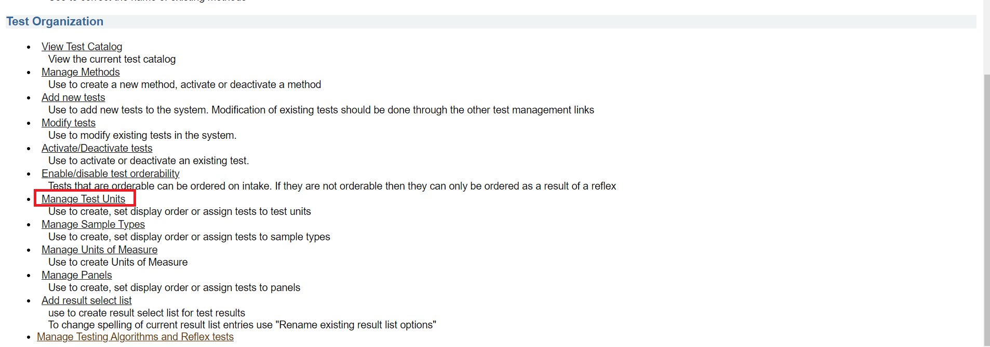

*Click manage test units*

### **How to create a new test unit**

1. Click on **create new test unit**  under the manage test unit page.

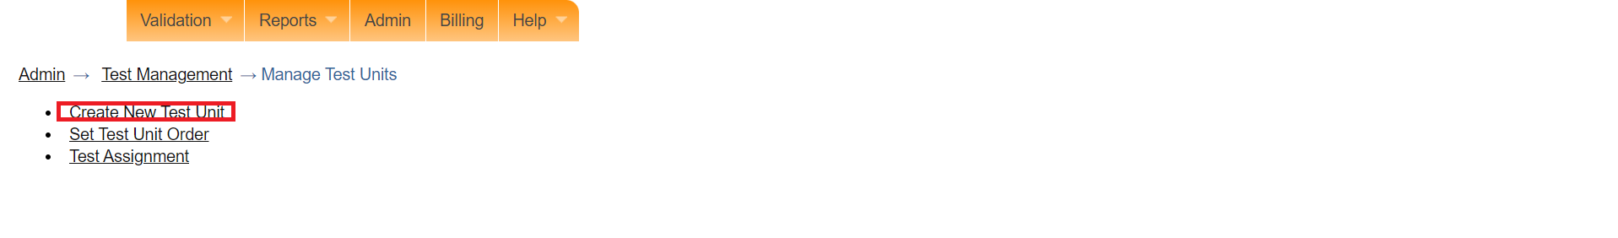

Click on create new test unit

1. Enter both the English and French names for the new test unit. In this illustration, “Test” is entered.

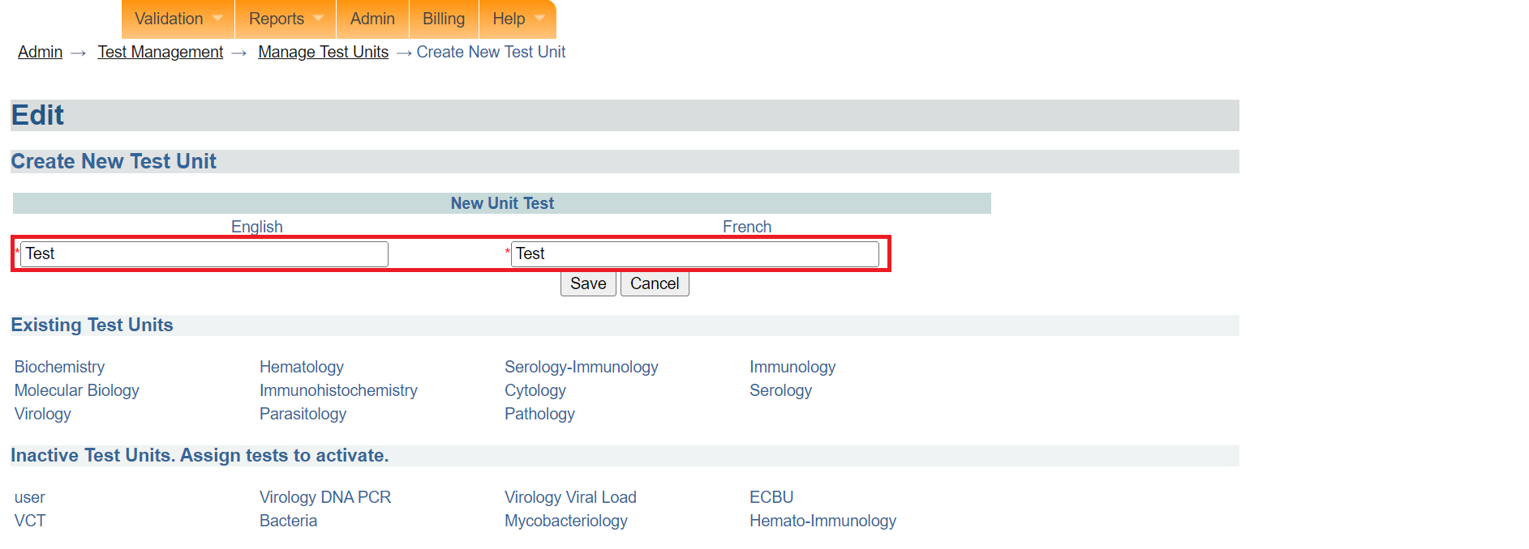

*Enter test unit names*

1. Click on the **Save** button.

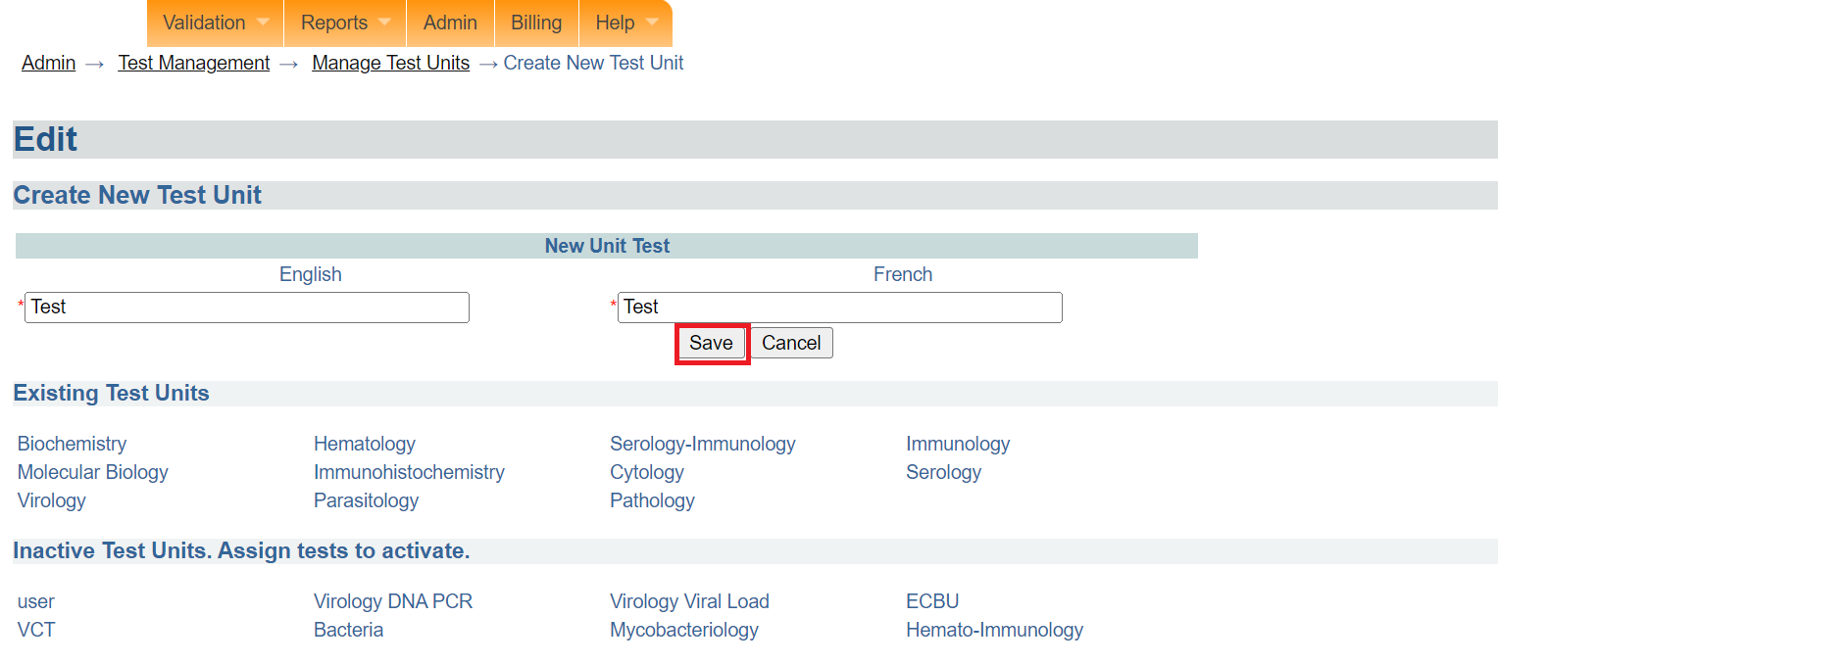

*Click save*

1. Click on the **Accept** button. The newly created test unit will be listed under the **inactive test units** section.

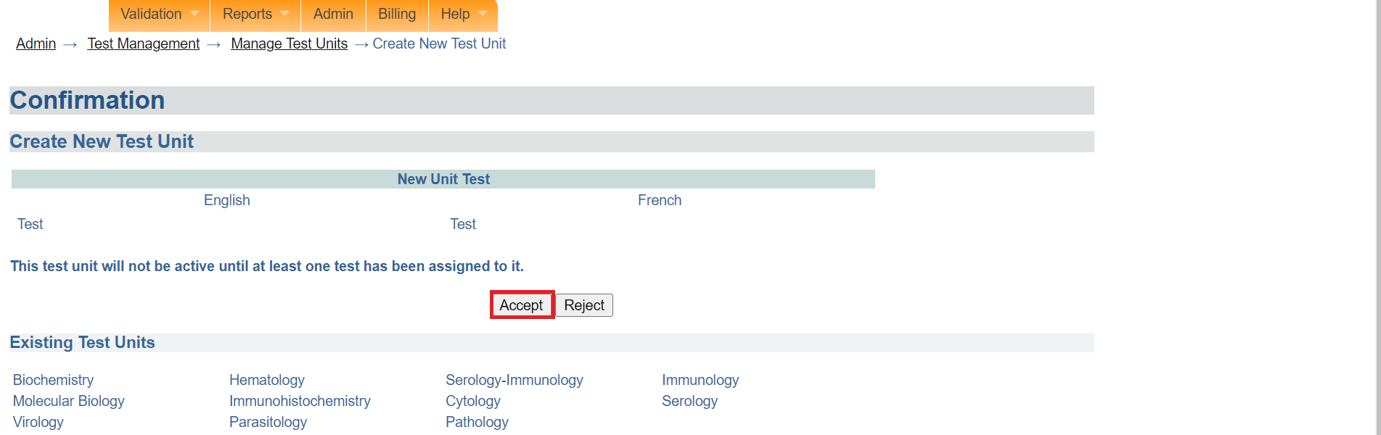

*Click accept*

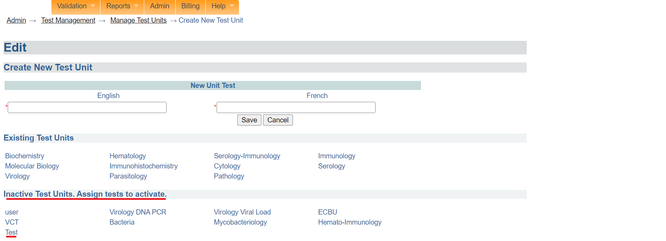

*Inactive test unit*

### **How to assign a test to a new test unit**

1. Click on the **test assignment** under the manage sample type page.

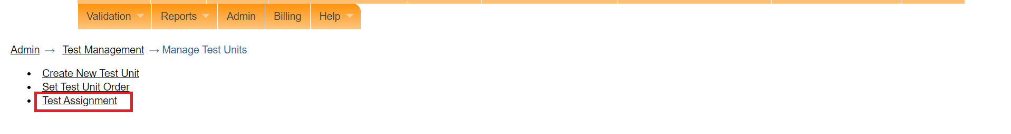

*Click test assignment*

1. Select the test to re-assign to a different lab unit by clicking the test name. In this illustration, **Amylase (serum)** under Biochemistry Is clicked.

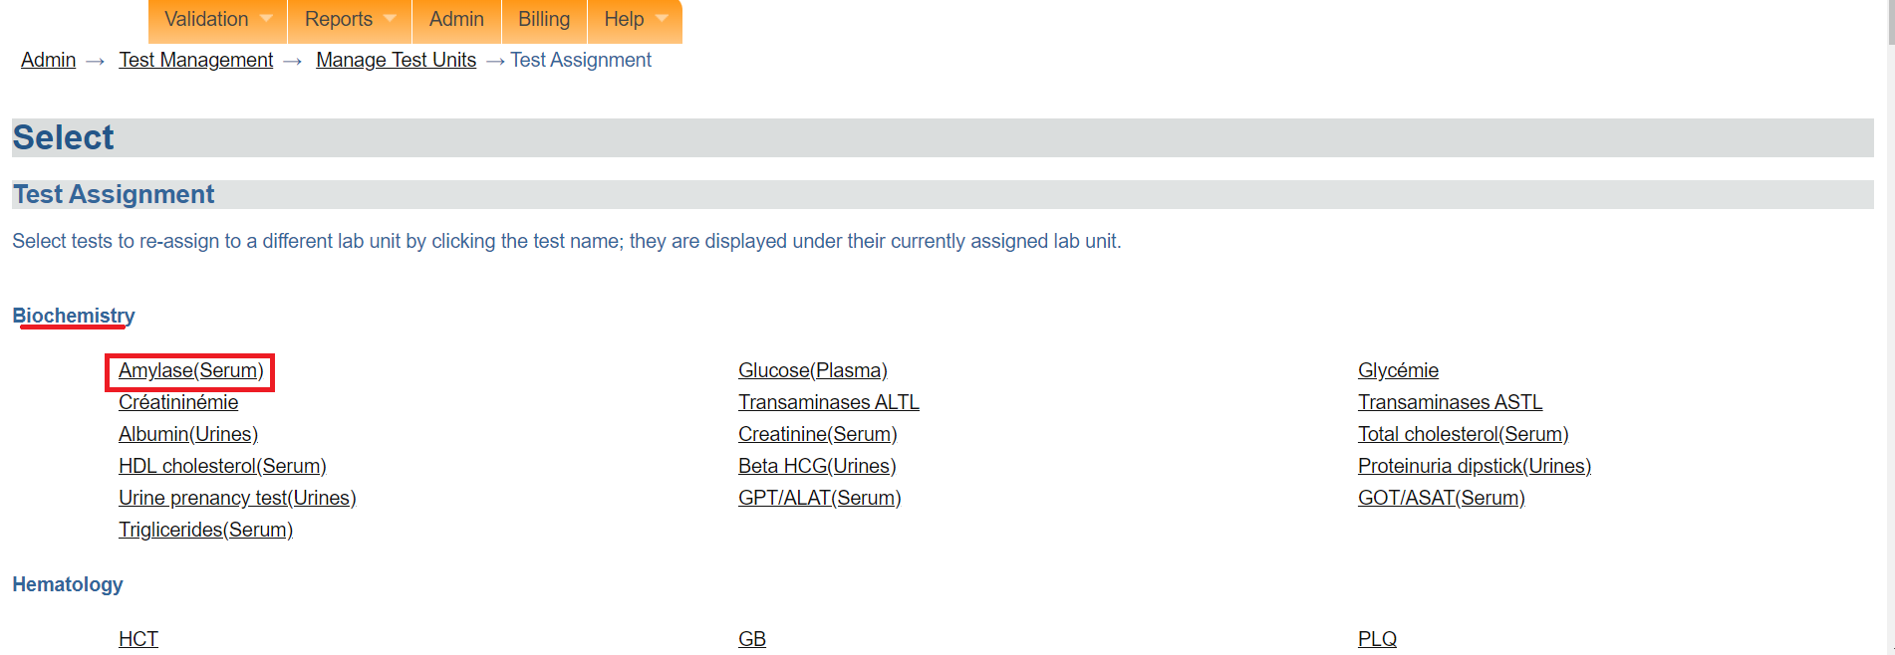

*Click test to re-assign*

1. Select the test unit from the assign test section drop-down menu.

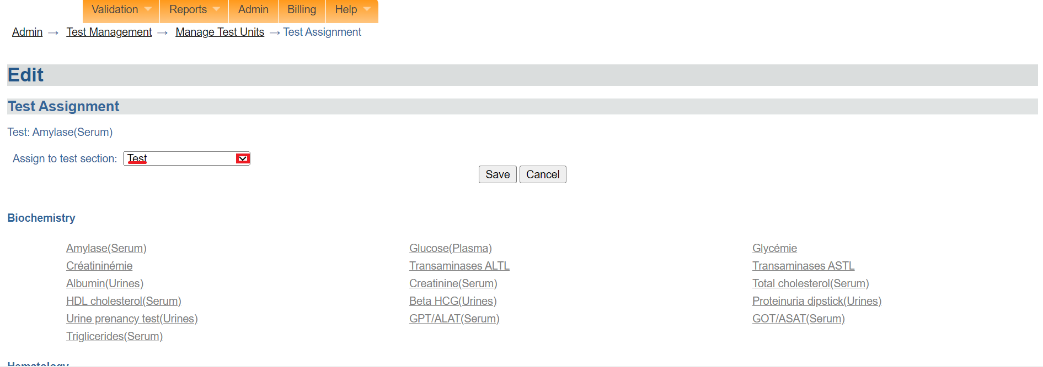

*Assign to test section*

1. Click on the **Save** button.

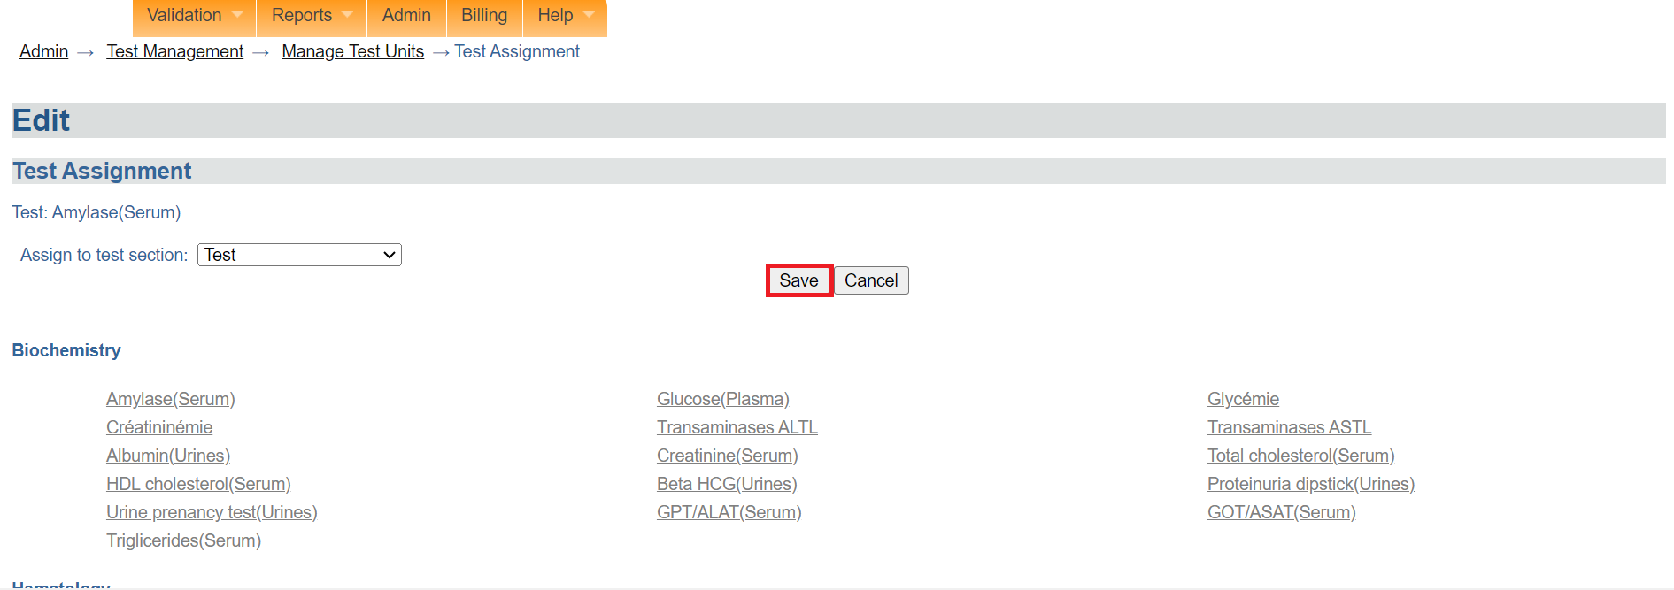

*Click save*

1. Click on the **Accept** button. The test will be reassigned to the newly created test unit.

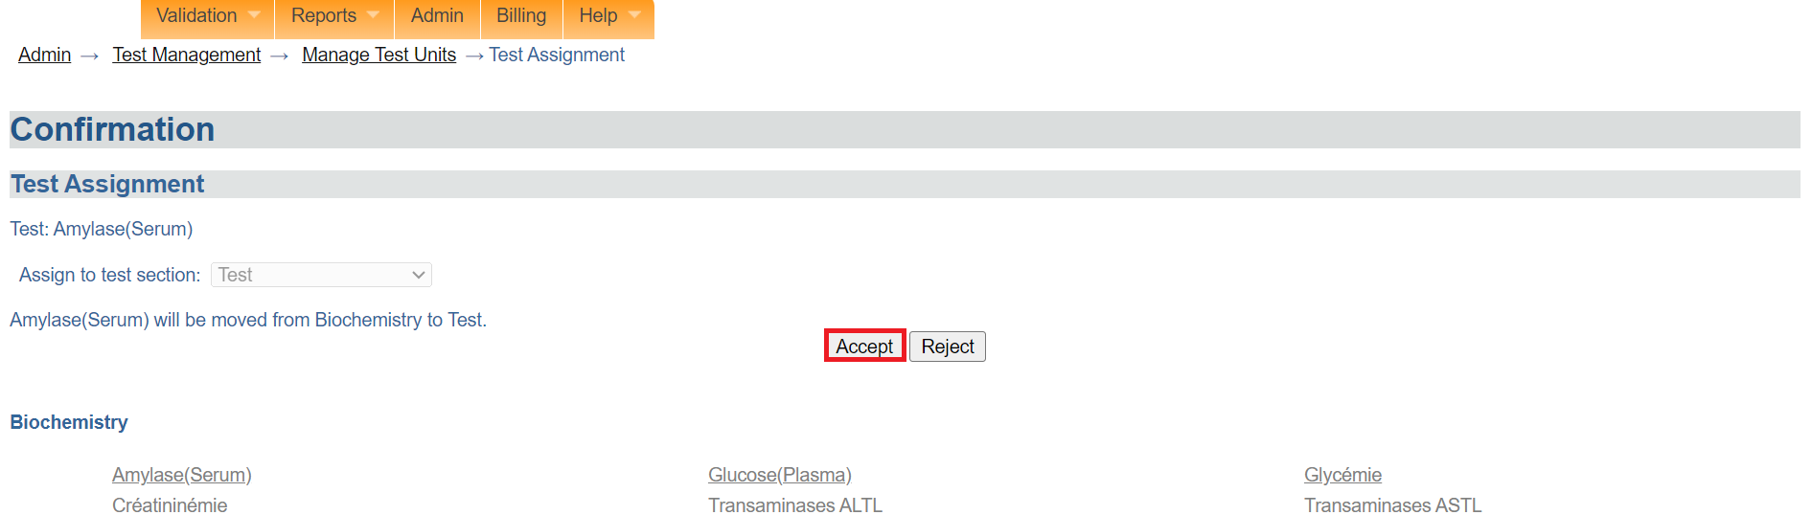

*Click accept*

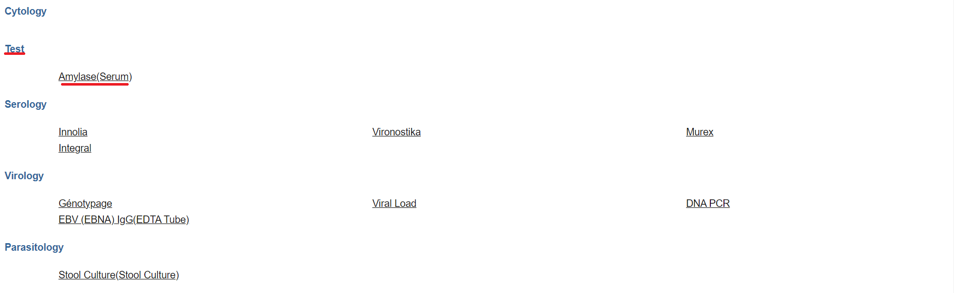

*Test reassigned to new test unit*

### **How to set test unit order**

1. Click on **Set test unit order**

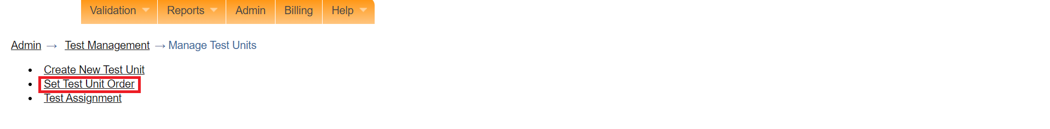

*Click set sample type order*

1. To reorder the display,click on a sample and drag the position using the arrow to the position you desire. In this illustration, the **test** unit position will be repositioned to the bottom .

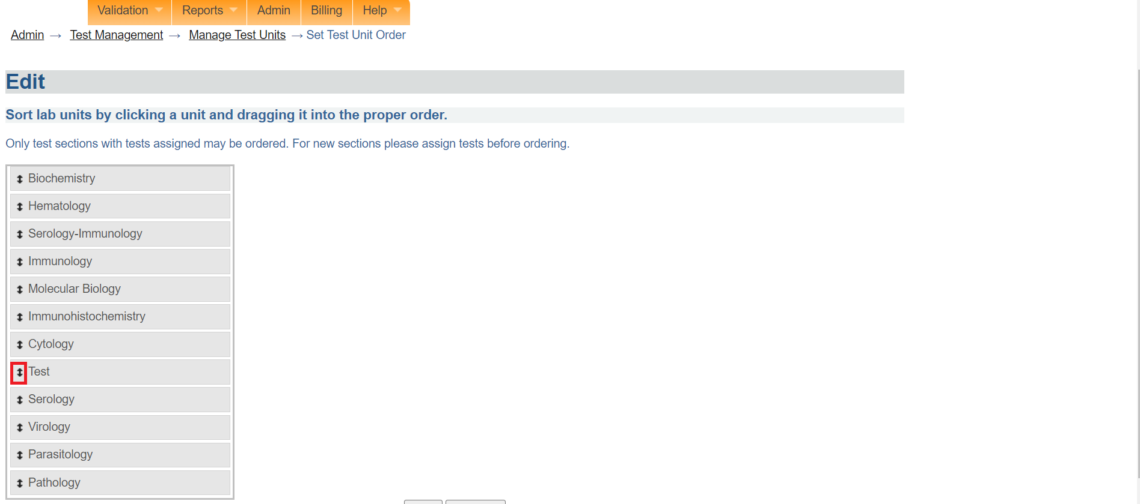

*Click to drag position*

1. Notice the position of the  **test** unit. Click on the **Next** button.

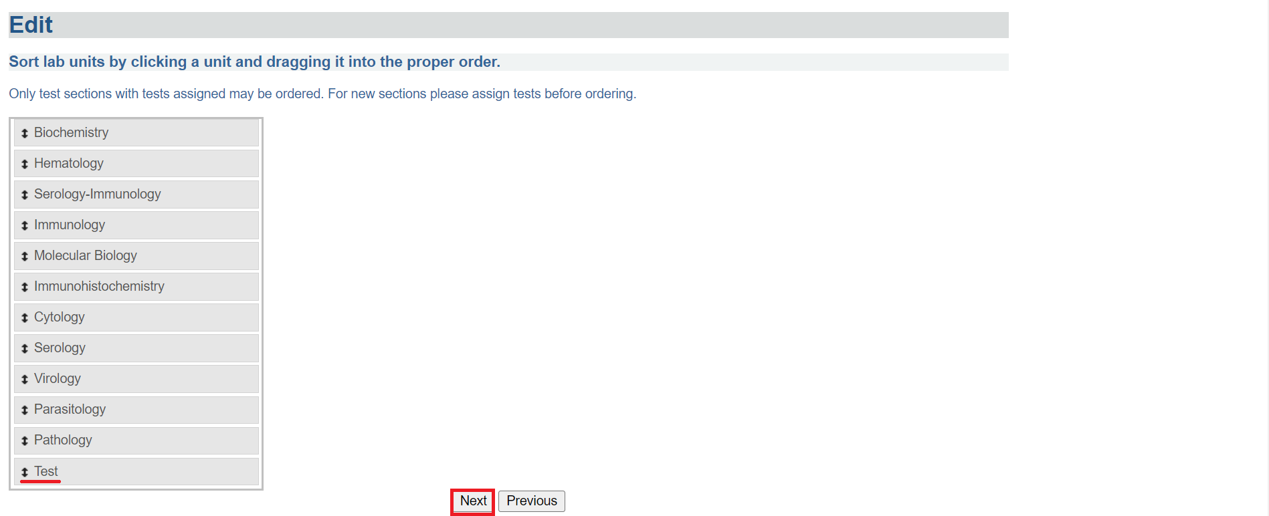

*Click next*

1. Click on the **Accept** button.

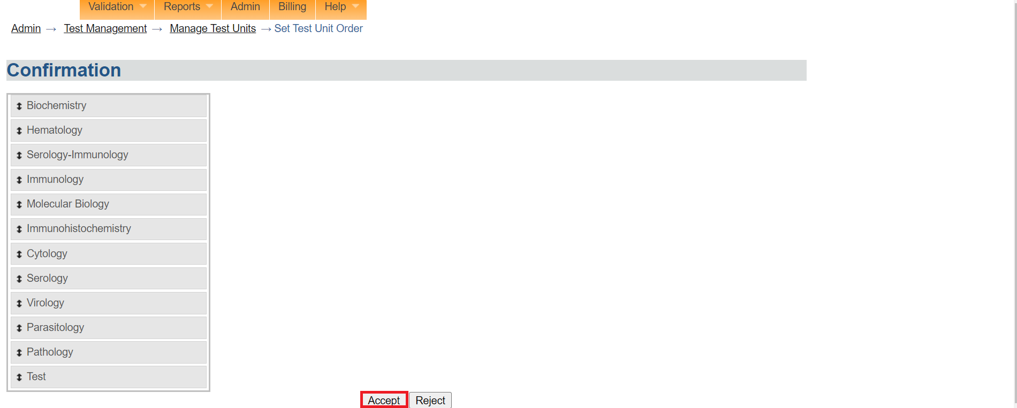

*Click accept*

## **How to add result select list**

1. The add result select list is used to create a result select list for available tests. To access the add result select list, Follow steps 1 and 2 under [how to access the OpenELIS administrator module](https://docs.google.com/document/d/1oPIYxrLgoBi4prx2-Anhe1fm4x23_QQanpE_DqAVaVA/edit?pli=1#heading=h.but495evqliv). Click on add result select list under the **test organization** section.

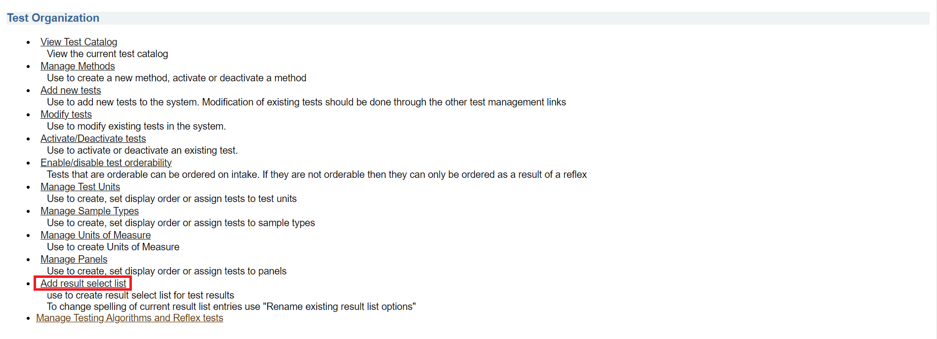

*Click add result select list*

1. Enter both English and French for the new selection you wish to add the list to. In this illustration, **test** has been entered.

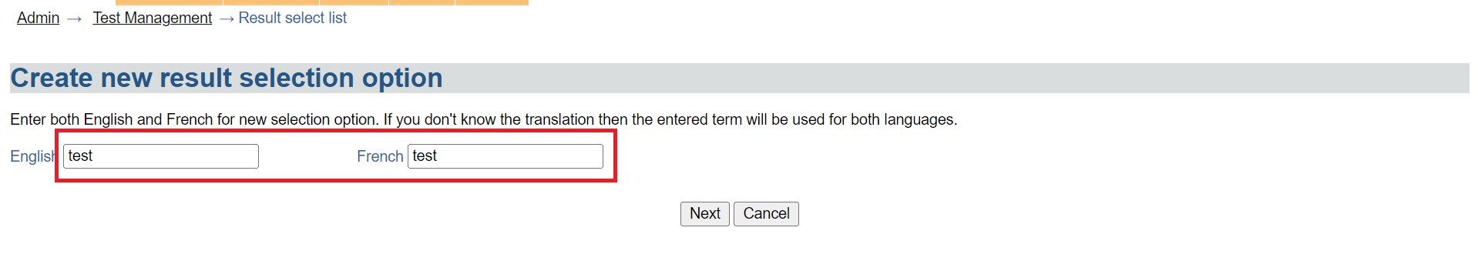

*Enter name for selection*

1. Click on the **Next** button.

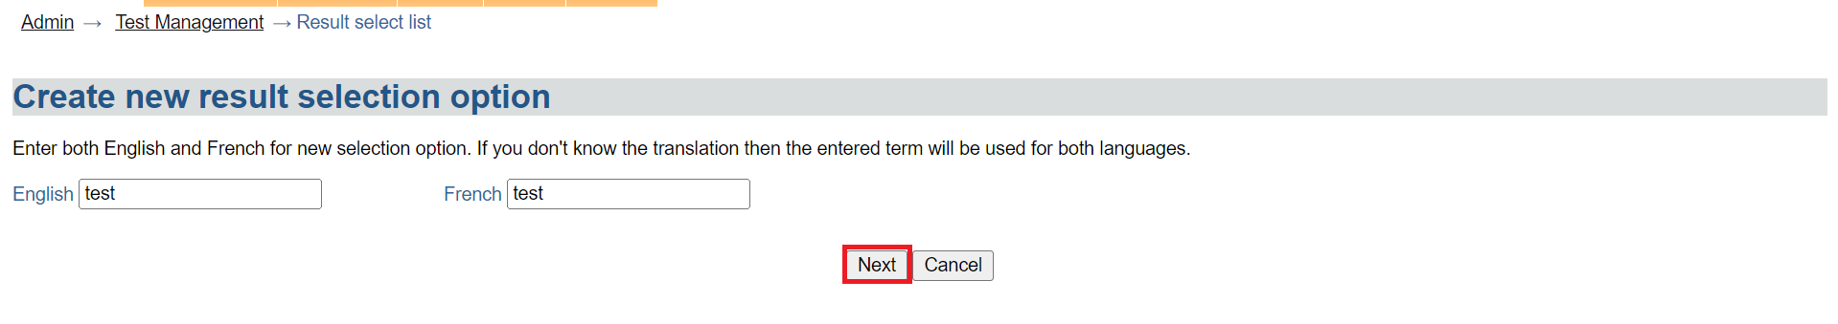

*Click next*

1. Click on the **Save** button.

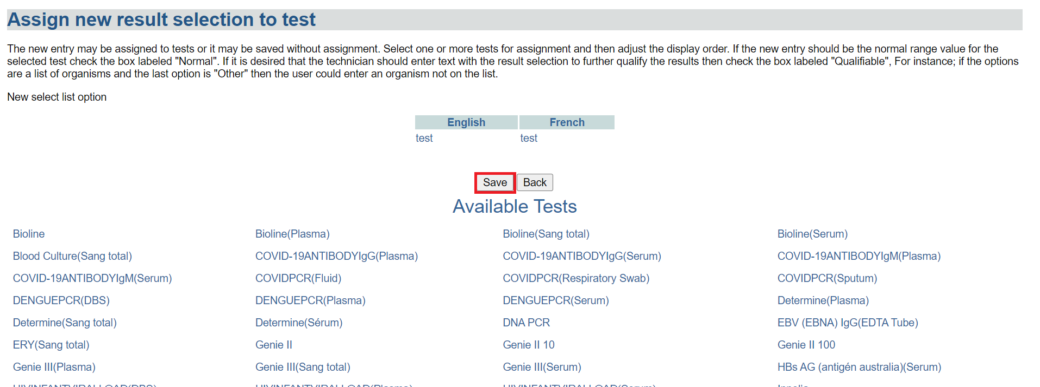

*Click save*

1. To assign the new result, click on an available test.

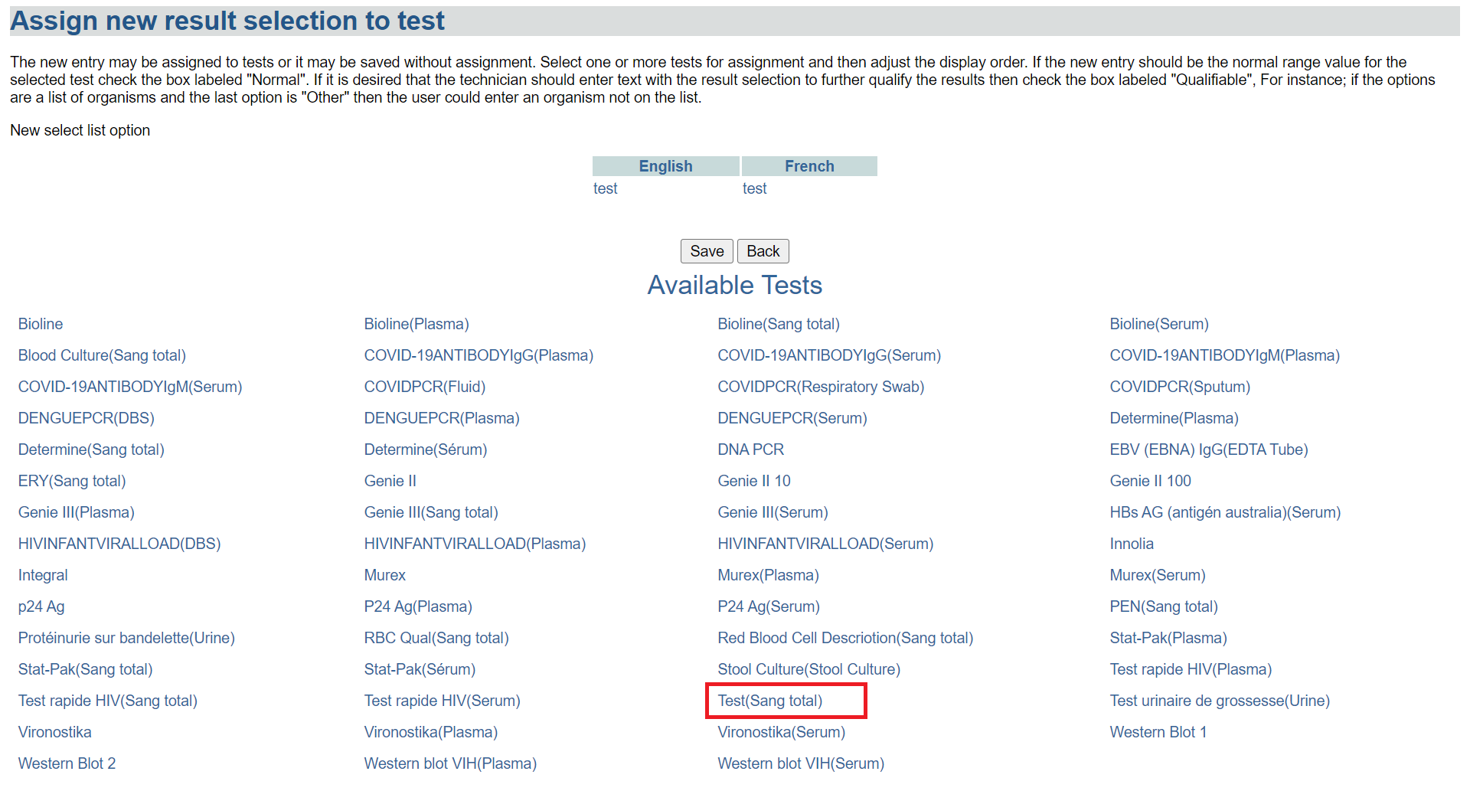

*Click on an a test*

1. The result “**test**” will be added to the available test. Click on the **save** button.

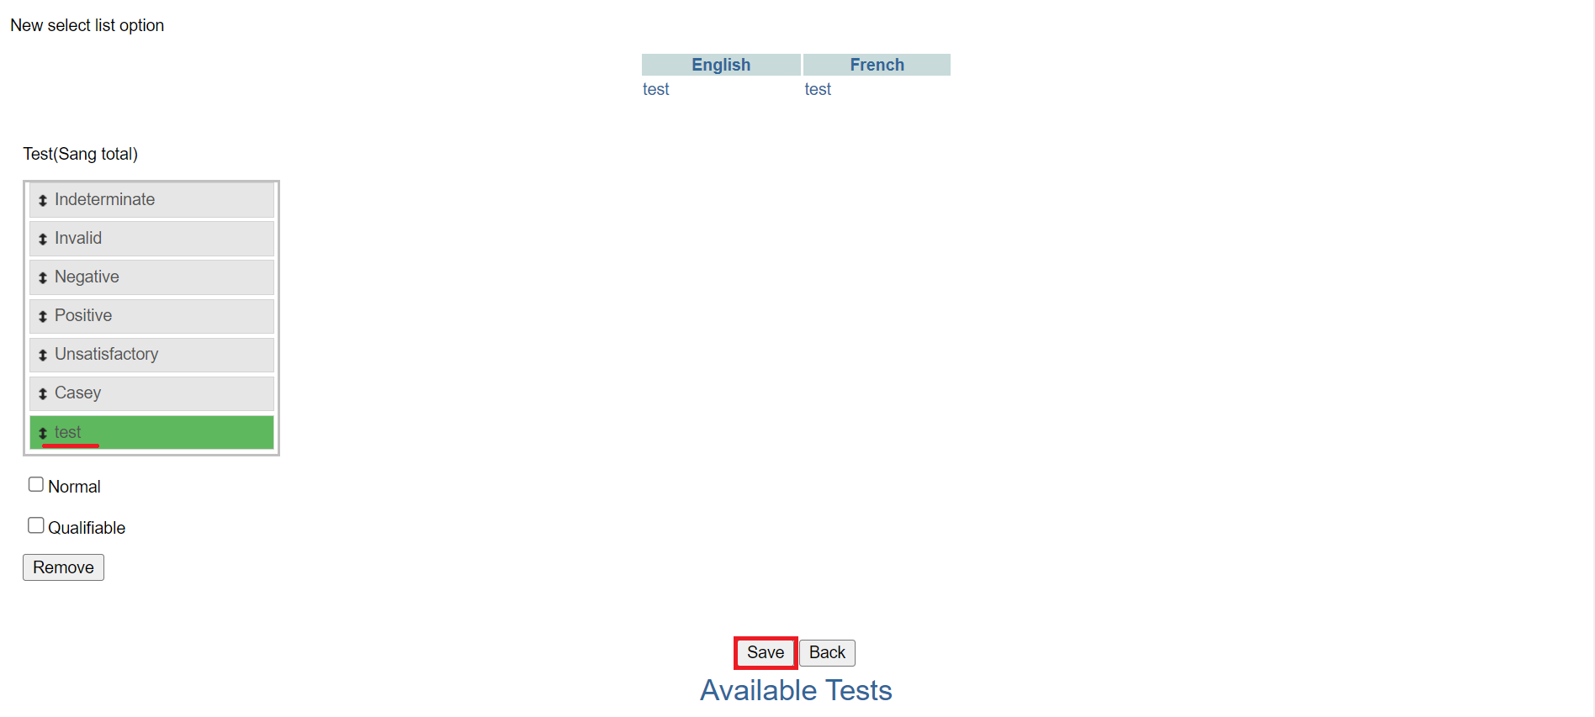

*Click save*

1. Click on the Accept button. The result will be added successfully. The select list option can now be assigned to a new test.

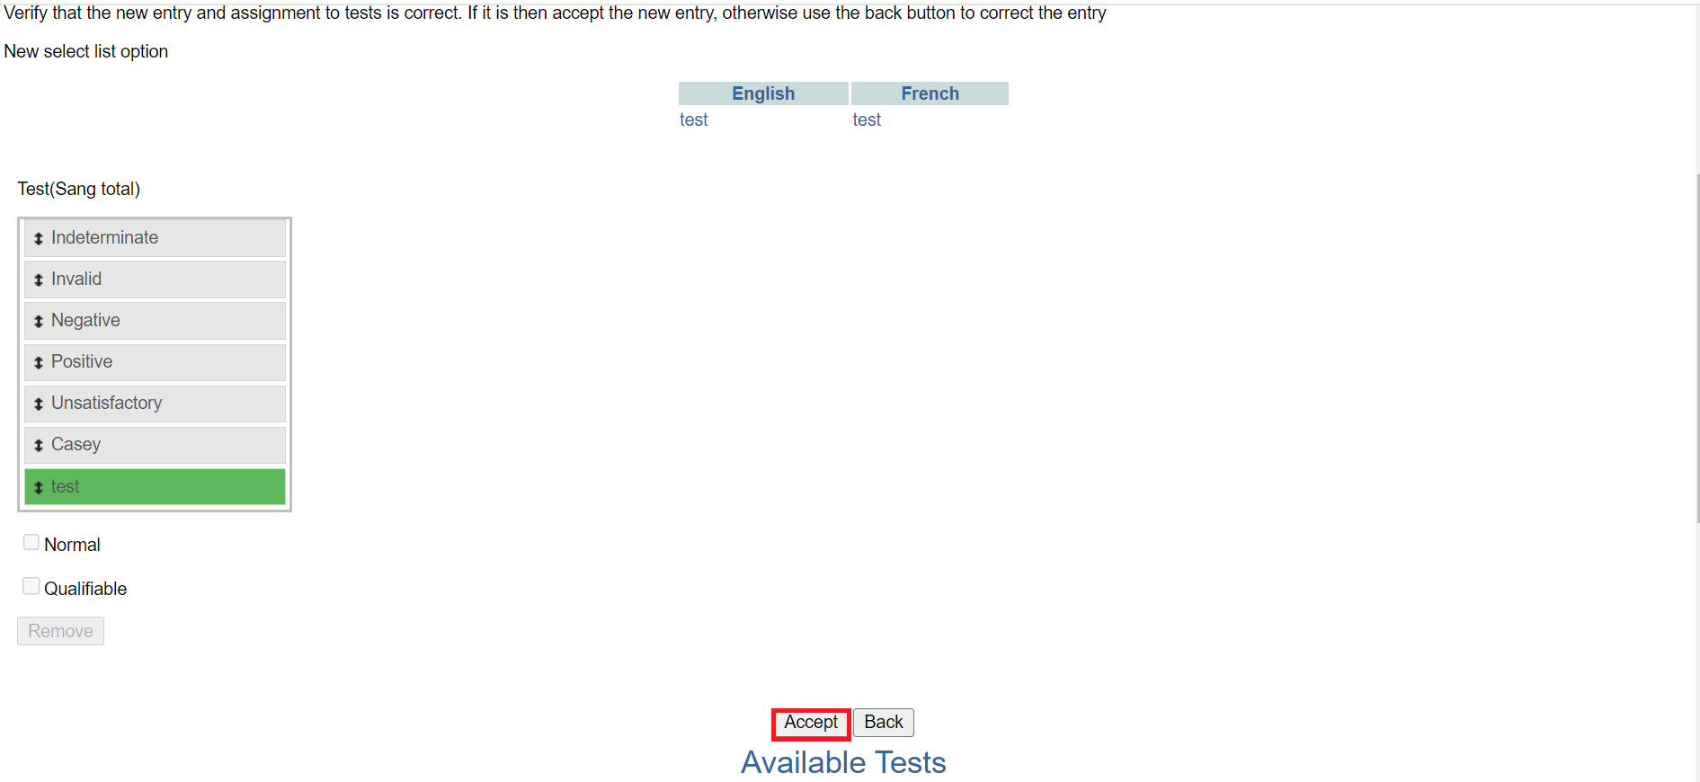

*Click accept*

## **Manage sample types**

1. The manage sample type is used to create, set display order or assign tests to sample types. To access the add result select list, Follow steps 1 and 2 under [how to access the OpenELIS administrator module](https://docs.google.com/document/d/1oPIYxrLgoBi4prx2-Anhe1fm4x23_QQanpE_DqAVaVA/edit?pli=1#heading=h.but495evqliv). Click on add result select list under the **test organization** section.

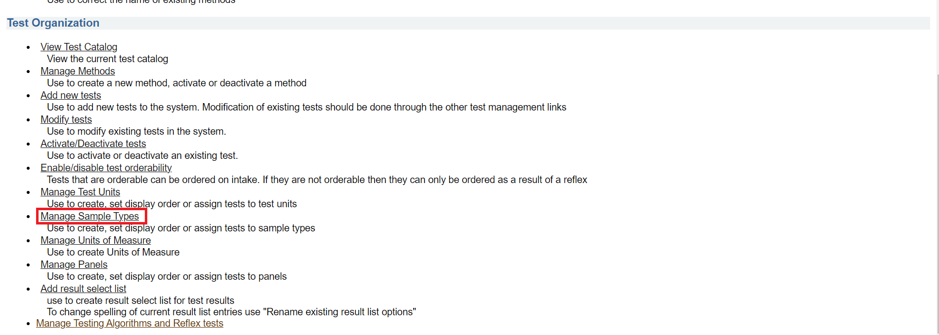

*Click manage sample types*

### **How to create a new sample type**

1. Click on c**reate a new sample type** under the manage sample type page

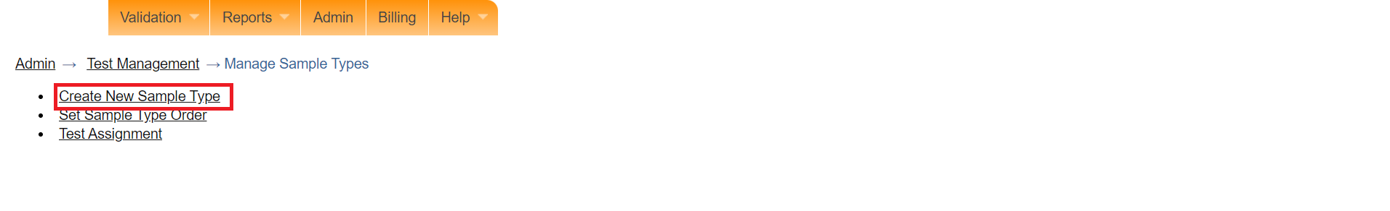

*Click create new sample type*

1. Enter both the English and French names for the new sample type. In this illustration, a purple top vacutainer is entered.

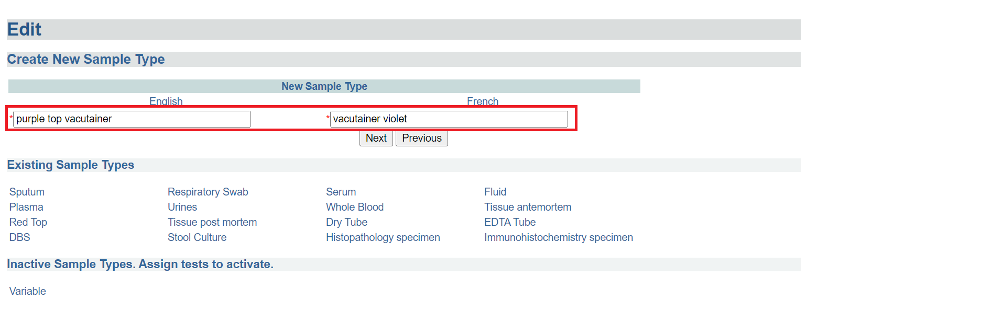

*Enter sample names*

1. Click on the Next button.

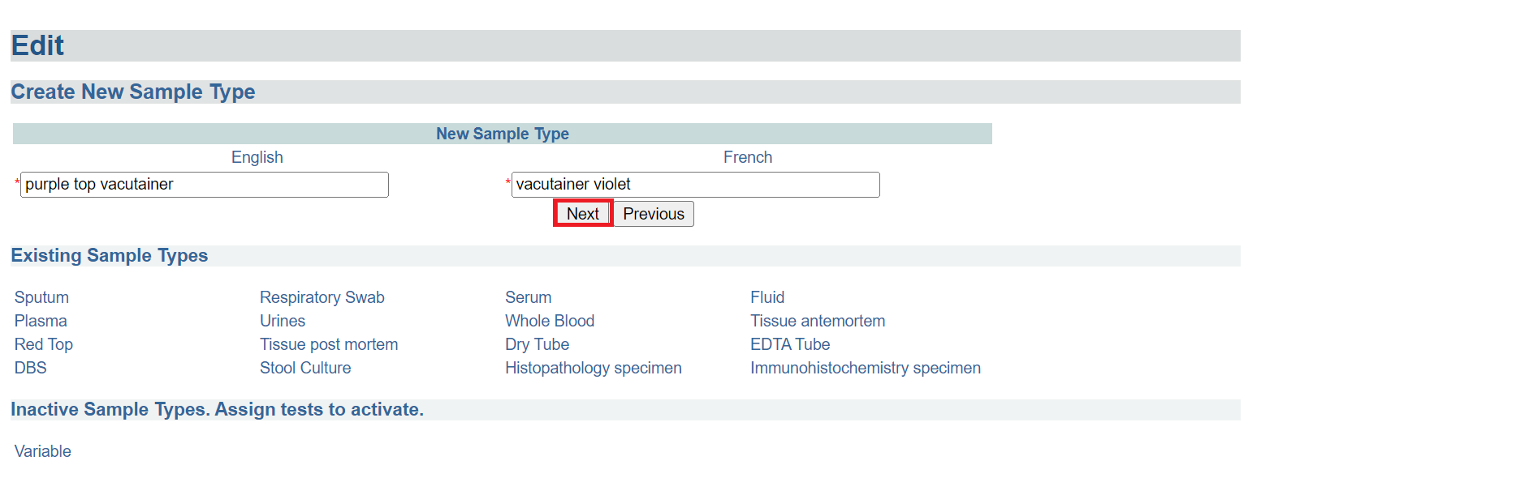

Click next

1. Click on the **Accept** button. The newly created sample type will be listed under the **inactive sample types** section.

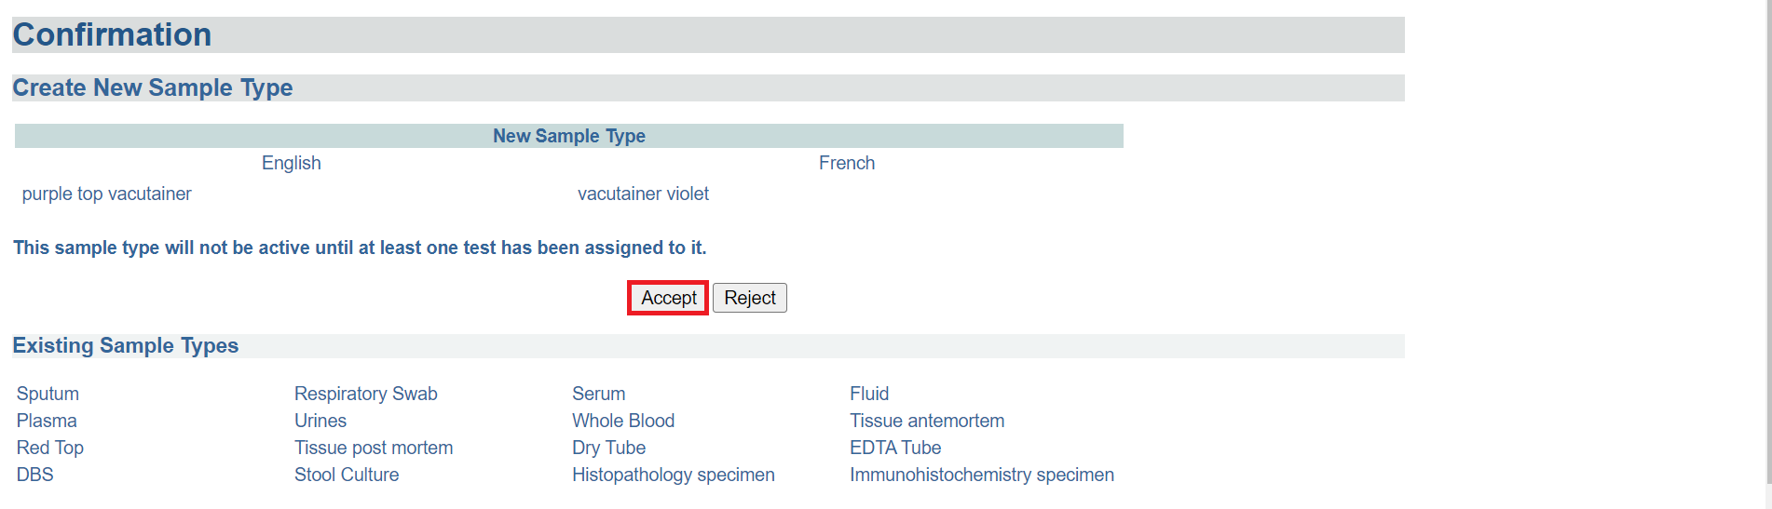

*Click accept*

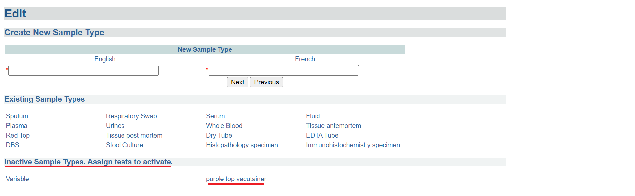

*Inactive sample*

### **How to assign a test to a new sample type**

1. Click on the **test assignment** under the manage sample type page.

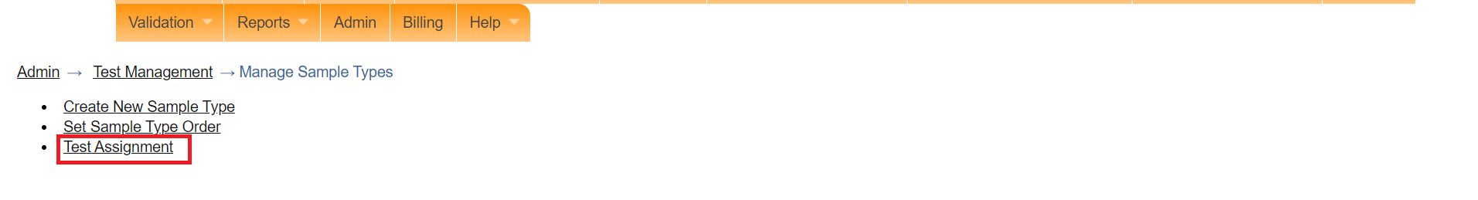

*Click test assignment*

1. Click on a test under the test assignment page. In this illustration, Blood count (serum)

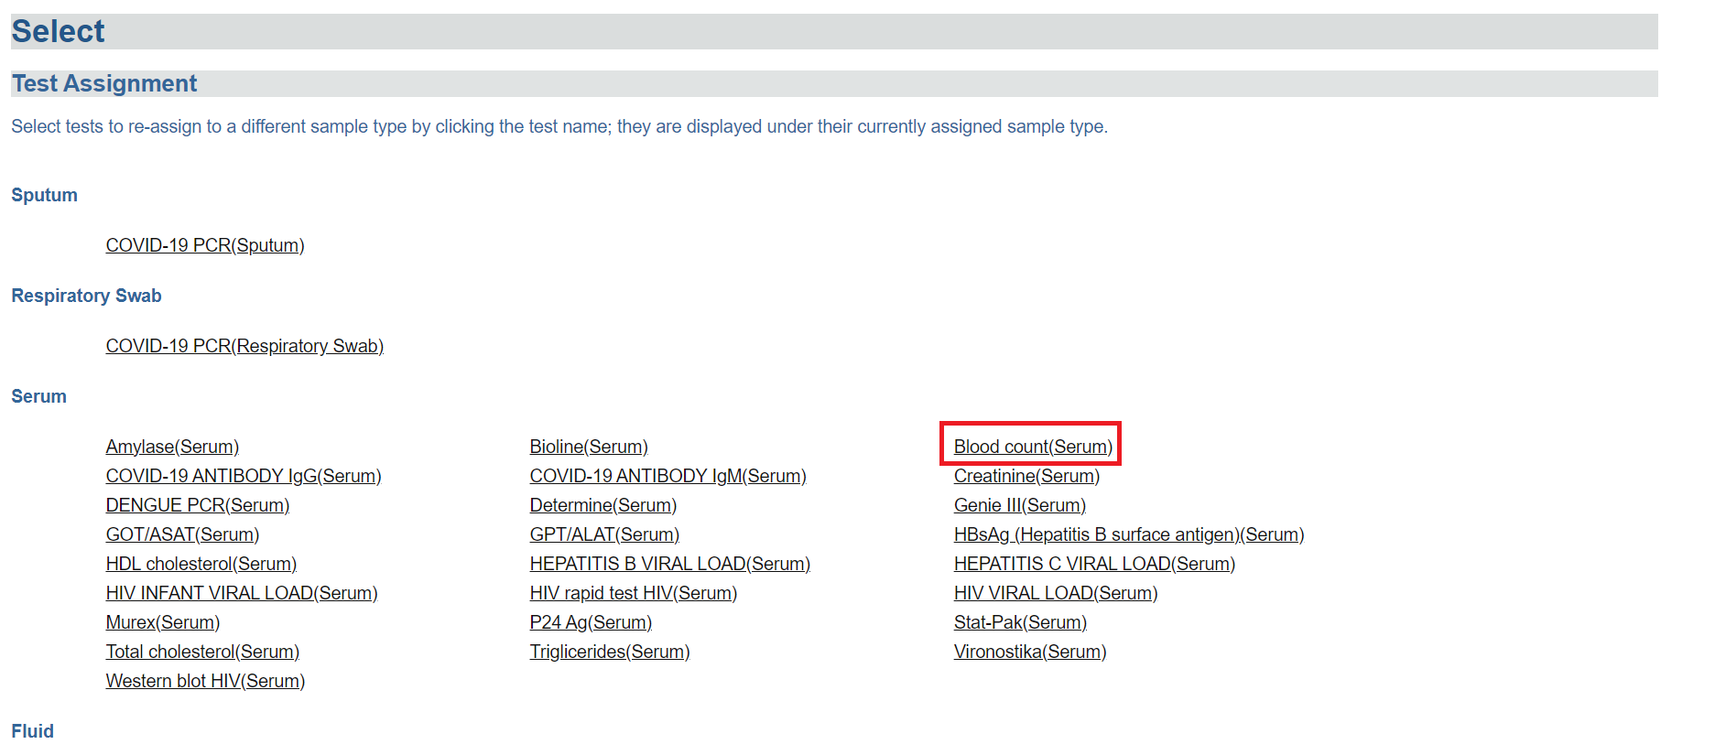

*Click on a test*

1. Select the sample type to assign from the dropdown menu. The **purple top vacutainer** is selected.

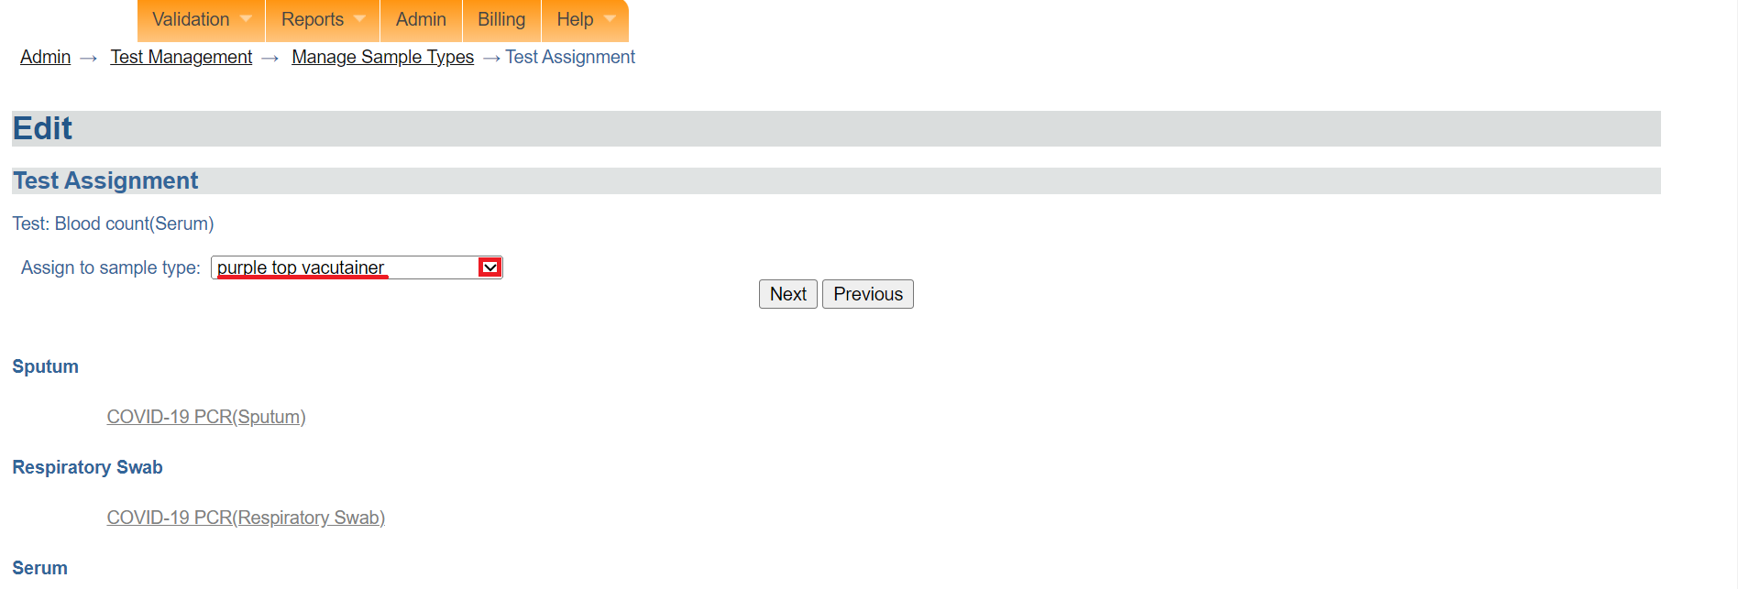

*Select sample type*

1. Click on the **Next** button.

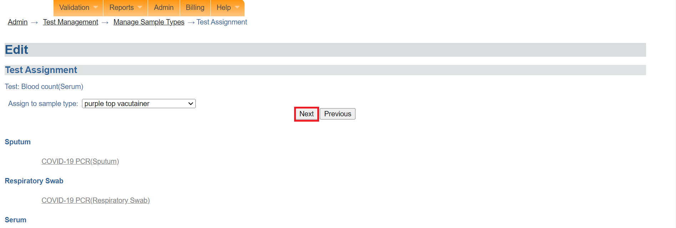

*Click next*

1. Click on the  **Accept** button. The test will be added to the sample.

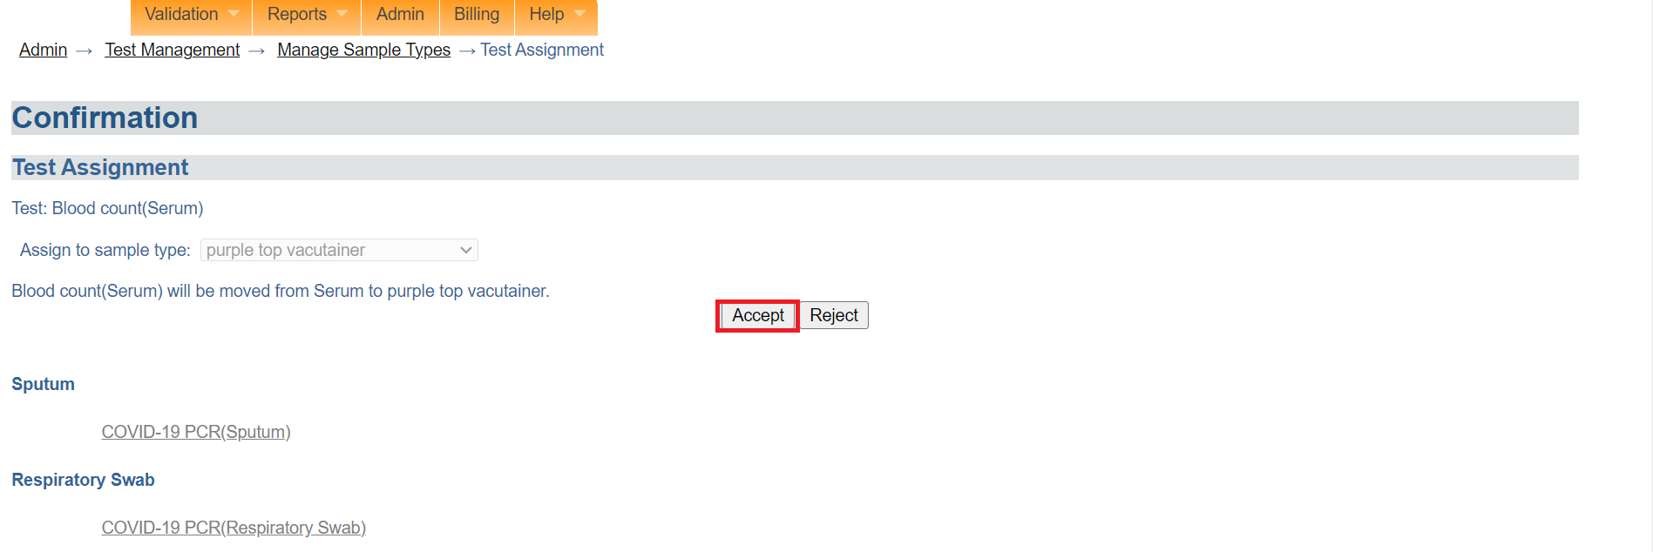

*Click accept*

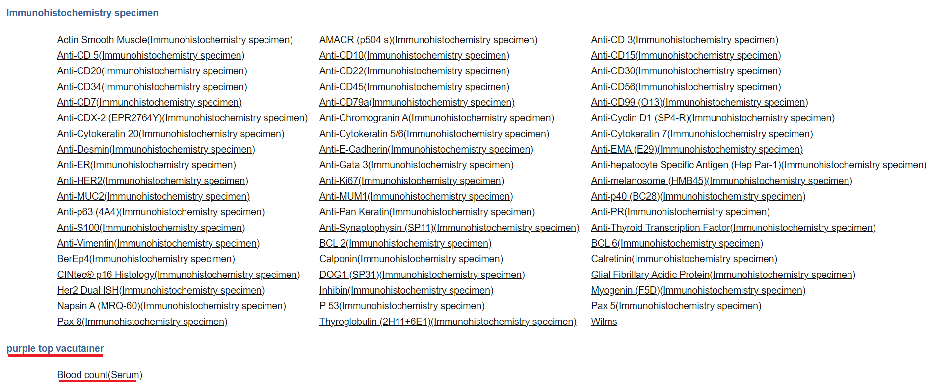

*Test added to sample type*

Note: The laboratory team can now access the newly created sample type.

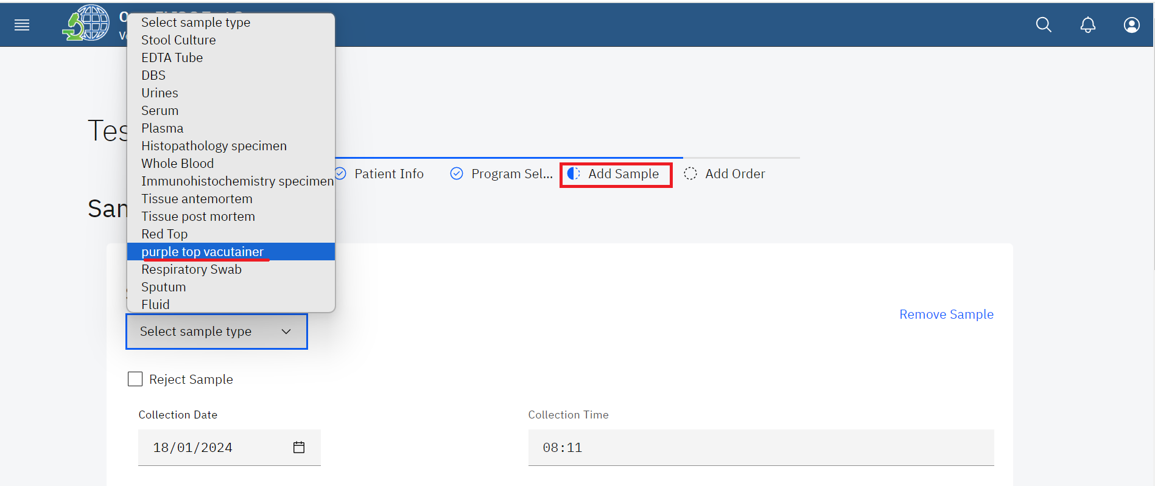

*Adding the new sample to an order*

### **How to establish the display order for samples**

1. Click on **Set Sample Type Order**

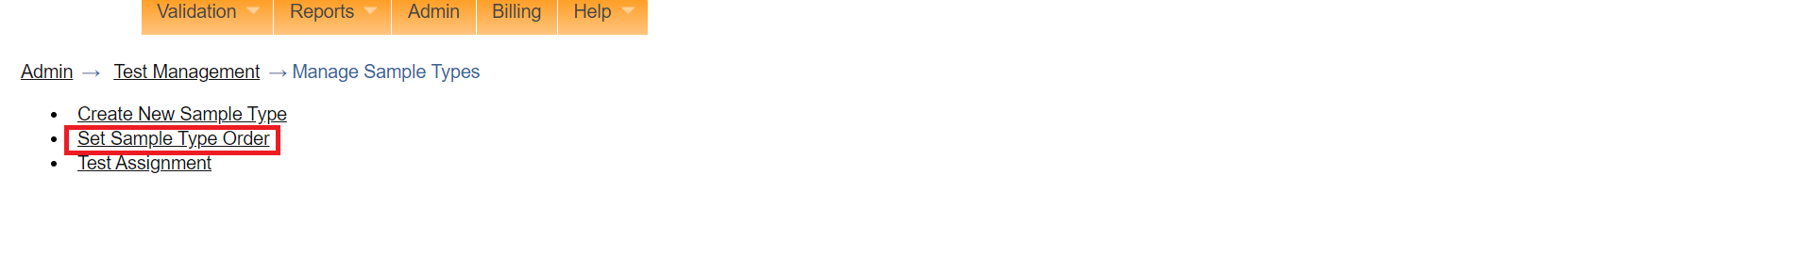

*Click set sample type order*

1. To reorder the display,click on a sample and drag the position using the arrow to the position you desire. In this illustration, the **purple top vacutainer** sample type position will be repositioned to the bottom .

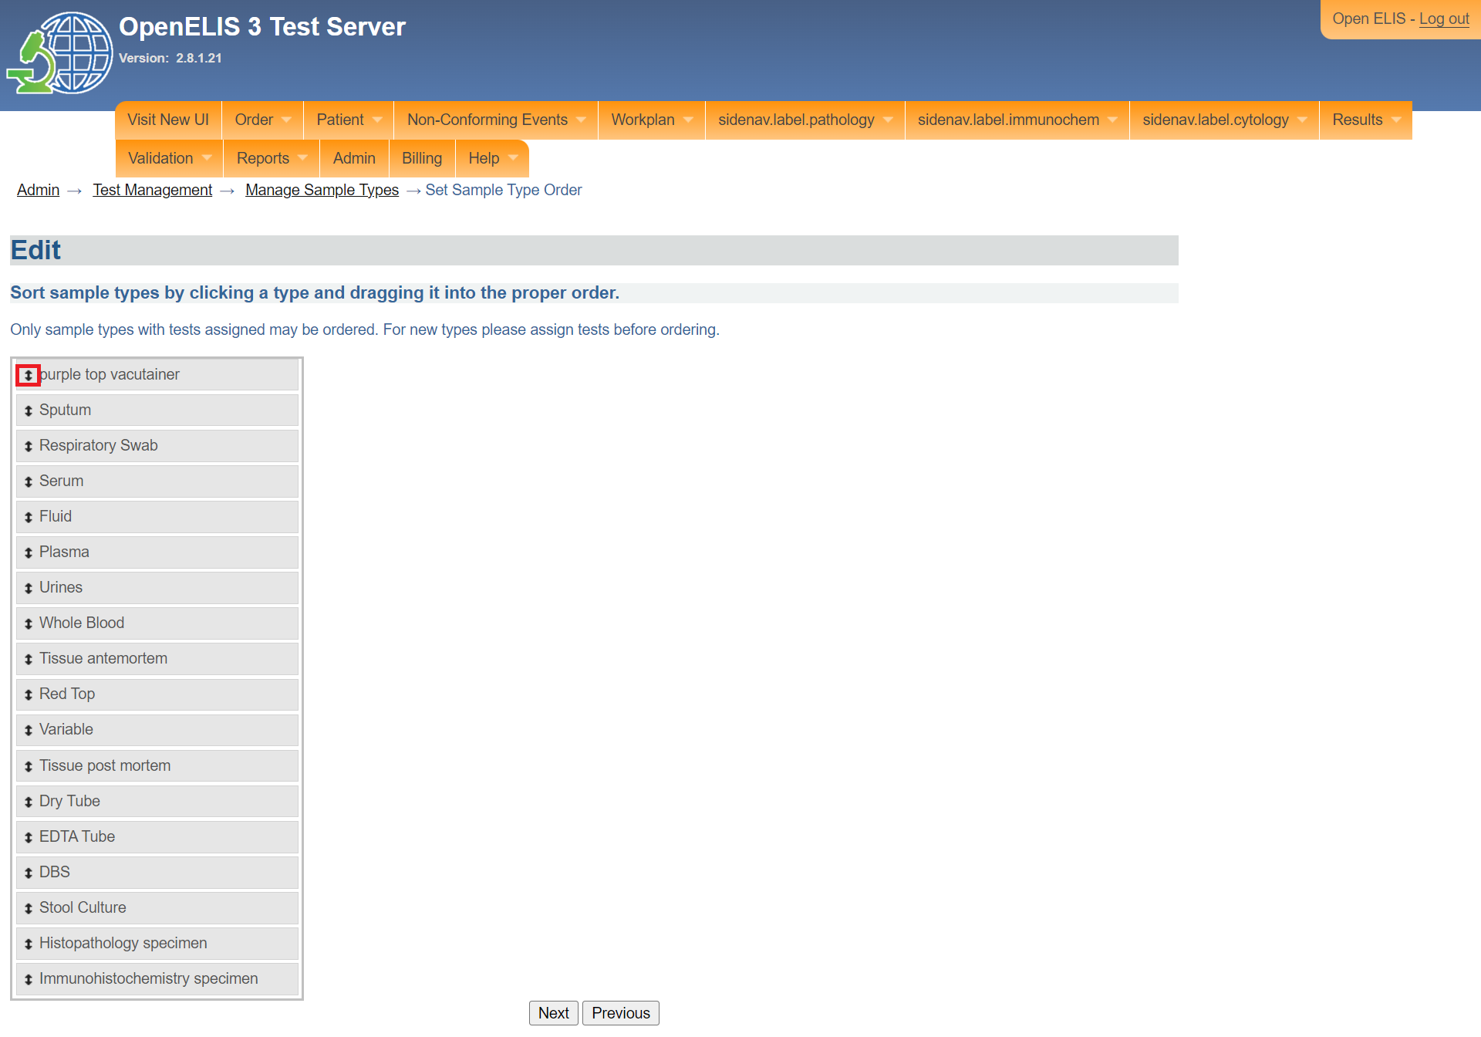

*Click to drag position*

1. Notice the position of the purple **top vacutainer** sample type. Click on the **Next** button.

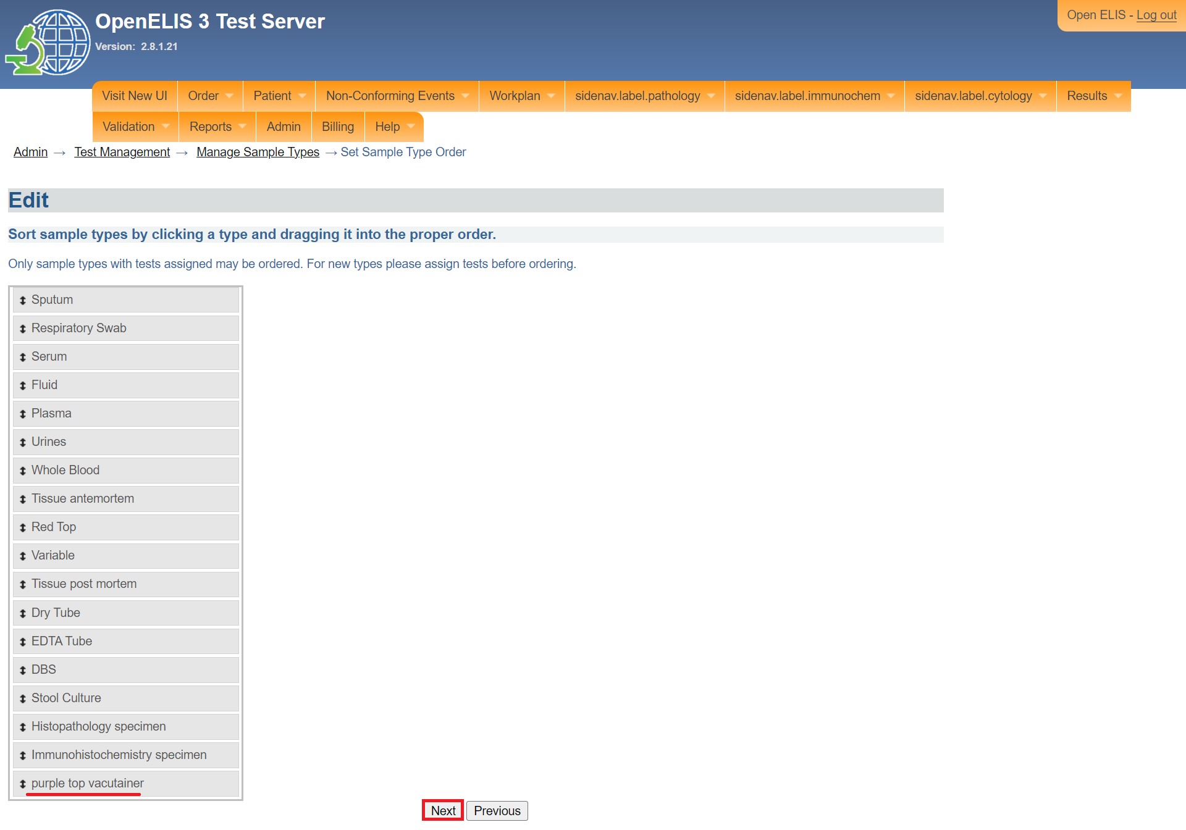

*Click next*

1. Click on the **Accept** button

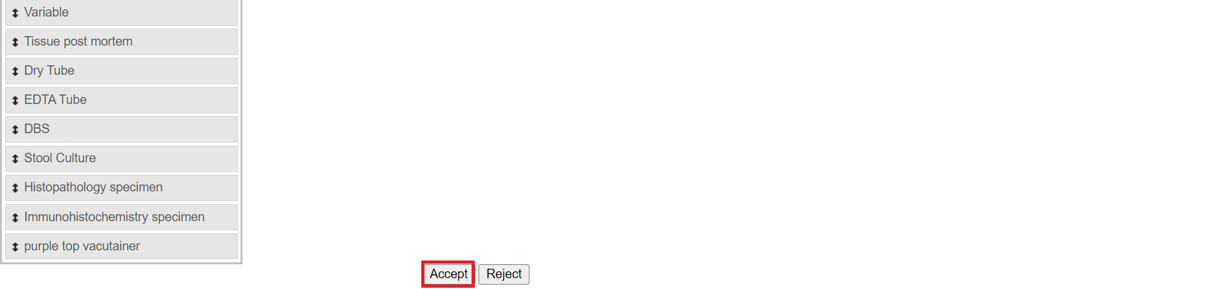

*Click accept*

## **How to create a unit of measure**

1. The manage unit of measure is used to create units of measure. To access the manage unit of measure, Follow steps 1 and 2 under [how to access the OpenELIS administrator module](https://docs.google.com/document/d/1oPIYxrLgoBi4prx2-Anhe1fm4x23_QQanpE_DqAVaVA/edit?pli=1#heading=h.but495evqliv). Click the manage unit of measure under the **test organization** section.

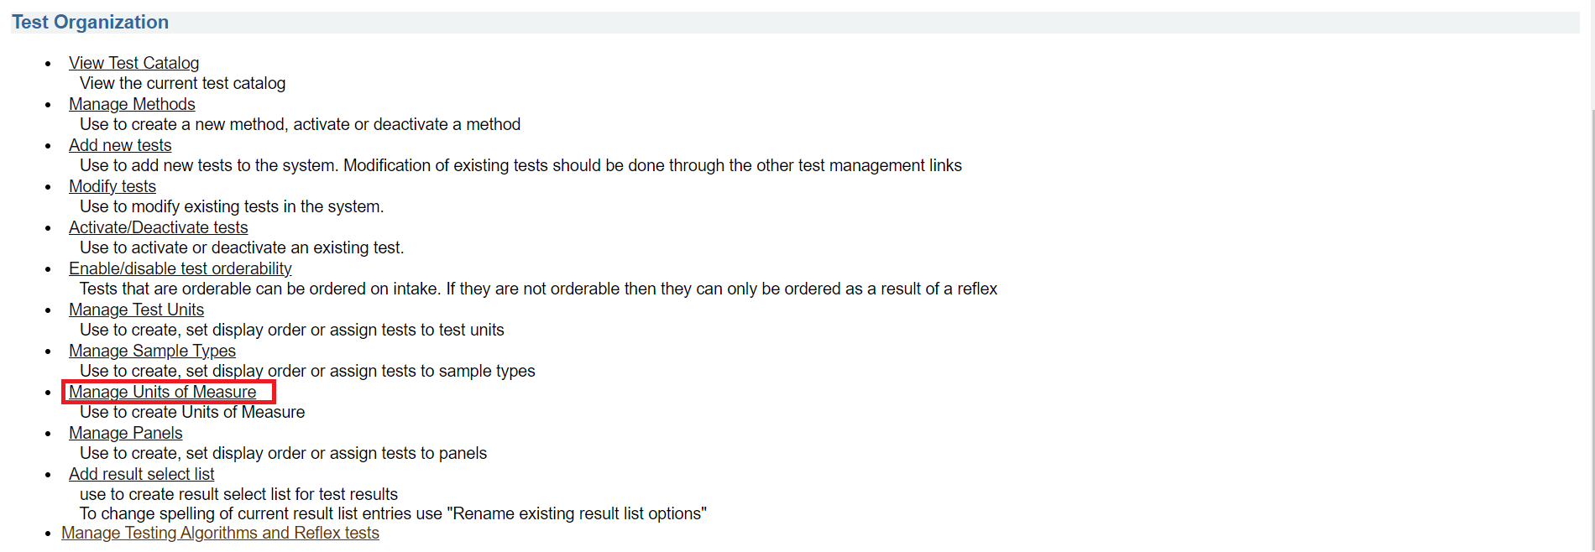

*Click manage unit of measure*

1. Click on unit of measure



*Click new unit of measure*

1. Enter the unit of measure under the text box. In this illustration, Micrograms per litre (mcg/L) is entered.

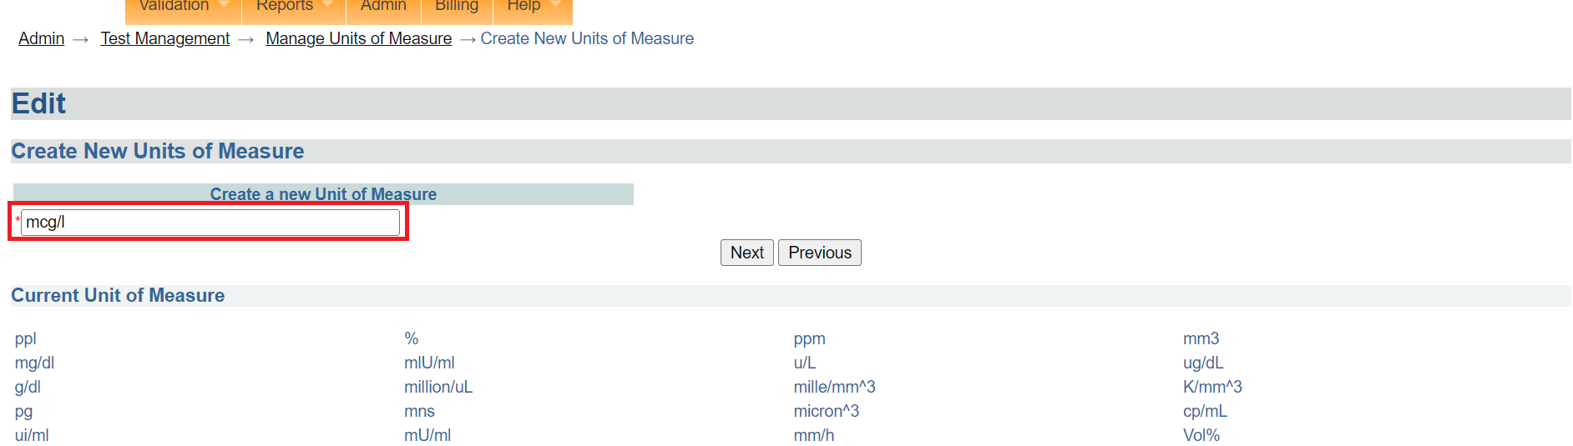

*Enter unit of measure*

1. Click on the **Next** button.

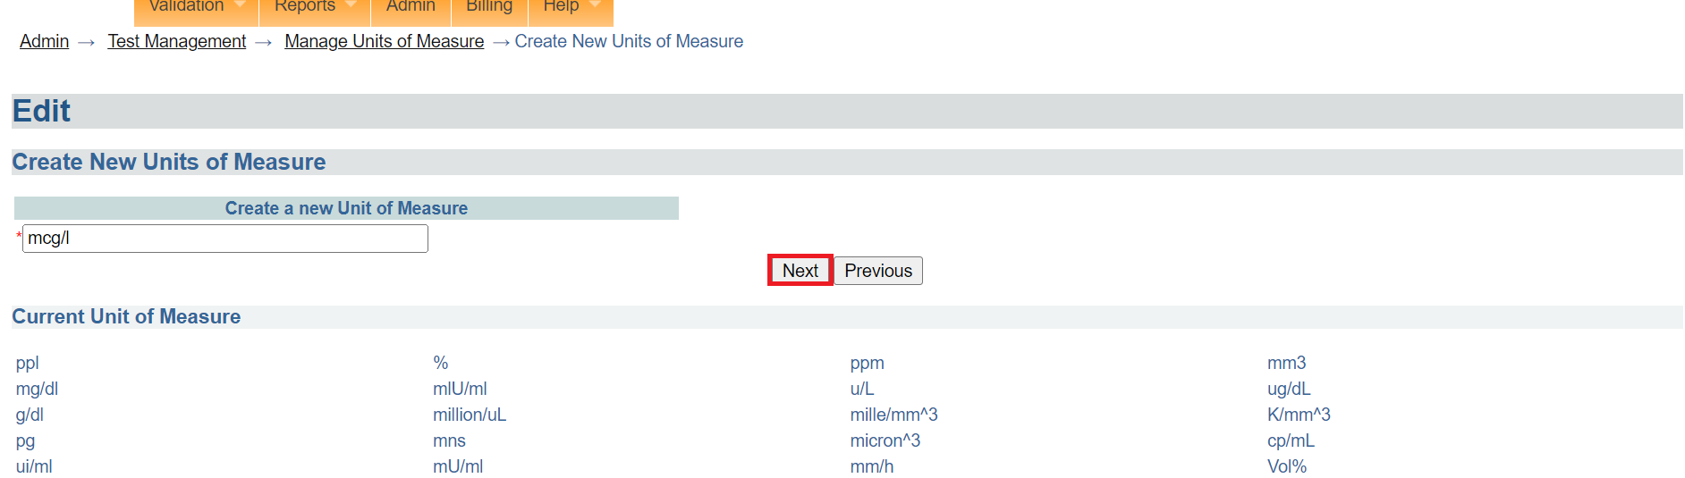

*Click next*

1. Click on the Accept button. The new unit of measure will be created successfully. Otherwise, click on the **Reject** button to cancel.

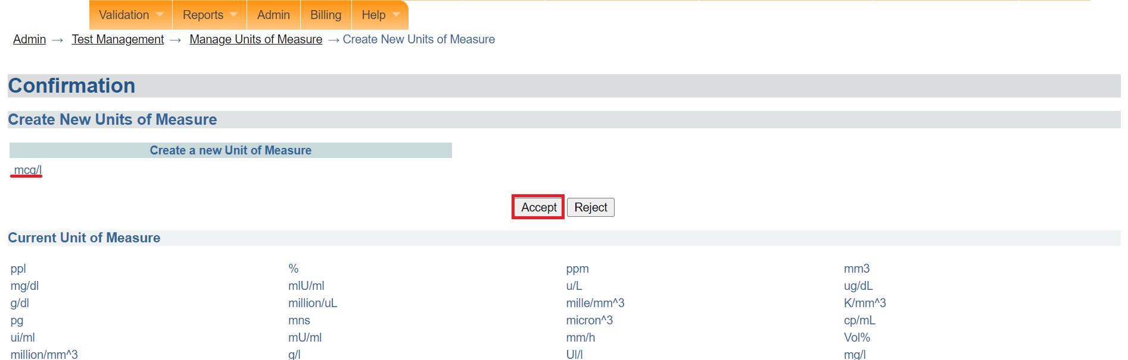

*Click accept*

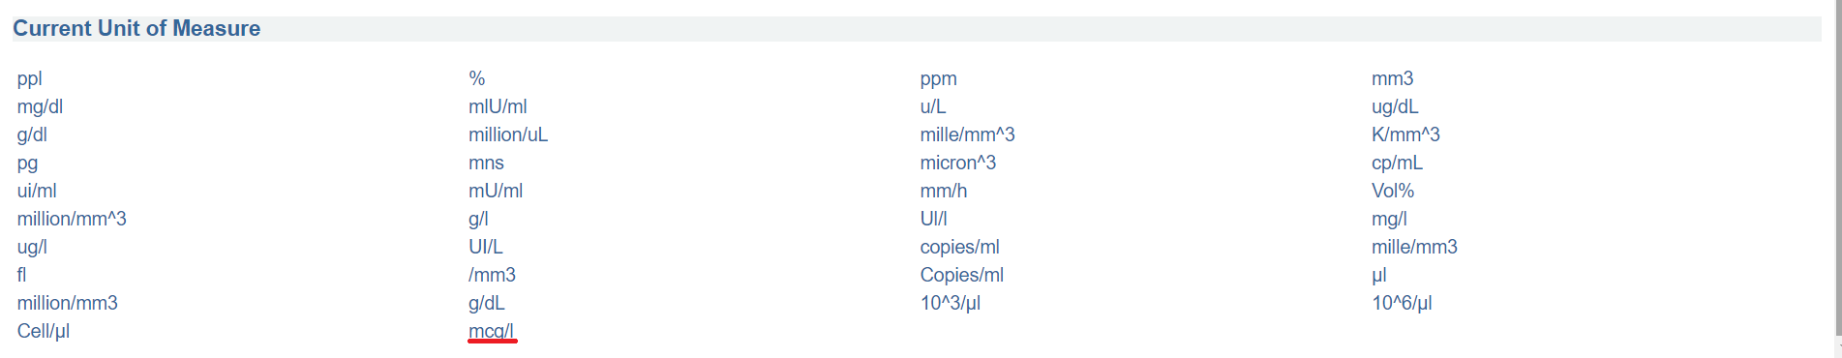

*Unit of measure listed successfully*

## **Manage panels**

1. The **manage panels** is used to create, set display order or assign tests to panels. To access the manage panel option, Follow steps 1 and 2 under [how to access the OpenELIS administrator module](https://docs.google.com/document/d/1oPIYxrLgoBi4prx2-Anhe1fm4x23_QQanpE_DqAVaVA/edit?pli=1#heading=h.but495evqliv). Click on add result select list under the **test organization** section.

### **How to create a panel**

1. Click on c**reate a new panel** under the type page

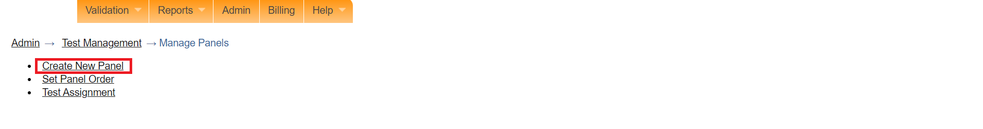

*Click create new*

1. Enter both the English and French names for the new sample type. In this illustration, **test panel** is entered.

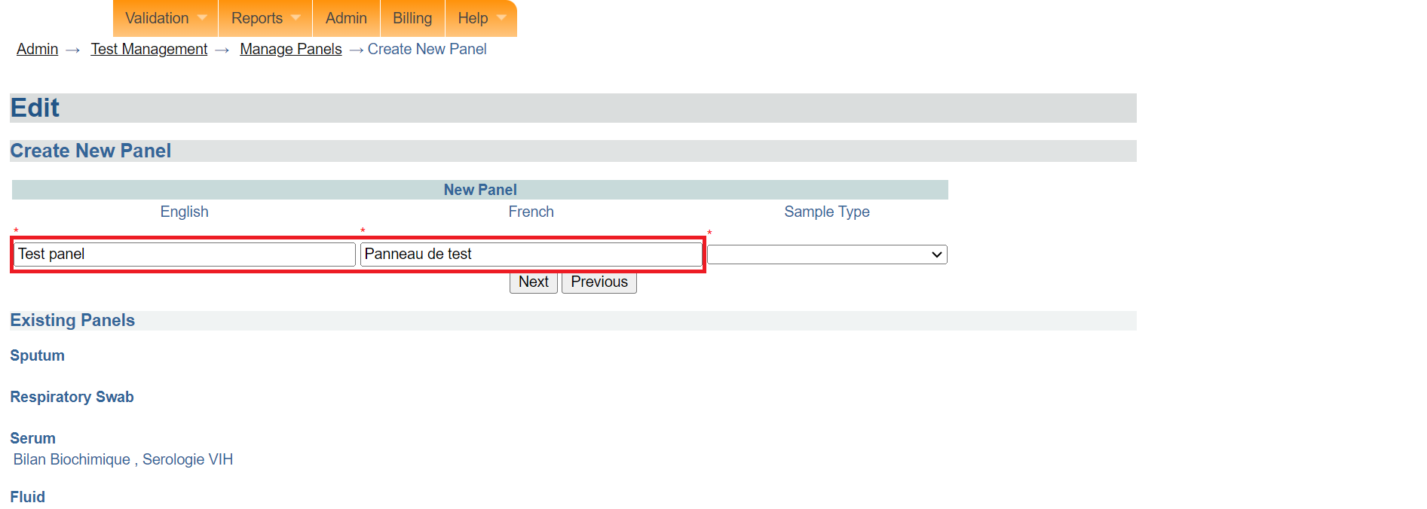

*Enter panel names*

1. Select the sample type from the Sample Type drop-down menu. In this illustration, Whole blood is selected.

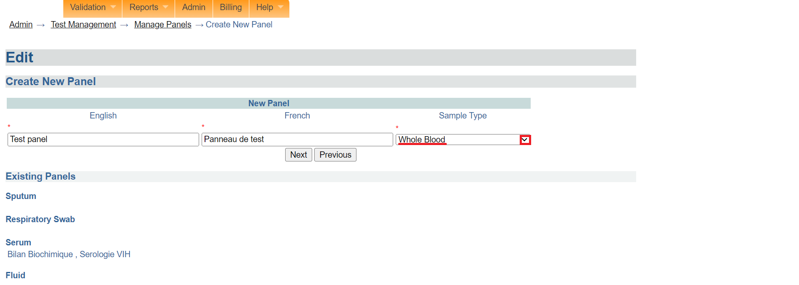

*Select sample type*

1. Click on the Next button.

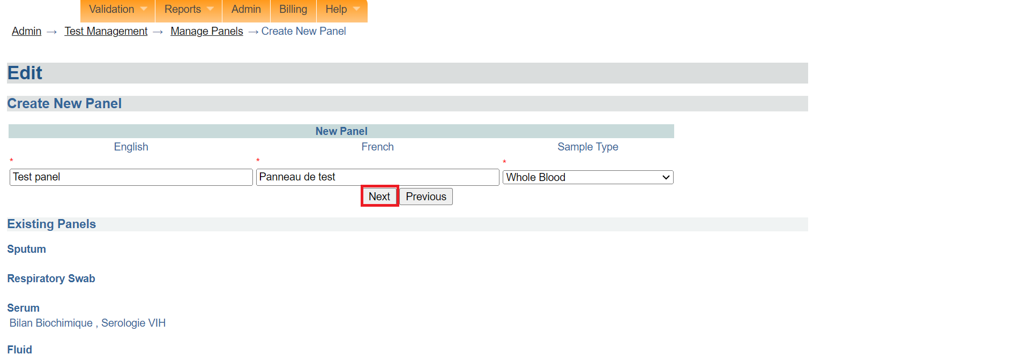

*Click next*

1. Click on the **Accept** button. The newly created panel will be listed under the **inactive panel** section.

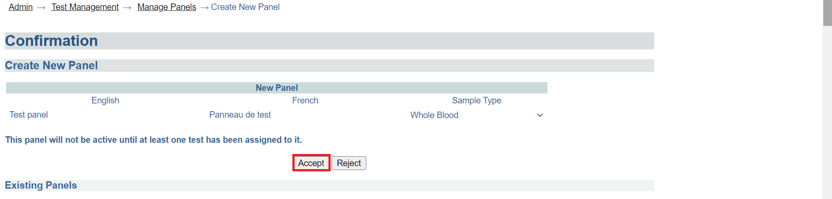

*Click accept*

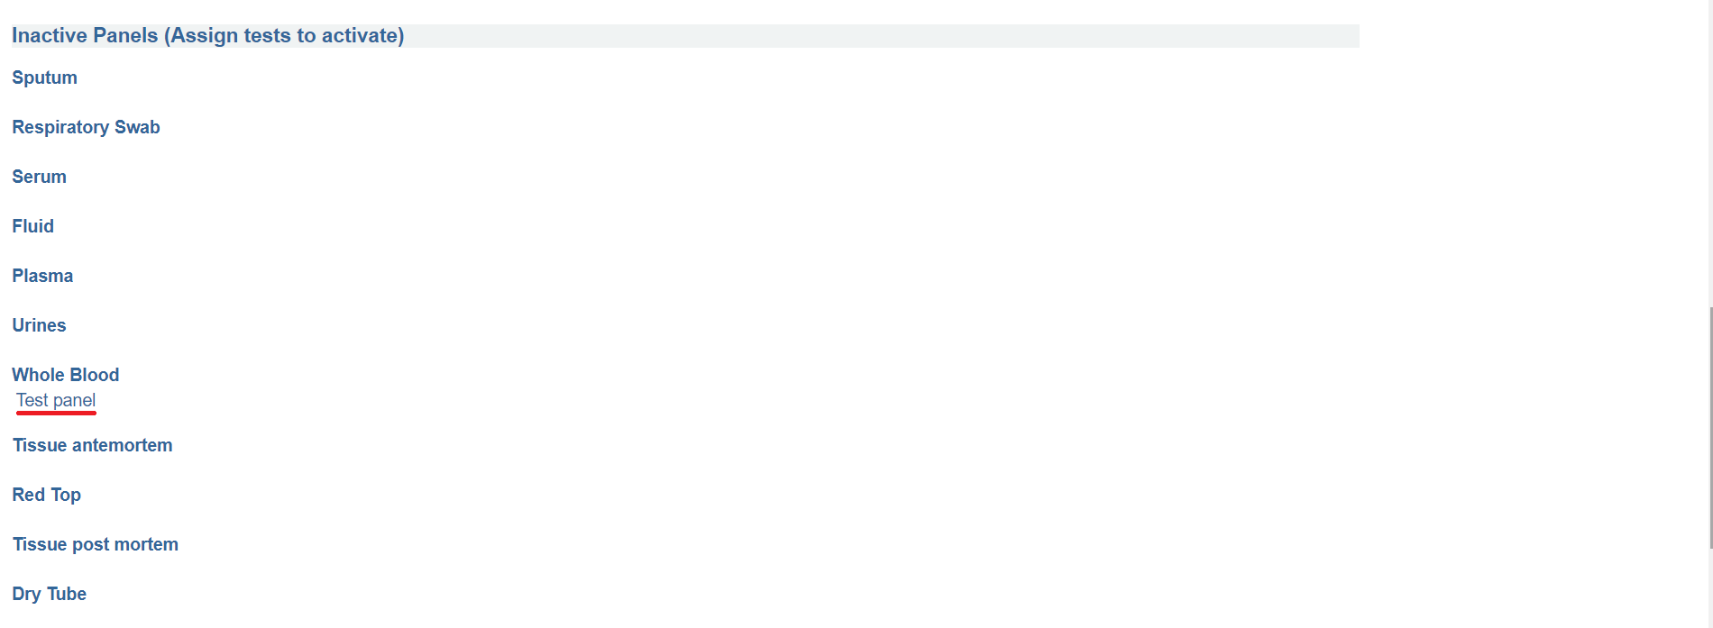

*Inactive panels*

### **How to assign a test to a new panel**

1. Click on the **test assignment** under the page.

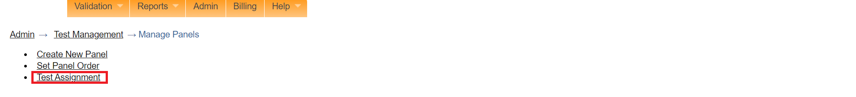

*Click test assignment*

1. Select the panel to assign tests to under the panel drop-down menu.

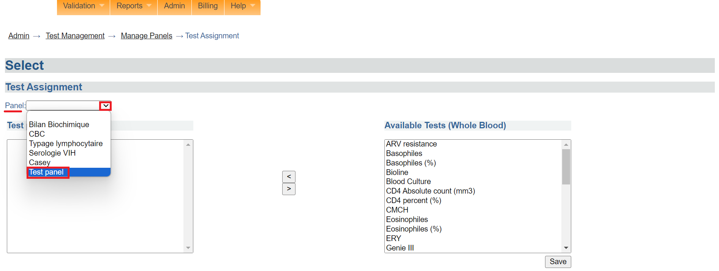

*Click on a panel*

1. Click on the test to be assigned to the panel under available tests.

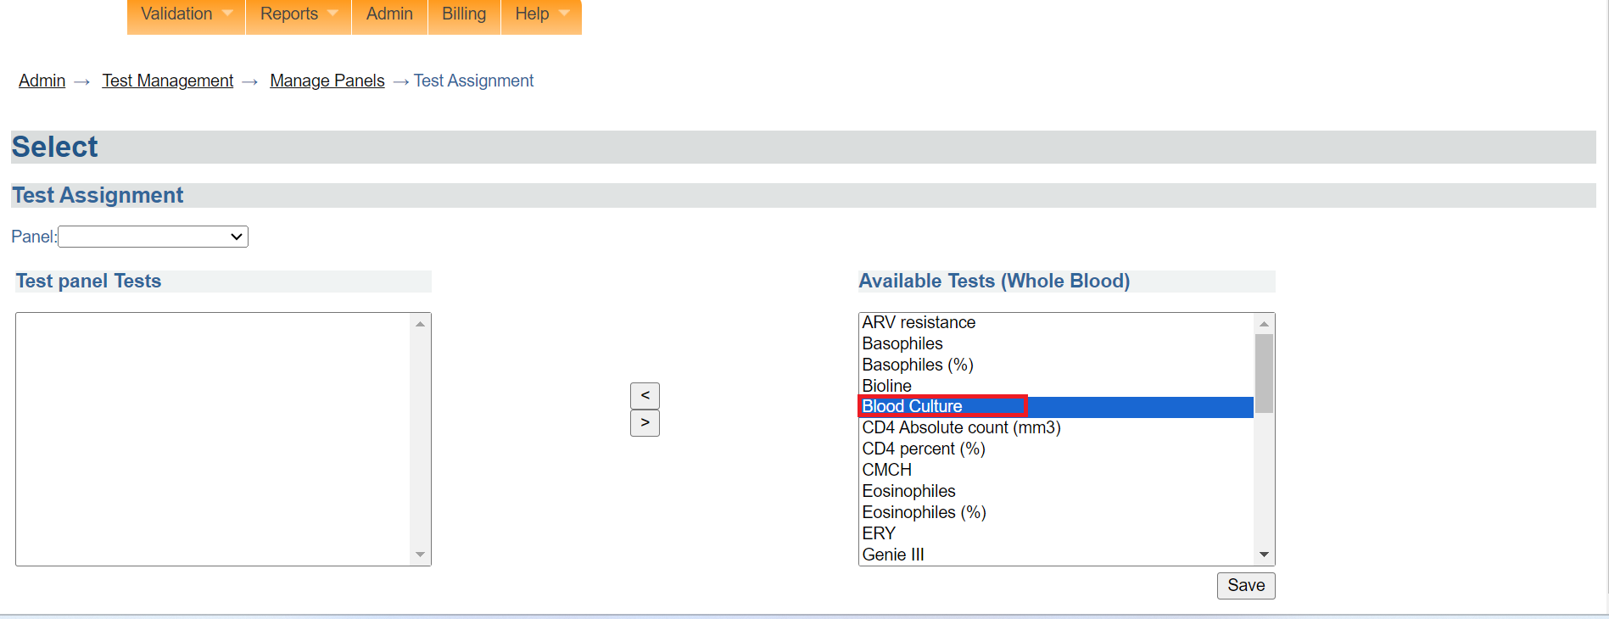

*Click on a test to select*

1. To select multiple tests, hold the SHIFT key on your windows operating system and click on the desired tests.

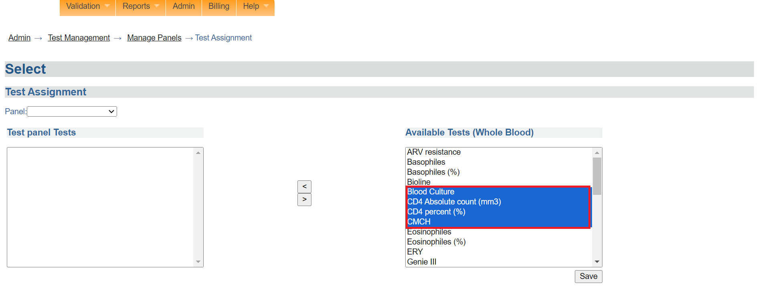

*Selecting multiple tests*

1. Click on the < arrow to move the selected test(s) under the panel.

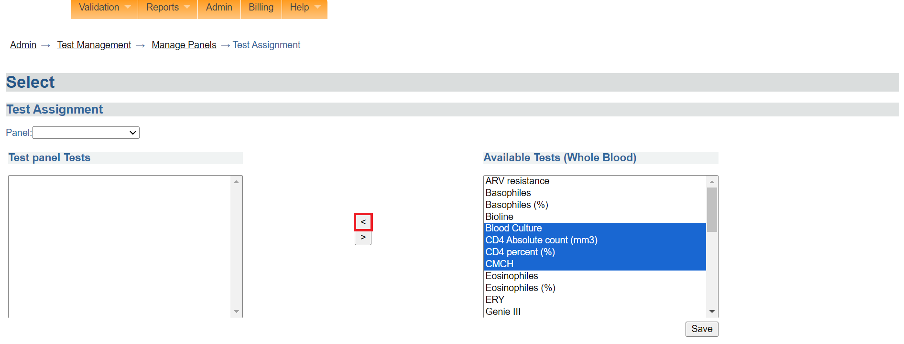

*Move tests to panel.*

Note: To remove a test from the panel, click on the test to select it then click on the > arrow.

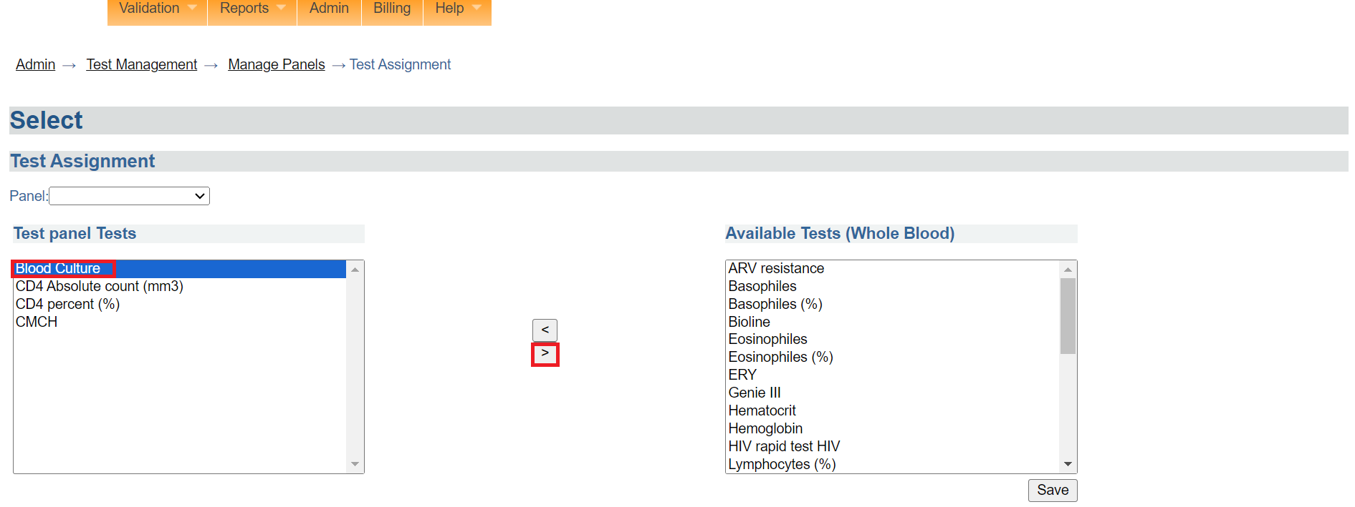

*Removing a test*

1. Click on the **Save** button. A “save successful” message will be displayed.

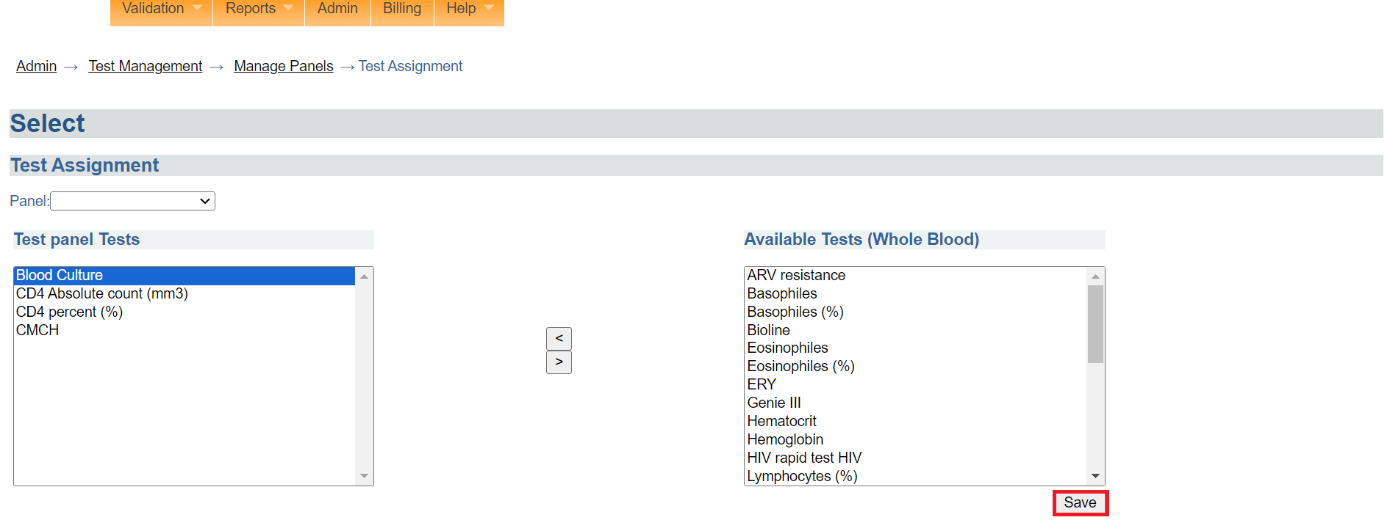

*Click save*

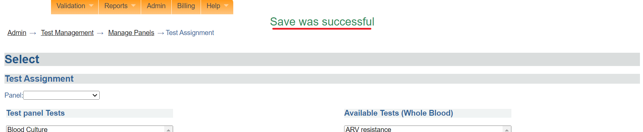

*Tests assigned successfully*

Note: The laboratory team can now access the newly created panel.

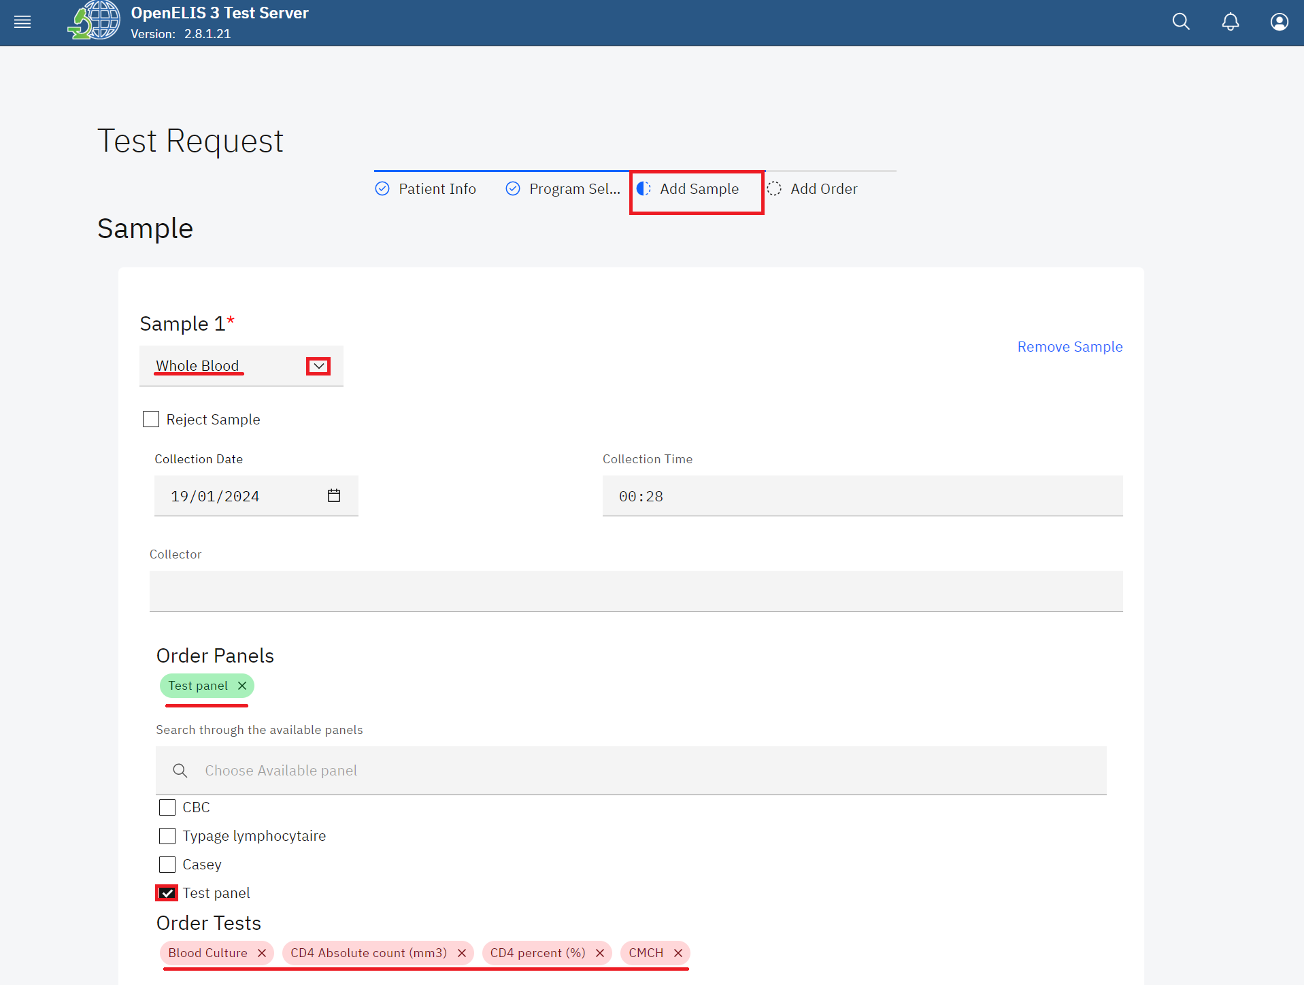

*Adding the new panel to an order*

### **How to establish the display order for panels**

1. Click on **Set Panel Order**

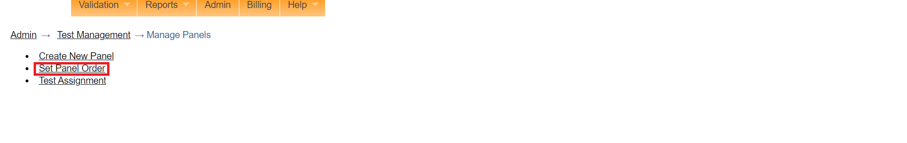

*Click set panel order*

1. To reorder the display,click on a panel and drag the position using the arrow to the position you desire. In this illustration, the **test panel** position will be repositioned to the top .

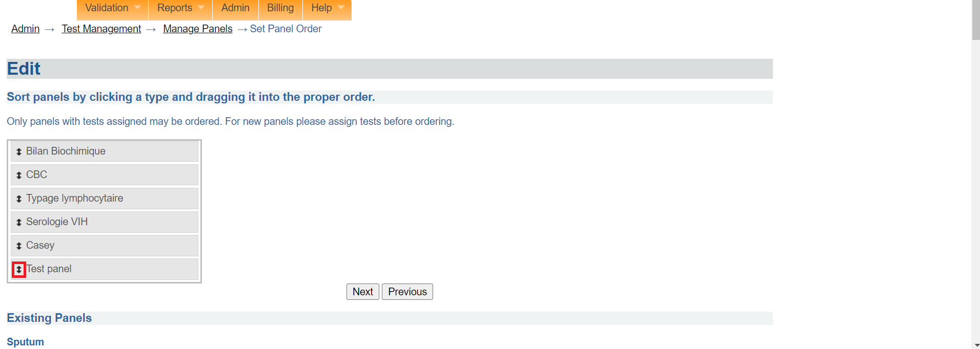

*Click to drag position*

1. Notice the position of the **test panel** . Click on the **Next** button.

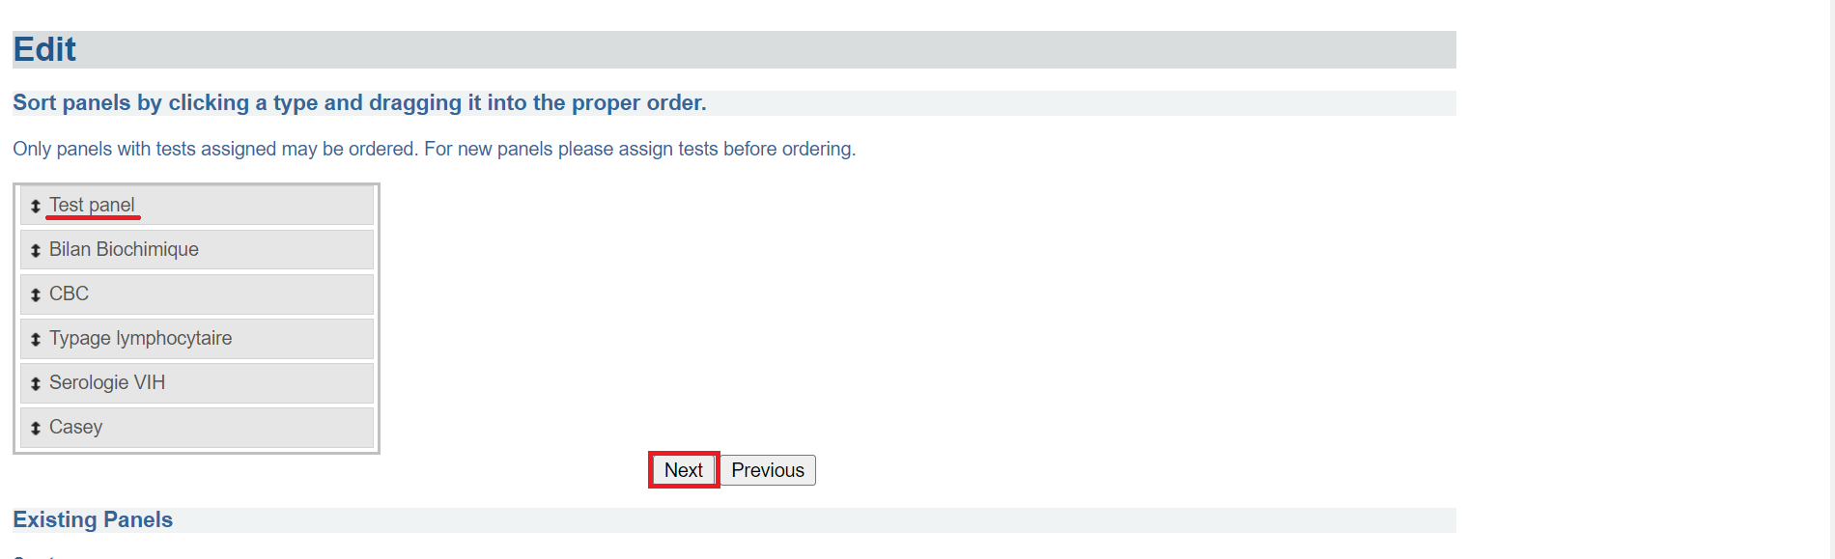

*Click next*

1. Click on the **Accept** button. The panel display position will be reordered successfully.

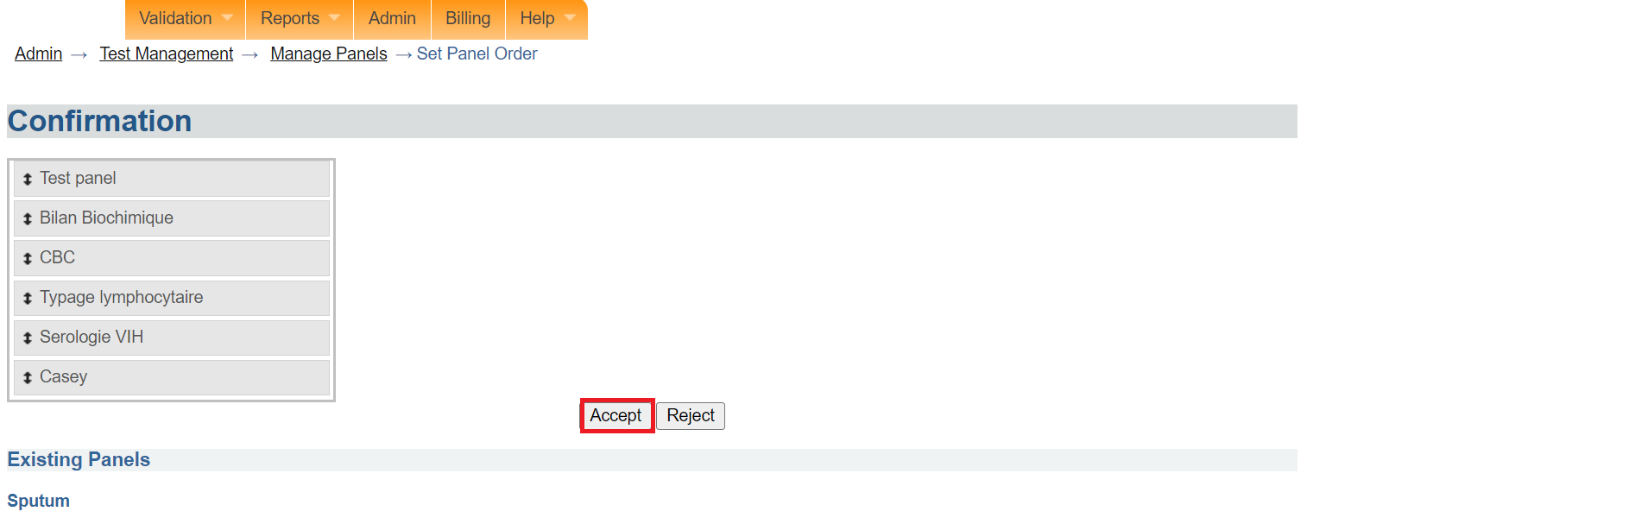

*Click accept*

# 

# **PART 5: USER MANAGEMENT**

## **How to access the user management module**

1. To access the main menu, click on the menu icon at the top left side of the screen.



*Accessing OpenELIS 3 Menu*

1. Upon clicking on the menu icon, click on **Admin**.

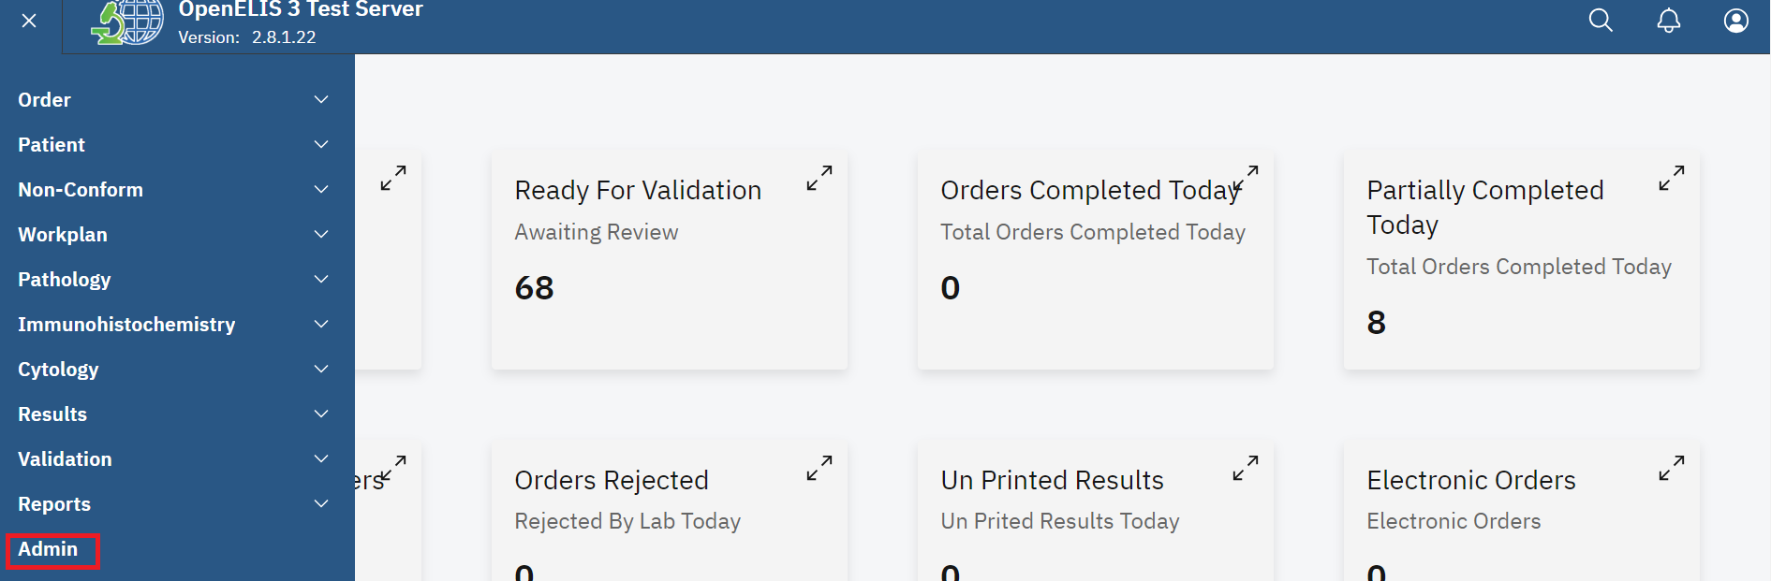

*Click admin*

1. Click on legacy admin

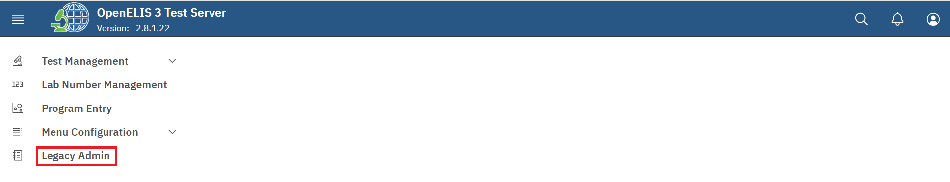

*Click on legacy admin*

Upon clicking on legacy admin, the master list page will be displayed. The user management menu item is listed on this page

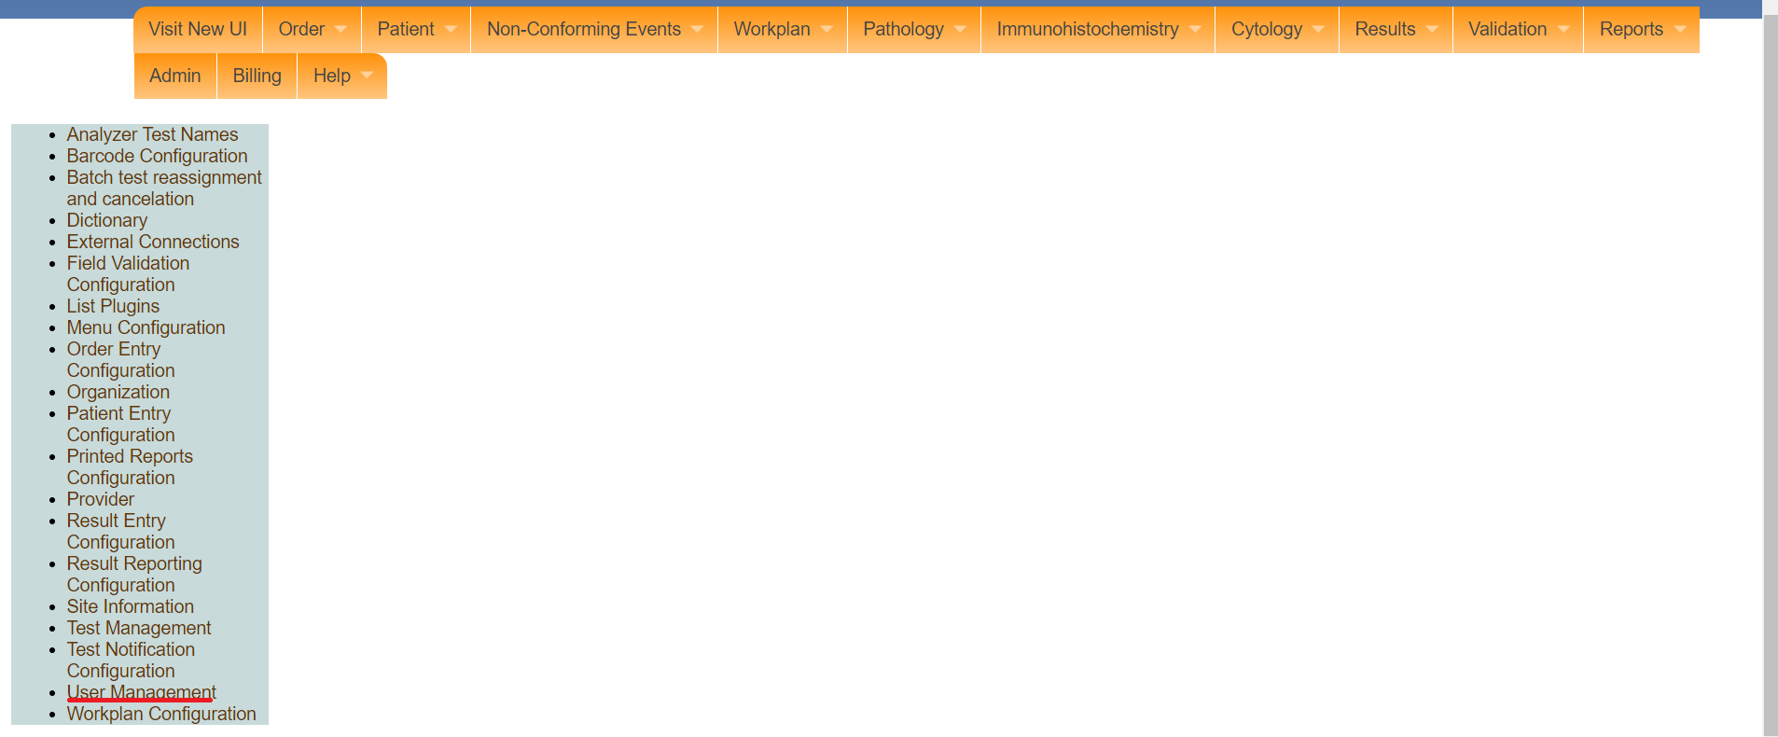

*User management*

## **How to add a new user**

1. To add a new user, click on user management.

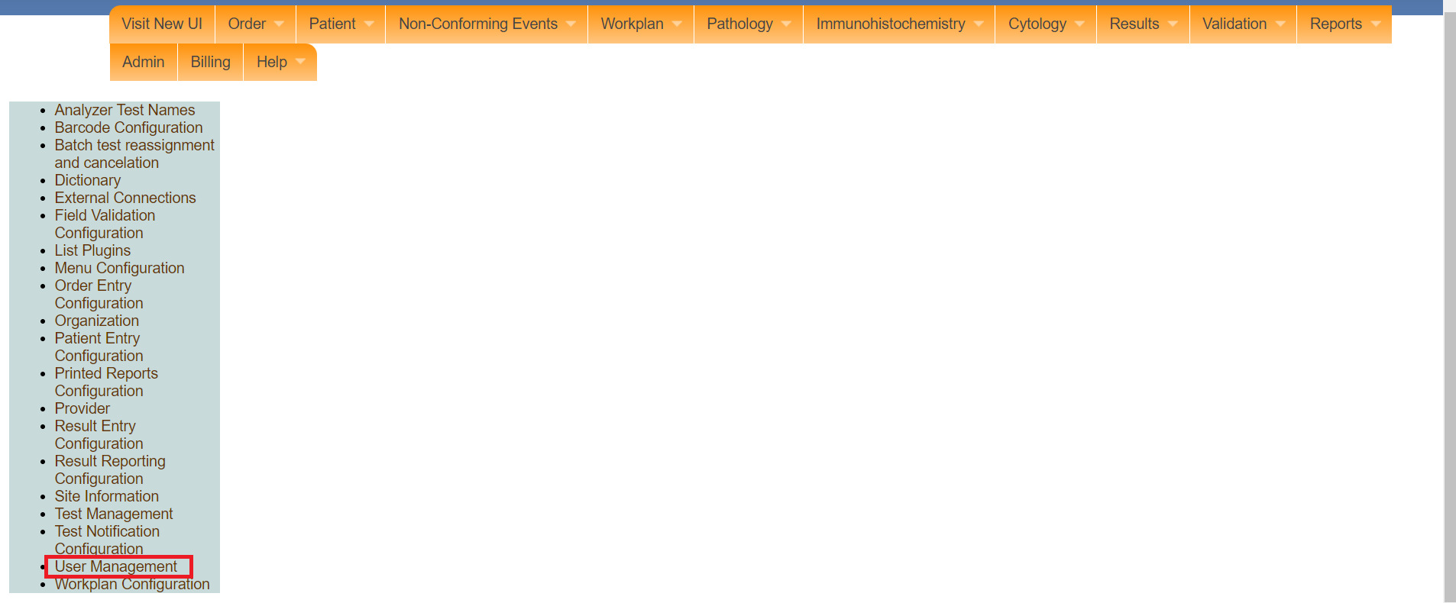

*Click user management*

Note: Upon clicking on user management, the user management page will be displayed. Tjis page displays a list of system user accounts.

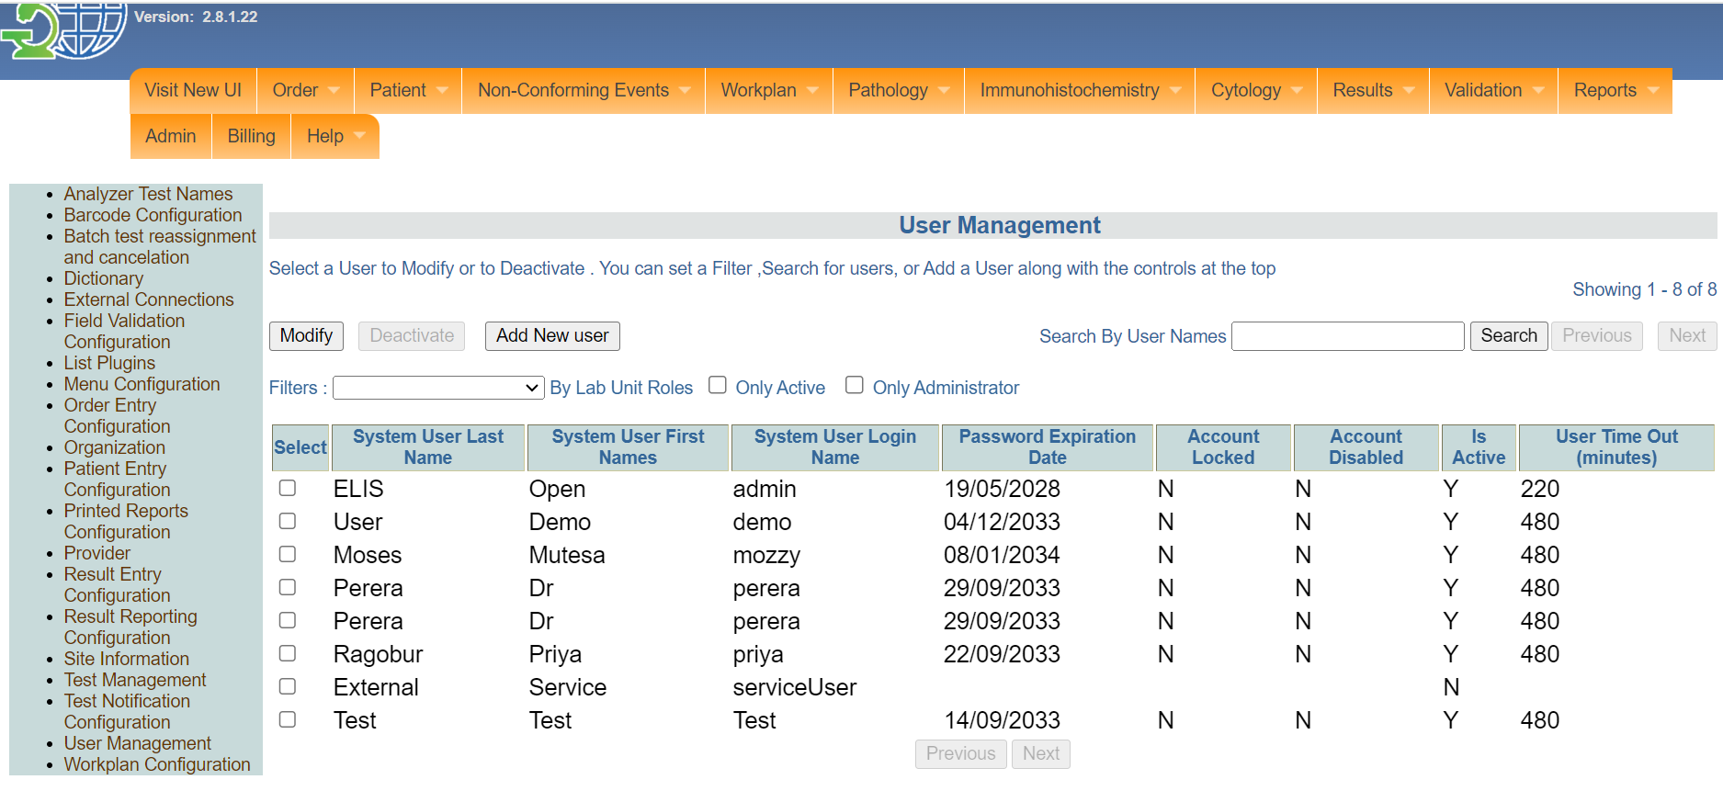

*User management*

Note: Use the **Next** button to see more system users. Use the **Previous** button to view the previous page of system users. The buttons are active when the list of users is large.

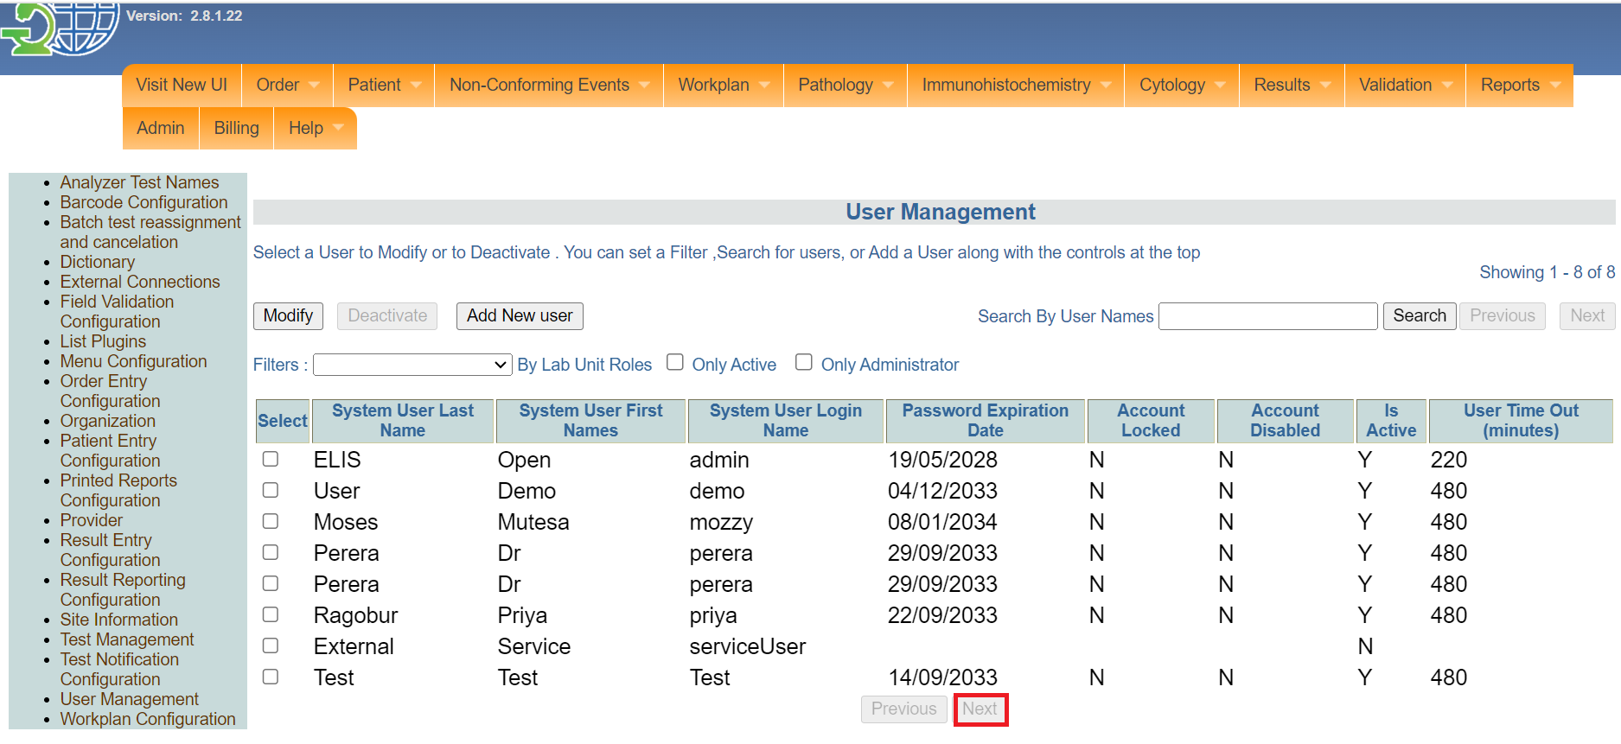

*Next button*

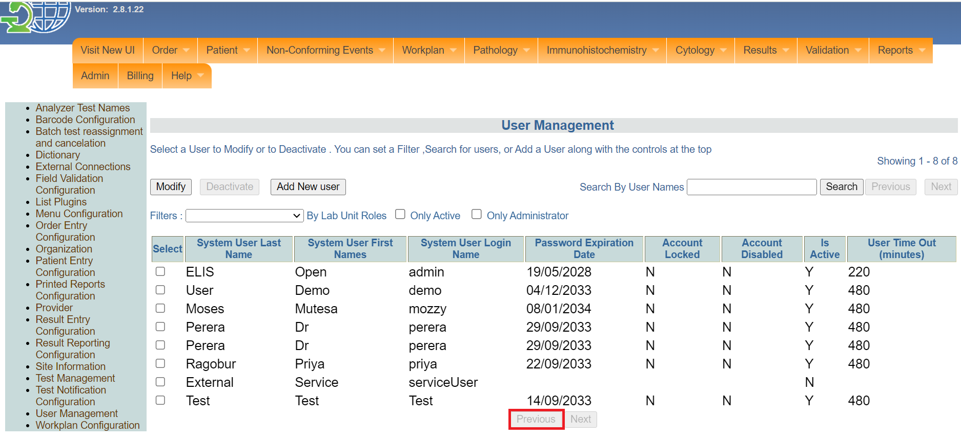

*Previous button*

1. To add a new user, click on the **Add New User** button. The new user form will be displayed. Fields marked with a red asterisk * are mandatory to fill.

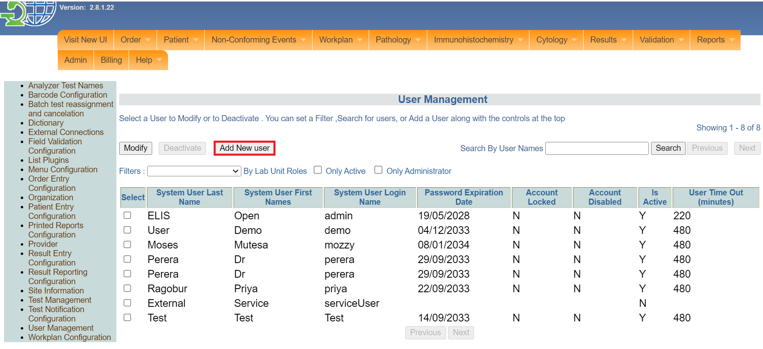

*Click add new user*

1. Fill in the **Login Name**, **Password**, **First Name** and **Last Name**.

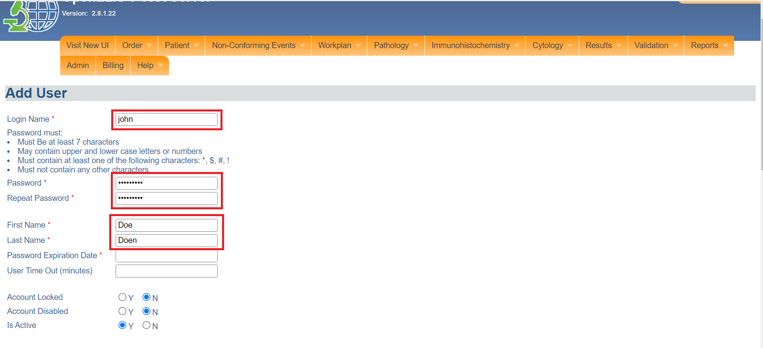

*Fill in account details*

1. Fill in the **Password Expired Date**, **User Time Out** in minutes or leave the default values

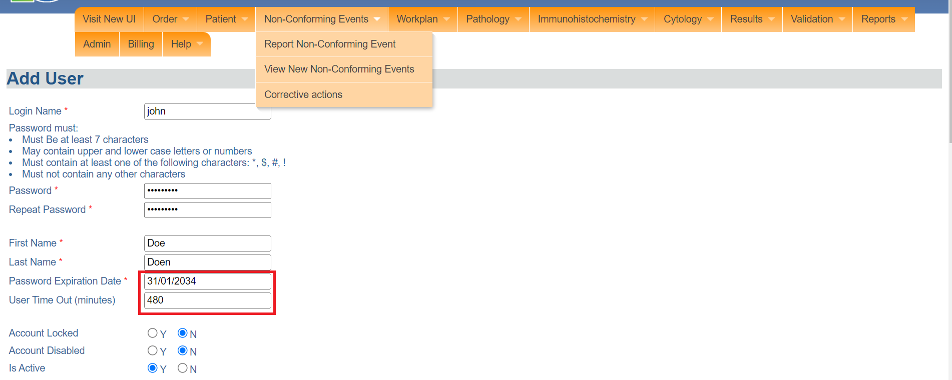

*Password expiration and user time out*

1. Select Y (Yes) or N (No) radio buttons for : Account Locked Account Disabled Is Active.

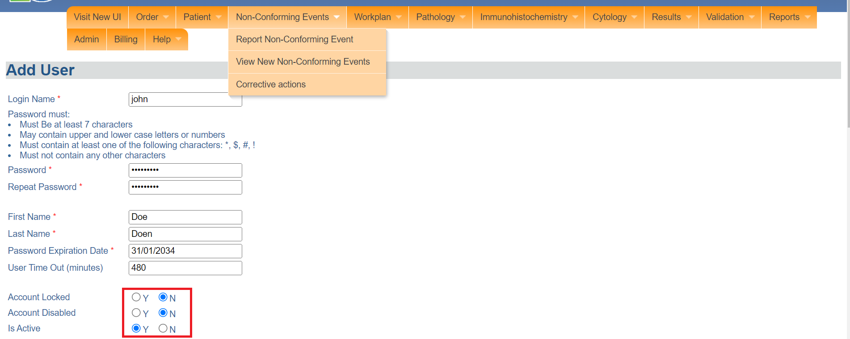

*Select radio buttons*

Note: To assign permissions to the account, you use the **Copy Permissions** feature to copy the permissions of an existing user.Ensure that you have filled all the information above and enter the **user name** whose permissions you want to copy into the box and click apply.

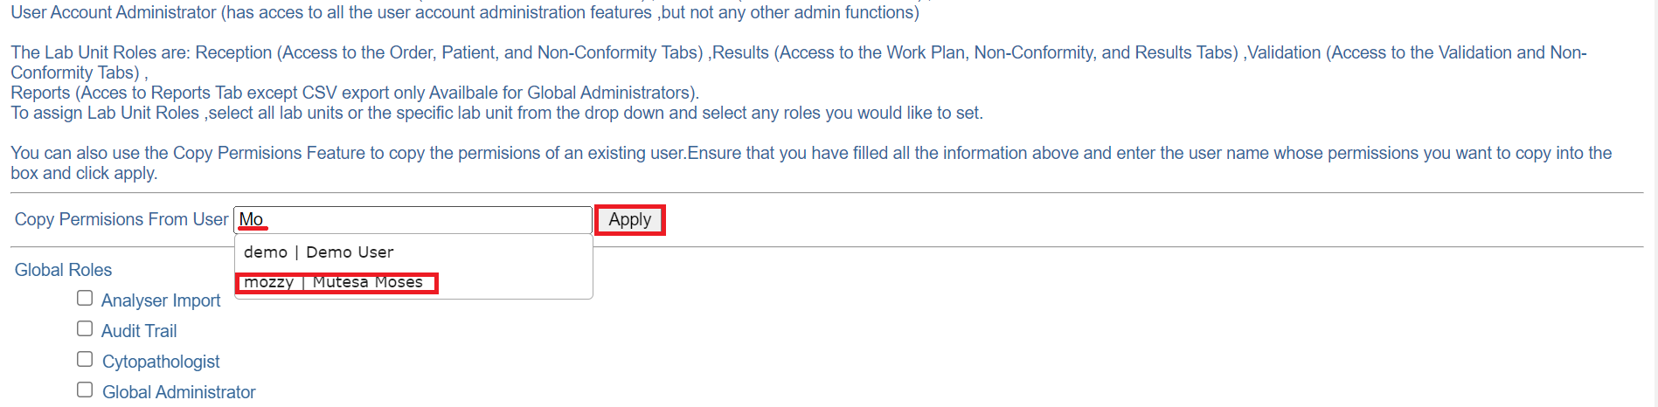

Copy permissions

1. Select the checkboxes for the global roles that can be performed using the account.

Note: The available **Global Role**s are: GLobal Administrator (Access to all Admin Functions) Audit Trail (Access to all Audit Trail) ,User Account Administrator (has access to all the user account administration features ,but not any other admin functions).

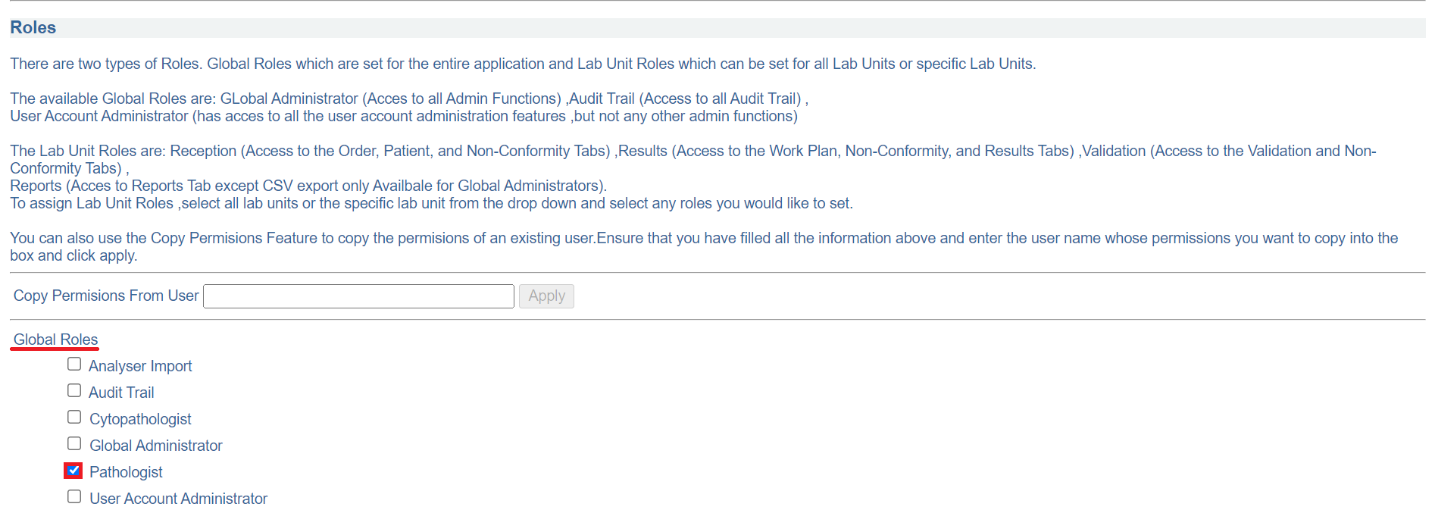

*Set account global role(s)*

1. To assign Lab Unit Roles ,select all lab units or the specific lab unit from the drop down and select any roles you would like to set.

Note: The **Lab Unit Roles** are: Reception (Access to the Order, Patient, and Non-Conformity Tabs) ,Results (Access to the Work Plan, Non-Conformity, and Results Tabs) ,Validation (Access to the Validation and Non-Conformity Tabs) , Reports (Access to Reports Tab except CSV export only Available for Global Administrators). In this illustration, **All Lab Unit** is the default lab unit role. The **All Permissions** checkbox is selected.

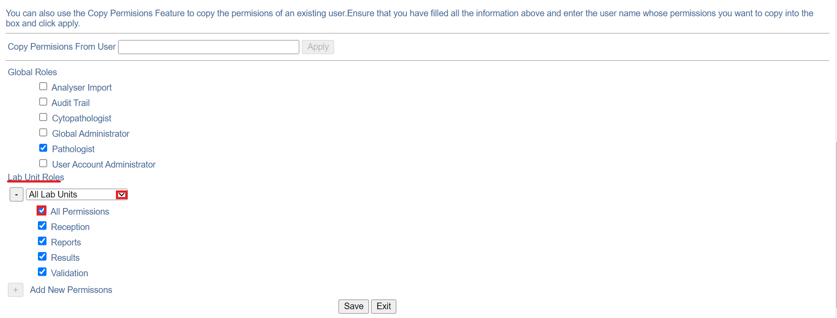

*Set lab unit roles*

1. Click on the **Save** button. The user will be added successfully. The **Exit** button is used to cancel the add new user.

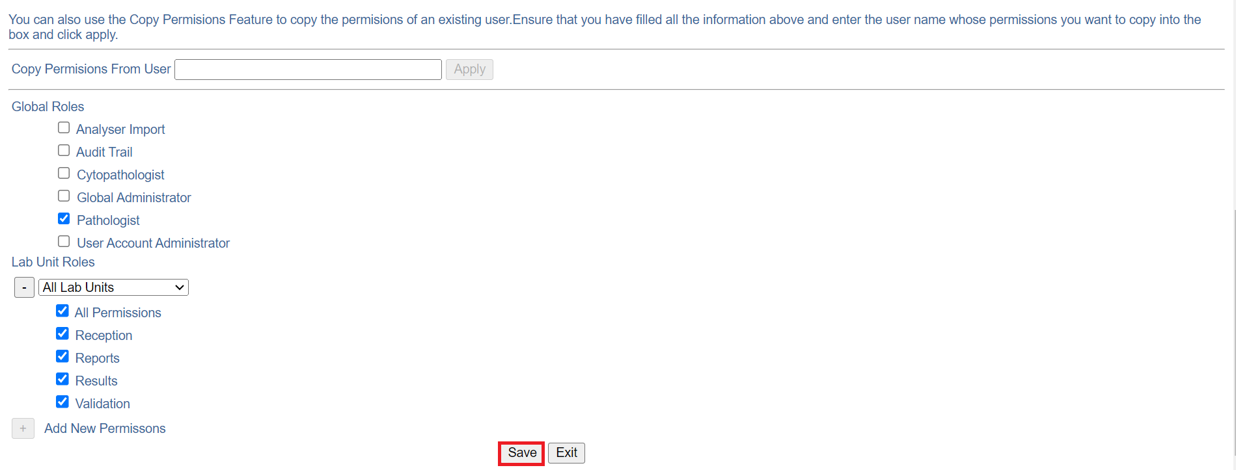

*Click save*

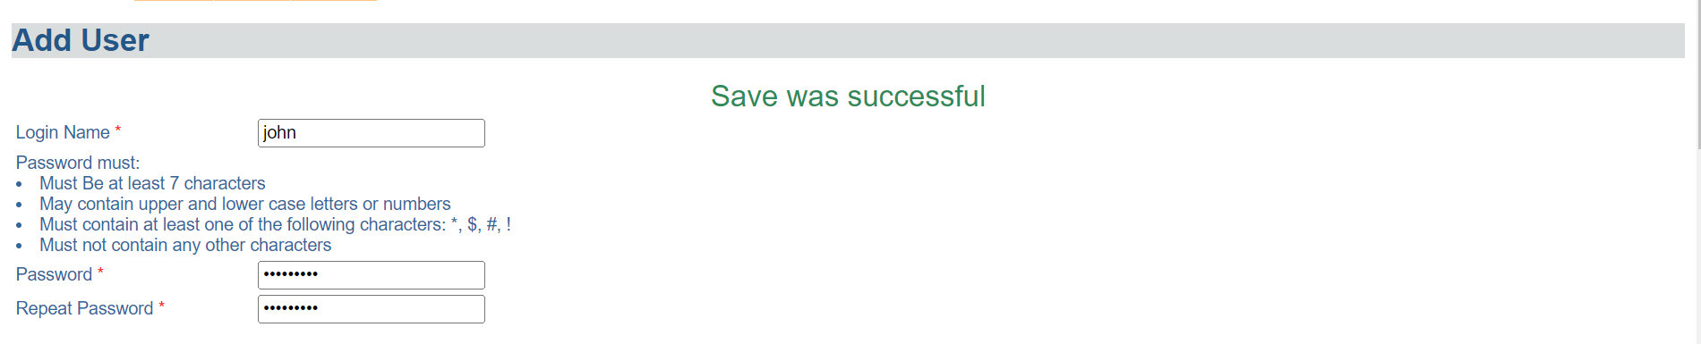

*Account created successfully*